OASIS TC Operations Handbook
Internal. Draft 0.8, 2 August 2026.
The companion to the public OASIS TC Handbook. That document sets out the rules; this one sets out the operation that carries them out, with an owner, a system, a permission, a timing and a record for every step.
Every operational claim in this handbook traces to the fact registry that ships beside it, or is marked [VERIFY] and listed in Appendix A. Qualifiers are verbatim from policy. Where an internal procedure and OASIS policy disagree, policy wins and the disagreement is recorded as a defect to file rather than reconciled in prose.

1. About this handbook

1.1 Scope
The public TC Handbook documents the rules a Technical Committee works under. This handbook documents the operation that carries those rules out. For every task in publishing a specification, running a ballot and running a public review, it records whose remit it is today, what system it runs on, what access it needs, how long it takes, and what record it leaves behind.
The audience is the Technical Committee and Standards Publishing Admin, the role that runs OASIS Technical Committee operations and standards publishing.
It covers:
- the publishing operation from intake to the audit record
- balloting
- public reviews
- the communications tied to those tasks
- the systems and access they depend on
- the records they produce
- the roles that hold them
- the known weak points in the operation, and what would fix each
Out of scope:
1. Interpreting OASIS policy: the TC Process and the public TC Handbook govern that, and section 1.3 sets out what happens when the two appear to disagree.
2. Deciding platform or infrastructure architecture.
3. Legal, membership or intellectual property questions.
4. Credentials, host addresses, account, bucket, distribution or zone identifiers, and paths into anyone's machine or into the infrastructure.
Systems are named by what they do, because this document circulates internally and outlives any one person's access.
Every reference in this document is cited, with a link to its origin source. Some figures may change over time, such as the number of checks the acceptance criteria apply; a document records them as they stood when it was written. The dated figures that appear throughout are explained once, in the note at the head of chapter 2.
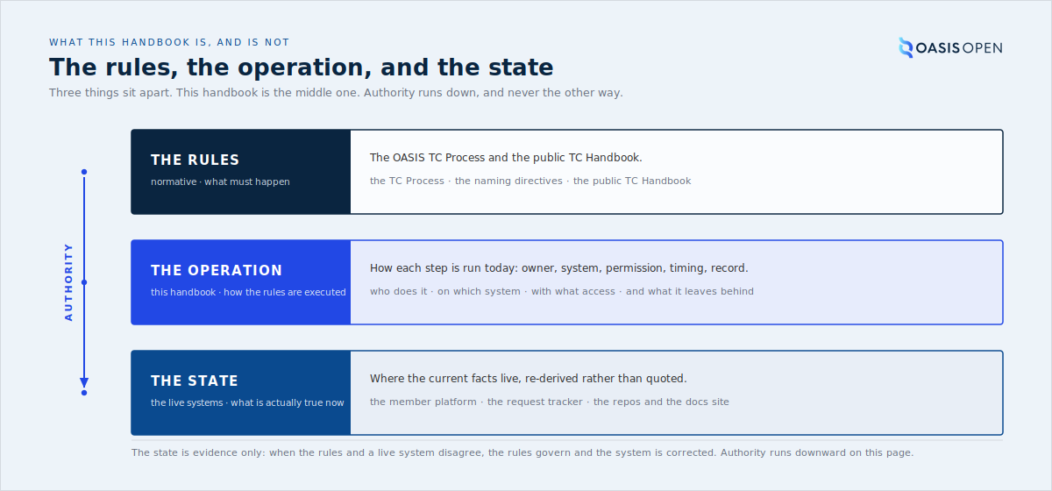
the three-way split between the TC Process and public TC Handbook (the rules), this handbook (the operation), and the live systems (the state), with an arrow showing which way authority runs

1.2 How to read an operations entry
Every operational section follows the same shape: a few sentences of plain prose that describe the task and why it exists, then, where it applies, a block of five facts.
- Owner: whose remit this is today.
- System: where it happens, named by function.
- Permission: the access a person needs before they can do it.
- Timing: how long it takes, or the clock it starts.
- Record: the artifact left behind, such as a ticket, a published file, a report or an announcement.
Not every section carries all five. A section that describes a relationship rather than a discrete action states only the fields that apply. The values come from the registry entry behind the claim. None of them is inferred, and no owner or permission is written into this handbook that has not been observed in the real operation.
The second thing to read in an entry is its authority. Every operational claim carries one of four natures, and the wording signals which one:
Nature | What it means | How it reads
Obligation | OASIS is bound by written policy, and the governing clause can be named | "OASIS must ...", with the clause cited
Practice | OASIS holds itself to this. It was earned from real work, and no single clause requires it | "OASIS does this, though no clause requires it"
Convention | An internal working agreement, adopted because it prevents a known failure | "The working convention is ..."
Finding | An observed state of the world, true on a stated date | "As of date, ..."
Read those as a scale of how hard something is to change:
- An obligation changes only when policy changes.
- A practice changes whenever OASIS decides to stop doing it, and nothing outside OASIS obliges it to continue.
- A convention changes at any time by agreement among the people running the operation.
- A finding changes when the world does, which is why every finding carries a date.
From any entry, a reader should be able to say whether OASIS is bound or has chosen. Chapter 3 is organised around that difference.
A claim marked [VERIFY] could not be confirmed against a source when it was written. It is not evidence, and it must not be repeated to a TC. Appendix A lists every one of them and what was needed to close it.

1.3 Relationship to the TC Handbook and OASIS policy
The OASIS TC Process, the Committee Operations Process, the Naming Directives and the public TC Handbook are authoritative on policy:
- what a TC must do to advance a specification
- what each ballot requires
- what a public review must include
This handbook does not restate them and never overrides them. Where it needs a policy fact it points to the entry in the public TC Handbook's own registry rather than writing the rule out a second time, so a policy revision is corrected in one place.
The rule for conflicts is the one OASIS already states to TCs in its publication documentation.
The conflict rule
Where the mechanics and the process rules appear to disagree, the TC Handbook and the TC Process win. The disagreement is then a defect, in this handbook or in the operation it describes, and it is filed as one.
The disagreement is filed rather than reconciled in prose, and the operation is never described as though the policy said something else.
This is an internal publication. It describes current practice rather than a fixed specification, and it changes as roles, systems and staff change. Draft 0.8 records the operation as it stood at the start of August 2026.

1.4 Technical Committees and Open Projects
Two standards programs
OASIS runs two standards programs, with different intake, governance and tools: Technical Committees and Open Projects. This handbook documents the Technical Committee program.
Technical Committees are the formal, member-based program under the OASIS TC Process. A TC is chartered by members, decides by ballot, and advances a specification through public review and the stages to OASIS Standard, with the approved work published to docs.oasis-open.org. Publishing, balloting and public reviews, the rest of this handbook, are TC operations.
Open Projects are the parallel program for open-source work: communities that develop code, APIs, reference implementations and specifications under open-source licences. A project is sponsor-funded, contributors join without dues, and it is centred on its own GitHub organisation, with a mailing group, calendar, roster and ballot alongside. Each project is governed by a Project Governing Board and a Technical Steering Committee, with the rest of its governance documented in the project's own GOVERNANCE.md. The program's policies and guides live in the Open Projects documentation repository.
The two programs run different early ladders and converge at the top. An Open Project advances work as a Project Specification Draft, then a Project Specification, each approved by its Project Governing Board, where a TC advances a Committee Specification Draft to a Committee Specification by TC ballot. From there both tracks pass through the same gate: a 60-day public review, three Statements of Use, a Special Majority Vote to approve a Candidate OASIS Standard, and a Call for Consent to the OASIS membership, with the option to submit the result to ISO, IEC or ITU. The administrator function that runs the ballots, reviews conformance, announces the reviews and publishes the approved work is the operation this handbook documents, so Open Projects are in scope here where they use it; a task written for a TC still does not transfer to a project unchanged.
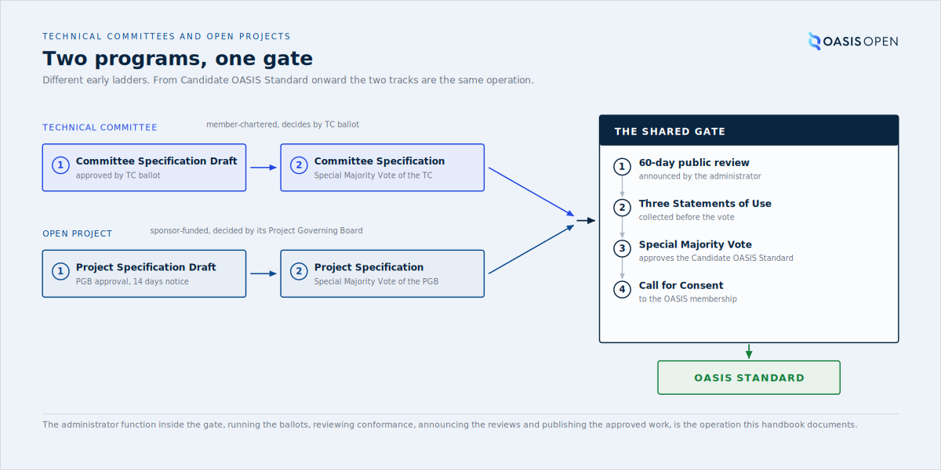
the Technical Committee and Open Project ladders side by side, each advancing its draft to its specification by its own vote, converging at the shared gate: the 60-day public review, three Statements of Use, the Special Majority Vote to Candidate OASIS Standard, and the Call for Consent
OASIS runs two documentation domains. Published specifications are served from docs.oasis-open.org. A second domain, docs.oasis-open-projects.org, was set up for Open Projects, but as of 29 July 2026 its index lists only one project, OSLC, beside a templates folder. That single entry is not a count of the Open Projects program. It reflects a move away from giving each project its own documentation site, and it does not depend on whether a project is an Open Project or whether it follows the TC Process.

2. The Technical Committees this manual serves
The rest of this handbook describes an operation. This chapter is about the people that operation serves: the OASIS Technical Committees (TCs), how they work, and how they differ from each other in ways that change how a request from them arrives, the tools they use, and how correspondence reaches them. The figures below come from an audit of TC requests and activity over July 2024 to July 2026.

2.1 Activity, as measured by tool usage
A busy committee can leave almost no trace in the systems OASIS runs, so this chapter reads a committee's engagement from the marks it leaves and never from any one of them alone.
Where the figures in this handbook come from
Some sections carry counts of committee activity, requests, ballots and turnaround. They are drawn from two fixed windows and one reading date, stated here once so the sections themselves can stay brief. The request and publication records cover July 2024 to July 2026. The member platform record covers March 2024 to July 2026. All were read at a single pull in July 2026, and staff posts are excluded from the committee-activity counts so the figures reflect member work. Every count is a finding true on its reading date, not a live total; each traces to a dated fact in the registry, and a figure written without its date should be treated as out of date.
There are four kinds of tool data. A TC that is quiet in one is often busy in another:
1. Developer tools: commits, issues, pull requests and comments on the two GitHub organisations, Jira issues, and wiki edits.
2. Meetings held: calls recorded as held on the member platform calendar across the platform window, March 2024 to July 2026.
3. Publications: specifications deposited on docs.oasis-open.org in the window.
4. Member discussion: discussion posts written by a member rather than staff.
No TC's activity level can be judged from one kind of data alone, because each kind catches TCs the others miss. Each TC reaches the organisation through different tools, and some barely use the tools at all.
Concretely, DSS-X surfaces only in the developer tools, ESAT only in meetings held, and BDXR only in member discussion; every other measured committee now lights at least two of the four kinds.
50  active Technical Committees | 34  leave a measurable footprint | 16  leave no in-window trace | 11  Open Projects beside them | 5  of those Open Projects active
The full population is 50 active TCs, alongside 11 Open Projects of which 5 are active. Of the 50, 34 leave a measurable footprint in the tools and the member platform. The rest are not all silent either: the July 2026 platform harvest recovered live work in four more (LVCSP, LegalXML-CourtFiling, TAC and VSMI; LVCSP alone held 60 meetings and filed 52 documents in the window), and six of the newest TCs run with no member-platform community at all: DPS, OSIM, SATIS, SNS, CES and OEMF, every one chartered after the 2024 platform migration. Where they have public work it lives on GitHub: DPS logged 613 GitHub actions in the window and published its first Committee Specification Draft in May 2026, OSIM logged 422 and SATIS 31; SNS, CES and OEMF are at pre-work with no public footprint yet. For staff the practical point is the correspondence path: an off-platform TC has no community to post to, so it is reached through its chairs. The banding below covers 33 committees; DocBook is omitted (its roster is now empty) and OpenCSA is a closed liaison subcommittee. Sorted by how many of the four signals each shows:
Kinds of data with activity | Technical Committees
4 of 4 | (none)
3 of 4 | CSAF, OData, OpenEoX, XACML, PKCS#11, TOSCA, CTI, UBL, ODF, OpenC2, KMIP, LEXIDMA, XLIFF, Emergency Management, LegalDocML, Energy Interoperation
2 of 4 | SARIF, MQTT, DITA, VIRTIO, CACAO, SAM, PMRM, AMQP
1 of 4 | DSS-X, ESAT, BDXR
0 of 4 | AMQP-BINDMAP, eMIX, LegalRuleML, LP, OpenCSA, WS-Calendar
No committee now lights all four kinds. The fullest engagement, three of the four, is shared by sixteen committees, spanning the tool-native TCs and the meeting-driven ones. Emergency Management is among the meeting-driven three there (with LegalDocML and Energy Interoperation): it lights meetings held, publications and member discussion, and records no developer-tool activity on the canonical spine. Read it as one of those committees rather than a tool-native one.
Six committees show in none of the four signals; for five the most recent trace is a 2024 migration notice and OpenCSA is a closed subcommittee. Absence from all four is worth a second look; absence from one proves nothing.
Absence from the data is not absence of work
Do not read how a TC works off one kind of tool data. A TC that never uses the calendar shows zero meetings even if it meets every week. Confirm how a TC works from its requests and its approved minutes; silence in any one tool proves nothing. The calendar signal now counts meetings held, not calls booked ahead, so a committee that meets without booking ahead is no longer dark; but a committee can still run intense governance off the calendar entirely, as VIRTIO does through 43 per-issue ballots with zero calendar meetings. This is set out in full in 2.3.
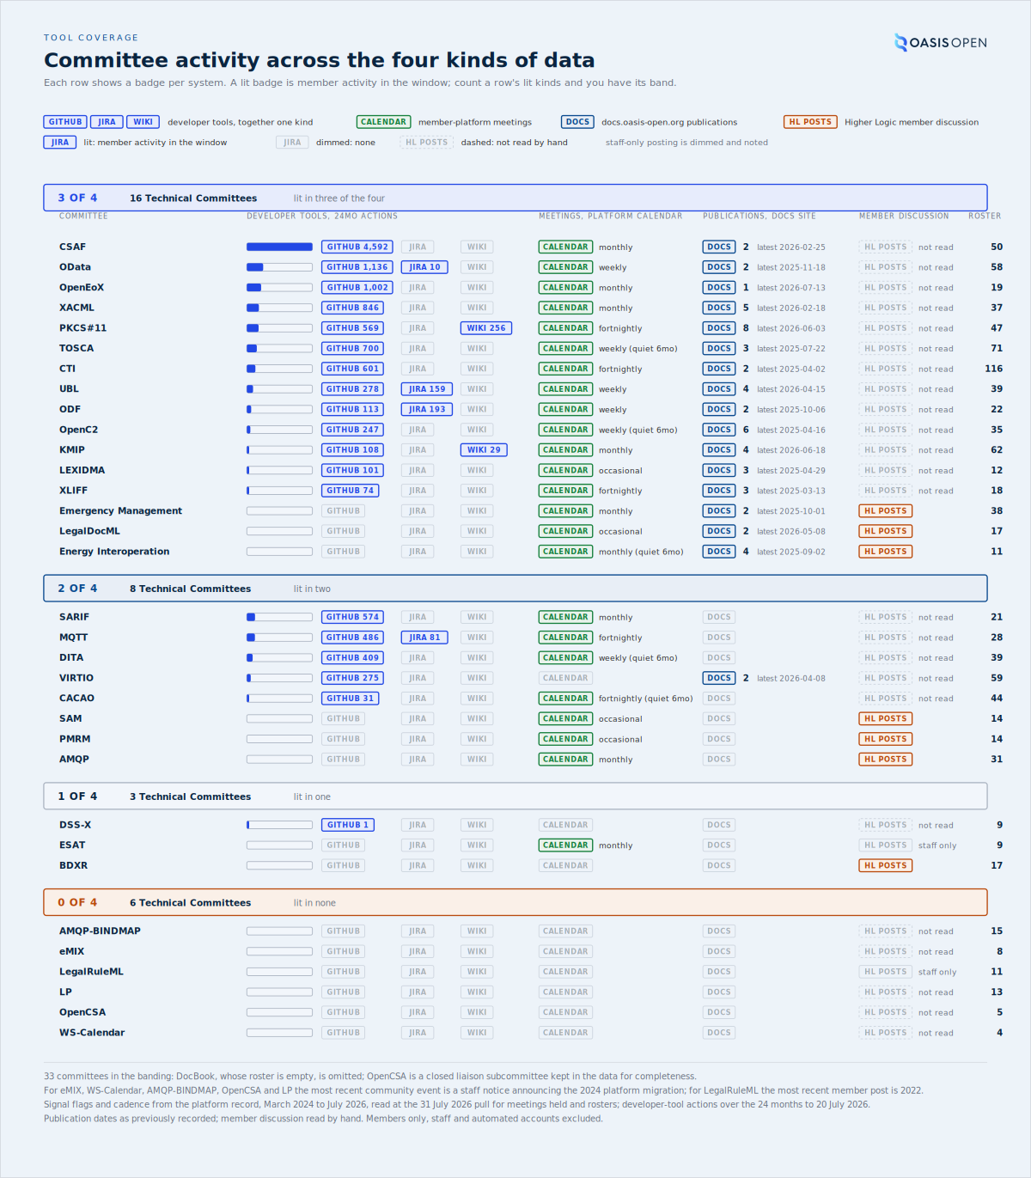
all 33 committees of the four-signal banding, one row per committee with a lit or dimmed badge per system, GITHUB, JIRA and WIKI for the developer tools, CALENDAR for platform meetings, DOCS for docs.oasis-open.org publications and HL POSTS for member discussion, so a row's band is the count of its lit kinds, with action counts and a magnitude bar, meeting cadence, publications with the latest date, the discussion reading and the roster beside the badges, grouped by band from 4-of-4 down to 0-of-4
- Owner: a measurement the TC Administrator keeps for orientation
- Record: the activity measurement in the engagement pack

2.2 Four operating cultures, and why the culture changes the operation
The measured committees fall into four operating cultures, and the culture tells the TC Administrator where the work lives, which tools the TC touches, and how correspondence reaches its members:
- Tool-native (16): CSAF, OData, OpenEoX, XACML, PKCS#11, TOSCA, CTI, SARIF, MQTT, UBL, DITA, ODF, VIRTIO, OpenC2, KMIP and LEXIDMA. The work leaves a repository trail, from CSAF's 4,592 tool actions in the window down to LEXIDMA's 101.
- Light-tool (3): XLIFF, CACAO and DSS-X, with 74, 31 and a single tool action respectively.
- Meeting-driven (8): Emergency Management, AMQP, LegalDocML, BDXR, PMRM, SAM, Energy Interoperation and ESAT. All eight record zero tool actions, several author their specifications in Word rather than in a repository, and every one of them reaches OASIS through the member platform alone.
- Dormant (7): AMQP-BINDMAP, LP, LegalRuleML, eMIX, OpenCSA, WS-Calendar and DocBook, none with a meeting, a publication or a developer-tool action in the window; only DocBook and LP carry any member discussion, 28 threads and 2.
Within the tool-native sixteen a further split matters day to day: VIRTIO governs asynchronously, with real repository activity and no calendar meetings at all (it ran 43 per-issue ballots in the window). DITA, TOSCA, UBL and OpenC2 hold regular calendar meetings (88, 85, 105 and 83 in the window) but book none ahead, so a forward read of the calendar shows them empty. CSAF, OData, PKCS#11, KMIP, XACML, OpenEoX, CTI and ODF keep a live meeting record and a live repository together.
"No meetings booked" is a statement about the calendar only. Some asynchronous TCs record their calls as posted minutes instead. BDXR is one example, and UBL's weekly Atlantic-call minutes sit on its discussion feed rather than on the calendar.
A roster counts who may vote, not who turns up, and it can overstate the working core by an order of magnitude: TOSCA lists 71 members and 5 attended in the window; OData lists 58 and 15 attended, 7 of them at almost every meeting.
169  distinct people attended a TC meeting in the window | 377  sets of minutes filed in the window | 3 to 13  the recurring core of a committee doing sustained governance | 14  people attend more than one committee
Read the roster for eligibility and the minutes for the working size. The roster answers who may vote, which is how the balloting chapter uses it; the attendance record answers how many hands the committee actually has.
The culture matters to the operation in three concrete ways:
1. The submission differs. A meeting-driven, Word-native TC delivers a rendered package and its approving minutes, while an asynchronous TC's work and its vote record may sit in a repository or in per-issue ballots.
2. The tools differ. A request about a meeting-driven TC will not be answered by looking at GitHub.
3. The comms path differs. A TC reachable through its Higher Logic community is reached differently from one whose editors coordinate by call.
Culture check
A tooling or communications decision that assumes one culture will not fit the others, because all four operating cultures exist in the measured set today.
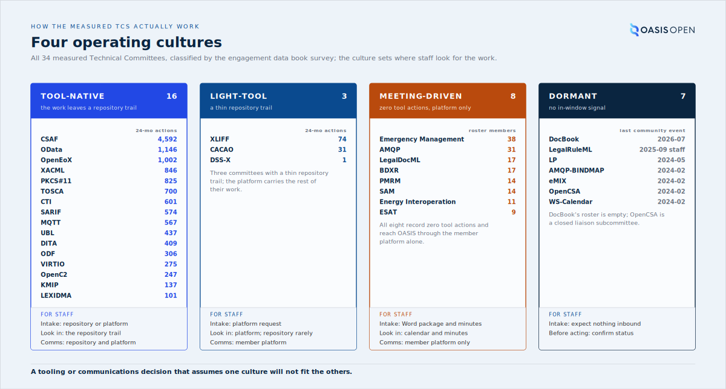
the four operating cultures as columns, each naming all of its Technical Committees with the datum that matters for that culture: 24-month action counts for the tool columns, roster members for the meeting-driven eight, the last community event for the dormant seven, with a row underneath showing the intake form, the tool to check, and the comms path each culture implies for staff
- Owner: TC Administrator, who reads the culture before acting on a TC's request
- Record: the operating-culture classification in the engagement data book, cross-referenced to the activity measurement

2.3 LegalDocML: an active TC that manages its work elsewhere
LegalDocML shows why intake must confirm where a TC actually works. On repository activity alone, LegalDocML appears inactive: its GitHub repository (oasis-open/legaldocml-akomantoso) was last pushed on 2 June 2022, and its Jira project exists but has never held a single issue. The committee is active. It published Akoma Ntoso v2.0 as a Committee Specification (cs01) on 8 May 2026 and passed a Special Majority Vote that closed on 15 July 2026, in which all six eligible Voting Members voted Yes and none voted No. Its work runs through its Higher Logic community and the TC Administrator process; the developer tools set up for it were never adopted.
Intake channel check
Do not assume a TC's channel. A publication or ballot request can arrive from a TC with no repository activity for years, and that inactivity is not a reason to question the request. Confirm the working channel per TC at intake, from the request and the approving minutes.
Do the same at every intake: confirm the working channel per TC from the request and the approving minutes, as the publishing and balloting chapters require, rather than inferring it from whichever kind of data is easiest to read.
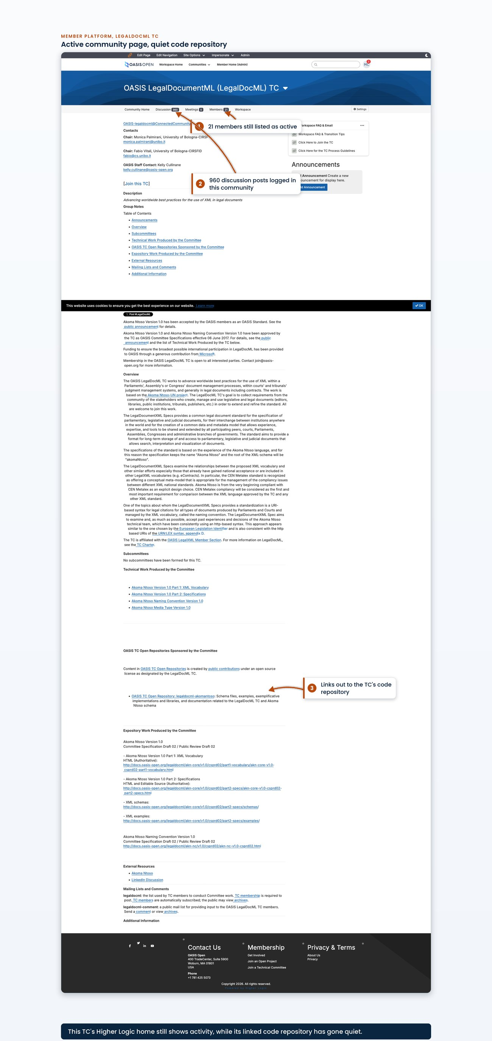
the LegalDocML Higher Logic community showing a recent discussion post date and the membership count, placed beside the GitHub repository page showing a last-push date of June 2022
- Owner: TC Administrator
- System: the member platform for the TC's live work; the request tracker for the request record
- Record: the published Committee Specification and the closed ballot, cited on the request ticket

2.4 What TCs actually ask for
Inbound requests belong to one process seen at different stages. Public reviews, ballots and publication requests are stages of one path from a draft to an approved standard, which is why the operation records far more publications than publication requests.
122  requests, 24 months | 85  carry a confirmed member name | 43  public review requests | 24  ballots and Special Majority Votes | 24  publication requests
Across the 24-month window there were 122 requests, of which 85 carry a confirmed member name. The mix was:
Request type | Count, 24 months
Public review requests | 43
Ballots and Special Majority Votes | 24
Publication requests | 24
Template and starter-document requests | 19
Other administration | 12
The 24 publication requests sit against 67 in-window publications because most publications happen as a stage of the review and ballot flow rather than as a separately requested event; see the publishing operation and balloting chapters for how one request carries a document through several published stages. The 19 template and starter-document requests are the intake end of the same path: drafts just beginning. The most frequent named requesters: Kenneth Bengtsson with 8 requests, all for UBL, Valerie Fenwick with 6 for PKCS#11, Judith Furlong with 6 for KMIP, David Lemire with 5 for OpenC2, David Filip with 4 for LEXIDMA, and Michael S. Tsirkin with 4 for VIRTIO. Fenwick and Furlong work in the Word-native TCs, whose TC work is recorded in requests, documents and minutes, outside repository activity.
Requests reach the queue two ways:
1. A member emails or posts and staff open the ticket on their behalf. The requester's identity is carried into the ticket.
2. A public web request form writes a ticket directly. The form is a Gravity Forms request page that writes into the request tracker as a service account and creates a TCADMIN ticket, as chapter 8 records. It submits as the service account rather than as the person, so the ticket does not carry the requester's identity.
Every request still gets a ticket, opened on behalf of the requester where the form did not, as chapter 9 records.
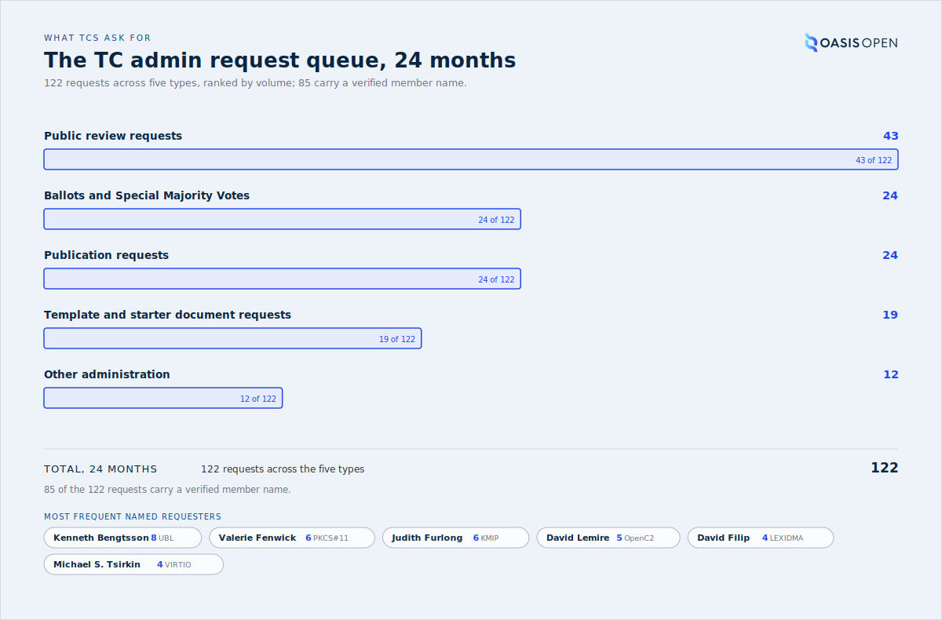
the 122 requests over the 24-month window split by the five types in the table, with the most frequent named requesters and the committee each requests for
The request tracker queue shows the same spread, with review, ballot and publication requests running as one flow rather than separate queues.
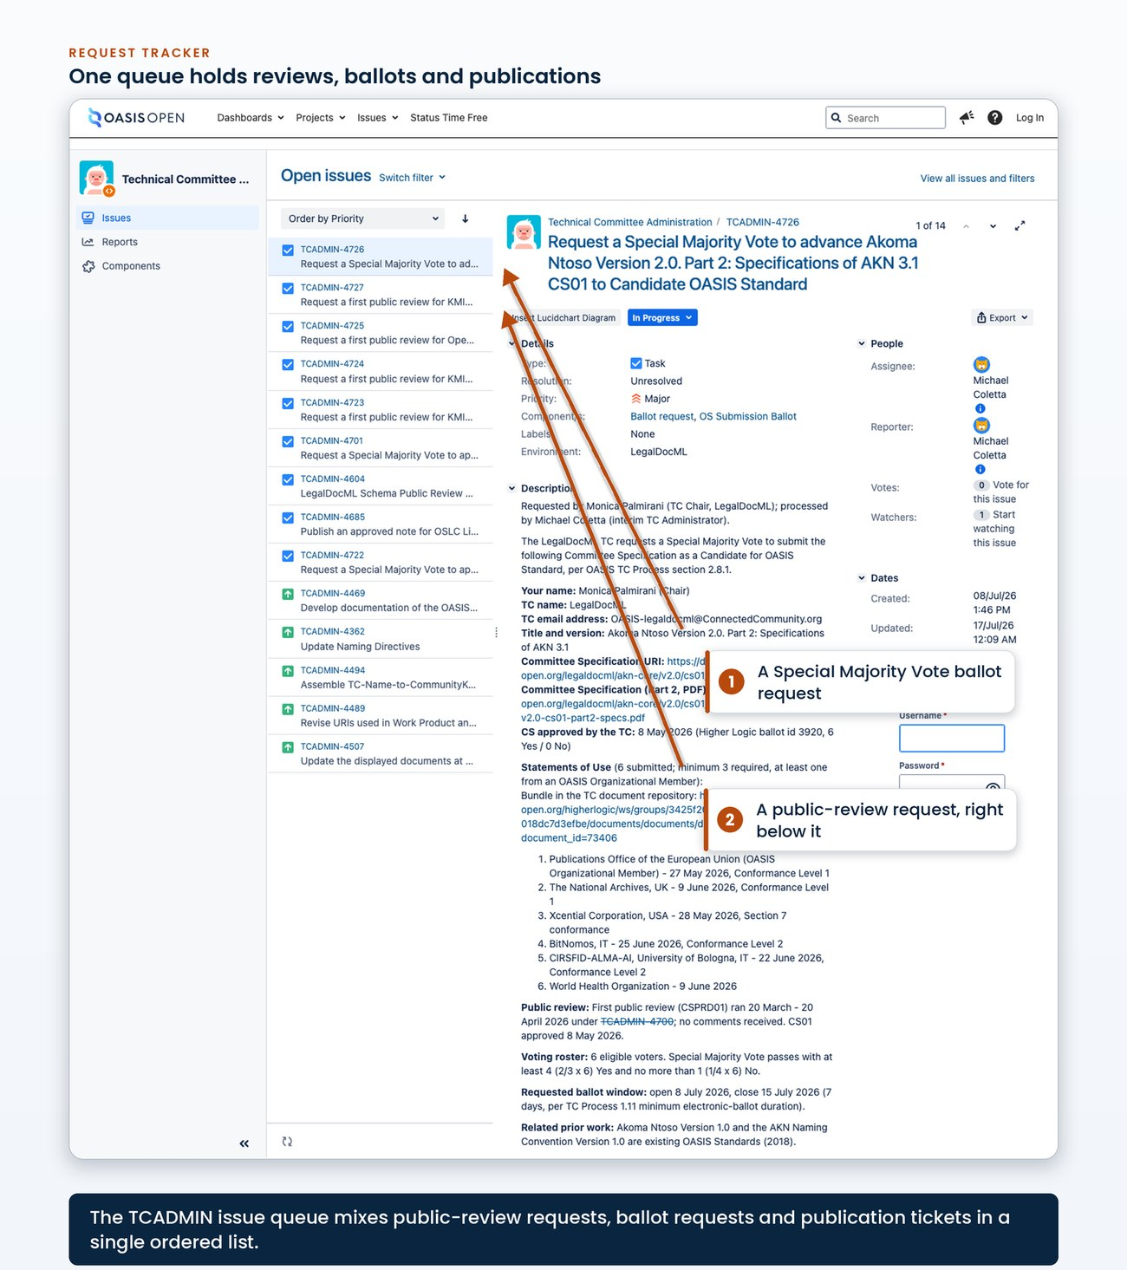
the request tracker queue filtered to the 24-month window, showing enough rows that the spread of review, ballot and publication requests is visible as one flow
- Owner: TC Administrator, who opens or completes the ticket
- System: the request tracker; the public request form for self-service submissions
- Permission: the requester needs no tracker access; the form submits as a service account
- Record: one ticket per request, per chapter 9

2.5 How TCs decide, and who signs the work
A TC's formal decisions are recorded in its ballots, and the ballot record shows how decisions are made. Of 93 recent closed ballots attributed to these TCs:
- 42 per-issue resolution votes, all of them VIRTIO, which governs by ballot and ran 43 ballots in the platform window;
- 34 spec-stage approvals of drafts, Committee Specifications, notes and charters;
- 15 candidates for OASIS Standard and calls for consent;
- 2 officer elections and other.
The standards ladder is visible in the ballot titles themselves: TOSCA v2.0 took six ballots from draft approval to the OASIS Standard call for consent, and ODF v1.4 took four, including a vote to continue after comments. The LegalDocML Special Majority Vote in 2.3 is one such ballot, and with exactly six Voting Members on the roster and six of six voting Yes, that voter list is the voting roster.
Published specifications identify the editors responsible for the text. Editors hold named, signed responsibility, and the editor set is often small even when the contributor list is large:
- Energy Interoperation listed Toby Considine as the single editor for all four of its in-window stage publications.
- UBL listed Kenneth Bengtsson as the single editor for all four stage publications of UBL v2.5.
- KMIP and much of PKCS#11 rest on three names from Cryptsoft, Tim Hudson, Greg Scott and Tony Cox, though Cox's affiliation is now printed as TC Logic, formerly Cryptsoft.
- Stefan Hagen signs seven of the window's publications across five committees, James Cabral six across three, David Kemp five across four, Greg Scott four across three, and Dieter Bong five, all of them PKCS#11.
Contributor appendices run to hundreds of names, CTI credits 310 and VIRTIO 204, while formal signed responsibility is assigned to one or two people per Work Product. The named editors are the continuity record that matters, and the published specifications are the only place that record can be read.
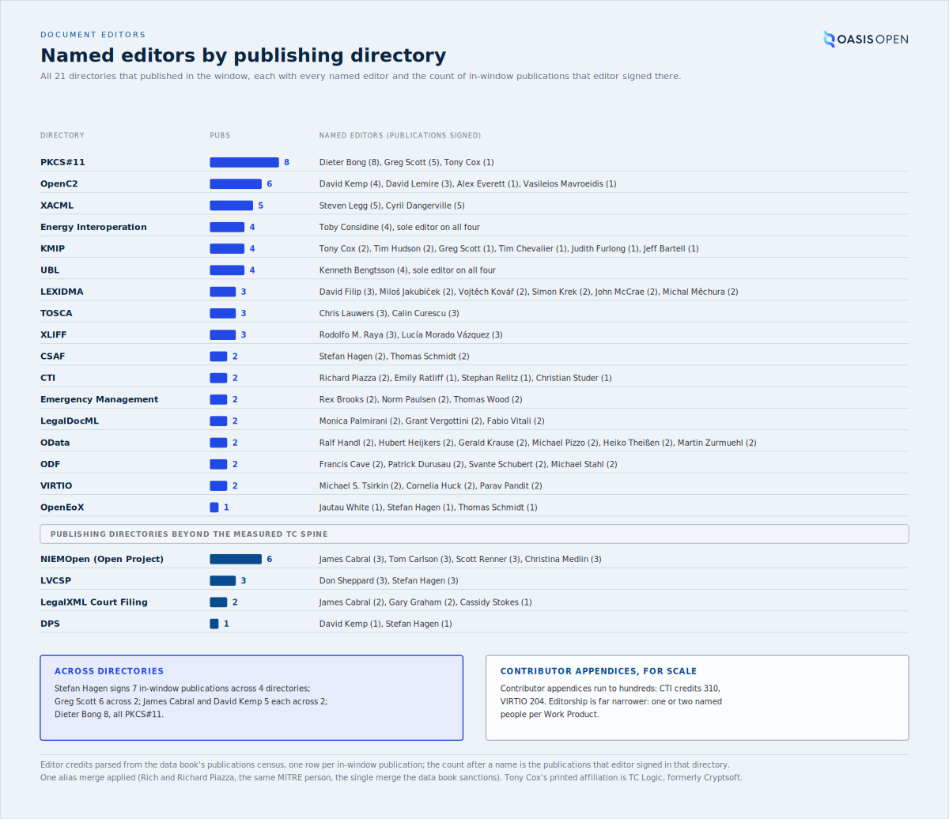
every one of the 21 publishing directories with its complete set of named editors and the count of publications each editor signed there, sole-editor Work Products noted, with the cross-directory editor spans and the contributor-scale contrast
- Owner: the TC votes and its editors sign; the TC Administrator runs the ballot mechanics and records the result
- System: the member platform for the ballot; docs.oasis-open.org for the signed publication
- Record: the closed ballot tally and the published specification front matter

2.6 The tools, and the mailing-list change that reshaped the comms path
Five tools serve the TCs, and each is different:
- The member platform (Higher Logic) is the member-facing service and record location for rosters, ballots, meeting calendars, document libraries and discussion. It covers 32 of the 50 active TCs by the site taxonomy, and 28 of 34 open communities had a post within the trailing 12 months. Eight TCs reach OASIS through no other tool at all: BDXR, Energy Interoperation, PMRM, AMQP, LegalDocML, ESAT, Emergency Management and SAM, the meeting-driven eight of 2.2.
- GitHub is three things at once: specification text under version control, the source code and schemas that ship alongside it, and the issue queues where implementers and the public file commentary on published specifications. It spans two organisations, oasis-tcs for specification work and oasis-open for Open Repositories.
- Jira is an active day-to-day tracker for two TCs, UBL and ODF, and four TCs depend on it enough that any replacement must migrate them first: ODF with 193 issues in the window, the one committee where Jira is the primary tool, then UBL with 159, MQTT with 81 and OData with 10. The licence is free and unlimited and the other roughly 80 projects are historical record, so the question about Jira is service quality; cost is zero.
- The wikis are nearly still: 285 edits by five members across the 24 months, all in two TC namespaces, PKCS#11 with 256 and KMIP with 29, out of 84 namespaces on the farm. The most recent edit anywhere is 22 May 2025, and the trailing 12 months hold none.
- docs.oasis-open.org is the publication service, the destination for approved work rather than a tool members work in; 67 publications came from 21 directories out of 119 in the window, and 98 directories published nothing.
The member platform holds the governance record for 46 TC communities: the meetings held, the documents and minutes filed, the ballots run and the member discussion. The rest of a committee's work sits elsewhere: the specification text of every GitHub-native and mixed committee lives in the oasis-tcs repositories, and the meetings themselves run on tools the chairs bring, as 7.6 records. A committee's work is spread across three kinds of place, the member platform for governance and the archive, GitHub for the drafting, and the chairs' own tools for the calls, and no one system shows all of it.
1,213  calendar meetings held | 753  documents filed, 377 of them meeting minutes | 83  ballots run | 3,545  member discussion threads
The February 2024 platform migration changed how TC communications are routed.
427,256  list messages, October 1999 to the freeze | 963  lists | 12,680  distinct contributors | 2024  the February migration that retired them | 28  of 34 open communities posting in the last 12 months
For two decades the classic mailing lists carried member discussion: 427,256 messages from October 1999 to the freeze, across 963 lists and 12,680 distinct contributors. In February 2024 the Higher Logic migration retired the classic list server, and all TC lists stopped carrying new traffic. The mail-forum model was a low-friction participation channel. DocBook, the largest list community at 40,133 messages, left OASIS in the migration year, and its practitioners rebuilt their site independently. The record itself was preserved: the full archive is read-only and searchable at lists-archive.oasis-open.org. The conversation also largely survived the change. On matched two-year windows either side of the migration, member discussion on the platform runs at 90 percent of the final two list years, and at 144 percent excluding VIRTIO, which moved its discussion off OASIS infrastructure entirely. For about a dozen TCs, KMIP and CACAO among them, the platform now carries live discussion the classic lists had already lost years earlier.
Current comment routing
Because the classic list server is retired, legacy TC list addresses no longer carry messages and do not return a bounce to the sender. Comment traffic now routes through the TC's public comment facility on the member platform, and announcements are posted to the member platform communities. Use the member platform routing for current TC comments and announcements.
The public-review comment routing described in the public reviews and communications chapters depends on this change and is stated there in full.
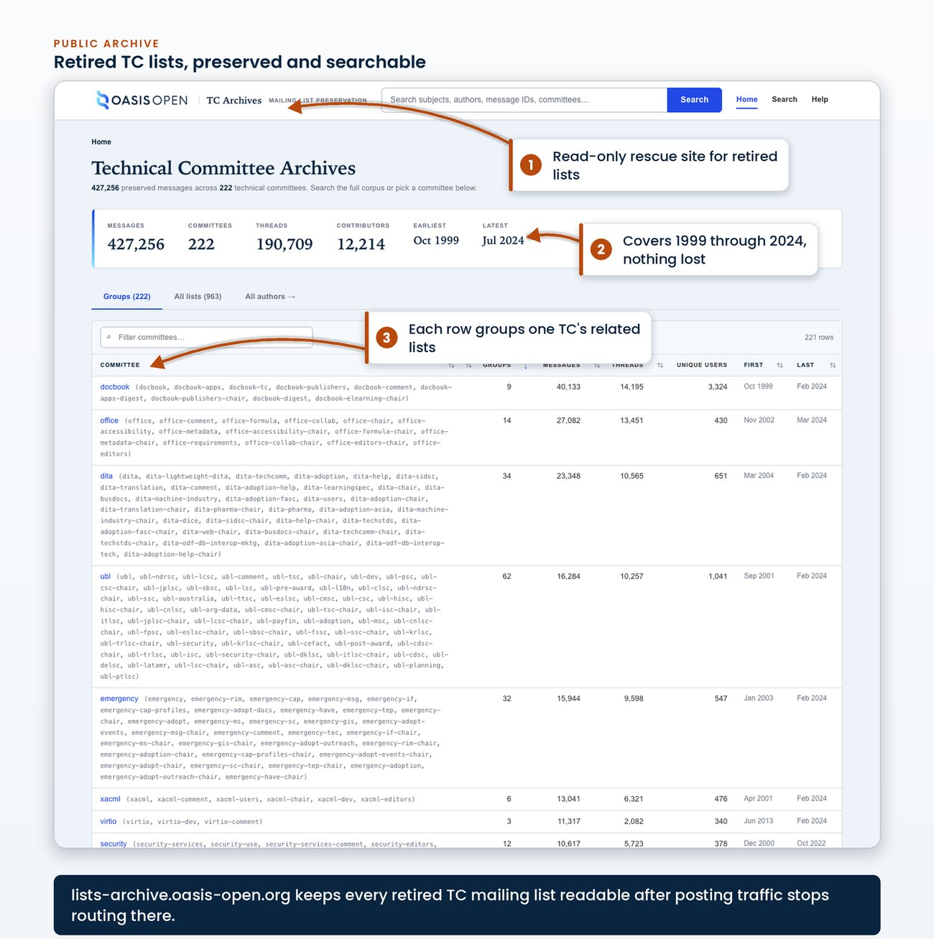
the lists-archive.oasis-open.org landing page showing the read-only searchable archive of the retired lists
Set out together, the five tools show which Technical Committees actually use each one.
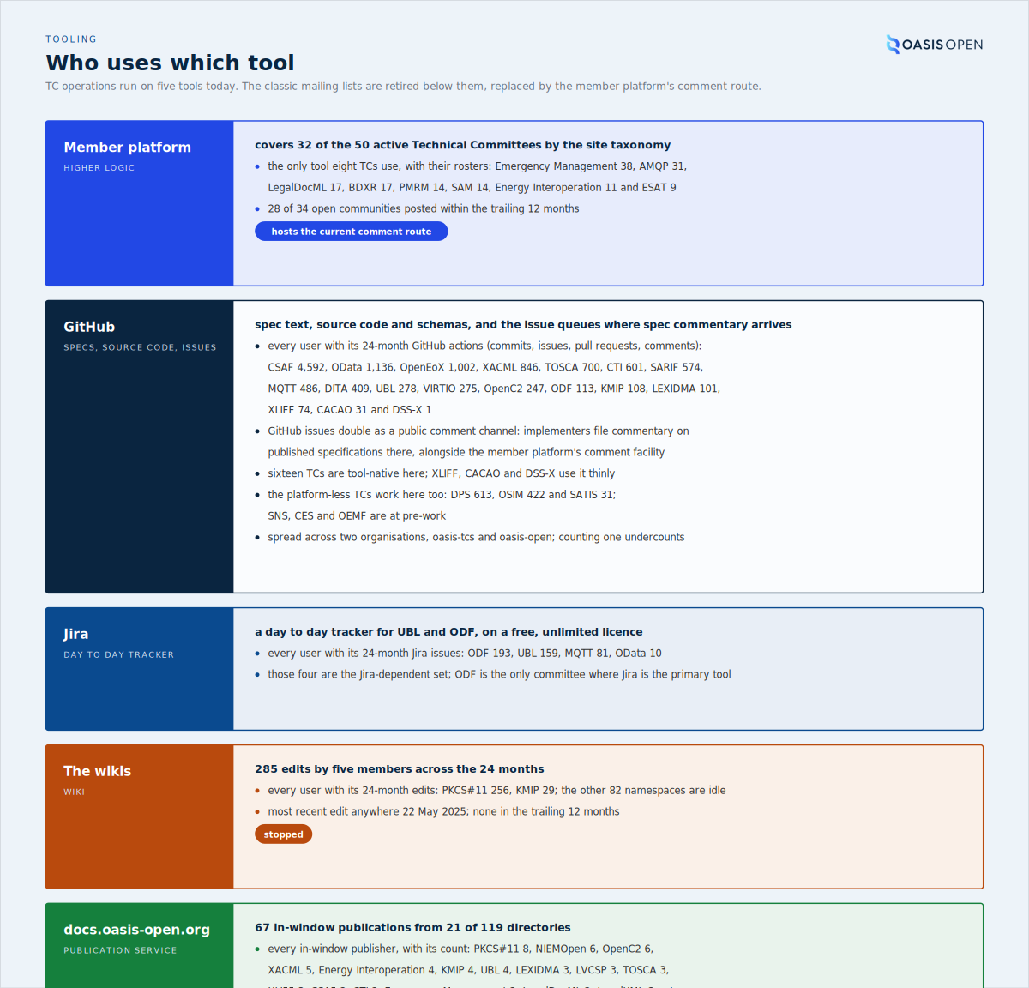
the five tools as rows, each naming every Technical Committee that actually uses it: the sixteen tool-native and three light-tool TCs on GitHub, the four Jira-dependent TCs, the two wiki TCs, the eight platform-only TCs, and every in-window publishing directory with its count, with the retired classic mailing lists drawn struck through and the member platform comment facility drawn as the current comment route
- Owner: TC Administrator for the comms path; the Director of IT for the platforms
- System: the member platform, the two GitHub organisations, Jira, the wikis, docs.oasis-open.org, and the read-only mailing-list archive
- Record: the engagement measurement in the pack, and the live archive at its published address

3. What OASIS owes a TC
A Technical Committee that asks what it gets from OASIS receives two different kinds of answer, and OASIS has never separated them in writing. Part of what OASIS does for a TC is required by written policy, and the governing clause can be named. The rest is practice: earned from real publications and held to consistently, backed by nothing except the decision to keep doing it. This chapter separates the two, then states the limits, because a limit OASIS has written down is as much a part of the contract as a promise.
The split shows in the acceptance criteria themselves. When the conditions OASIS confirms before it publishes were matched to their governing clauses in July 2026, the exercise covered the 96 conditions in the registry at that time: 38 were grounded in written policy and 58 were operational quality rules with no single written clause behind them.
96  conditions mapped, July 2026 | 38  grounded in written policy | 58  earned quality rules | 165  executable checks enforcing them | 55  check classes
Of those 96 mapped conditions, close to three in five are conditions OASIS confirms because it chose to. That ratio describes the 96 mapped conditions and has not been recomputed for the checks added since.
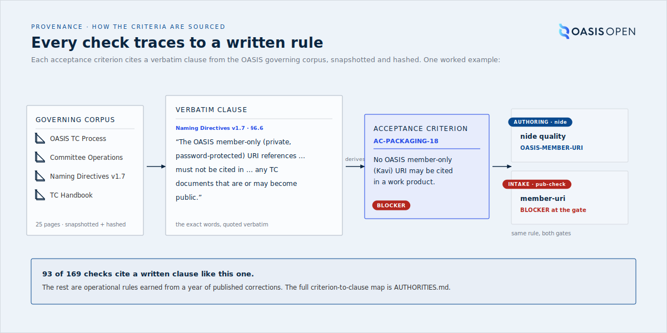
the acceptance conditions divided into the policy-grounded set and the earned set, with the governing documents named on the policy side and the failure classes named on the earned side

3.1 The obligations written into policy
An obligation is something OASIS is bound to do, where the governing clause can be quoted. These are not commitments OASIS chose. They are terms of the OASIS process, and they bind the TC and OASIS alike.
Four obligations govern what is published:
- All approved versions of OASIS Deliverables must be published in (1) editable source, (2) HTML or XHTML, and (3) PDF formats (TC Process 2.2.2).
- All documents and other files produced by the TC, including Work Products at any level of approval, must use the OASIS file naming scheme and must include the OASIS copyright notice (TC Process 2.2.1).
- Work Products must present three general kinds of URI as display metadata: This stage, Previous stage where applicable, and Latest stage. The latest-stage alias is the only one of the three that may be updated when a newer version is published (Naming Directives v1.7, 6.2).
- All normative computer language definitions must also be provided in separate plain text files (TC Process 2.2.5). Embedding a schema only in the document body does not satisfy the clause. Non-Standards Track Work Products are not subject to it.
One obligation governs what happens after publication, and the publishing workflow is built to satisfy it. URIs for published OASIS resources must be persistent, and resources published in the OASIS Library, the TC document repository and other venues must not be deleted or otherwise altered; resources may be revised, but all revisions are retained (Naming Directives v1.7, 6.3 and 6.4).
A published stage URL is permanent
It cannot be reused, corrected or withdrawn. That is why the publishing operation ends with staff confirming the live result rather than at deploy, and why an error found an hour after publication costs a new stage instead of a re-upload.
Two obligations constrain how names are formed:
- A stage abbreviation with its revision number must be used in lower case as a discrete path component for the document identifier, the document URI and the principal document filenames (Naming Directives v1.7, 5.2).
- A directory must not contain two or more names, filenames or directory names, that differ ONLY in case (Naming Directives v1.7, 4).
Both are blocking conditions in the acceptance criteria.
On the Standards Track, a Work Product must include a conformance clause section before it can be submitted for public review, approved as a Committee Specification, or approved as an OASIS Standard (TC Process 2.2.6). The guidelines on writing conformance clauses are recommended rather than required; the binding obligation is the Process clause, and only the Process clause is quoted when a TC is corrected.
One obligation governs visibility rather than files: all web pages, documents, ballot results and email archives of all committees and subcommittees shall be publicly visible (Committee Operations Process 1.5). Everything this handbook says about announcements, published ballot results and public review records follows from that single clause.
Alongside policy, OASIS has written down five guarantees about the publication pipeline itself, in the documentation TCs are pointed at. For every publication run:
- the source is preserved verbatim at the canonical URL alongside the renderings;
- the HTML and PDF are byte-deterministic from the same source on the same toolchain version;
- the pipeline catches known regression classes before publication rather than after;
- published artifacts are immutable at their stage-specific URL, and corrections require a new stage;
- and cache layers are refreshed on every publication so the public URL serves the new version within minutes.
Those five are stated to TCs, so OASIS is answerable for them. Two restate a policy obligation in operational terms: the immutability guarantee is the permanence clause, and source preservation is part of the three-format obligation. The other three are the pipeline's own commitments, and they change if the pipeline does.
- Owner: TC Administration.
- System: the publication pipeline and the acceptance gate.
- Record: the published package at its canonical stage URL, and the publication audit record.
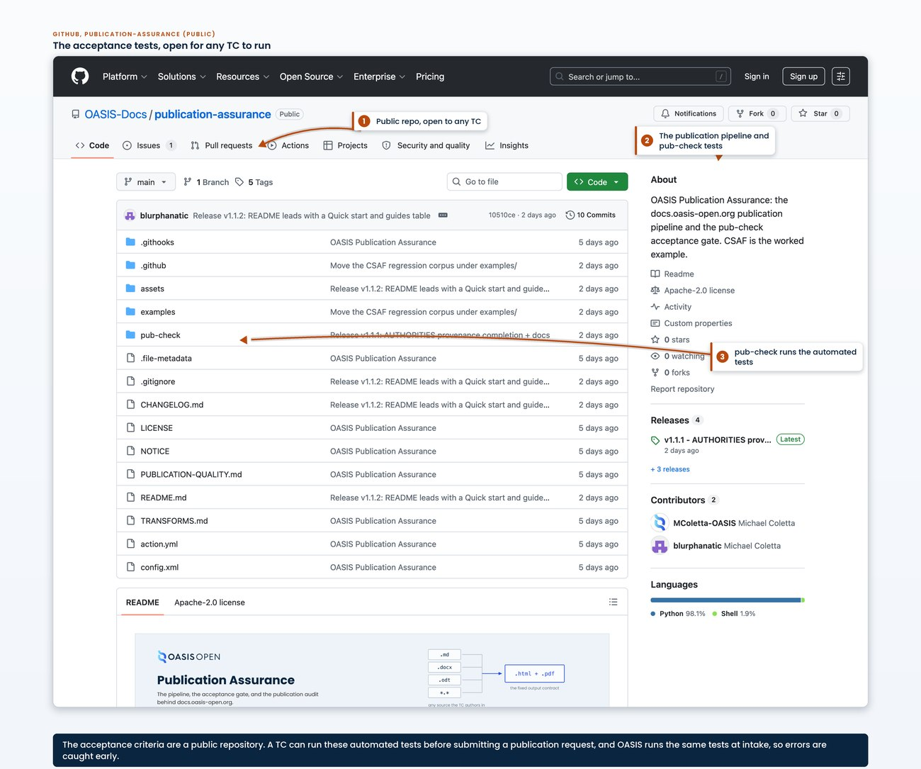
one entry from the authority catalog showing a check, its acceptance criterion id, the governing document and section, and the clause quoted verbatim with its severity

3.2 The practice OASIS holds itself to
The 58 earned conditions in that mapping have no clause behind them. Each one exists because a real publication went wrong in exactly that way:
- a TODO: add the link. that shipped and stayed live for years;
- a lowercase citation that returned not-found on the case-sensitive host;
- a PDF rendered from an older draft than the HTML beside it;
- a self-referential symlink that a deploy materialized into 41 nested directories.
The acceptance criteria are the accumulated record of those correction rounds plus the publication pipeline's own lint registry, calibrated against a 13-package regression corpus of real submissions in their original received form.
The practice is not owed
No policy requires any of it. A TC has no standing to demand it and no clause to cite if it stopped. It is practice, and across the conditions that have been mapped it is more than half of what OASIS inspects.
The practice is organised in two layers:
- The first is validation. The acceptance criteria run as code against the package alone, and the TC runs them itself before it votes.
- The second is the publication audit. OASIS examines the publication event against evidence no package-level tool can see.
Both sides run identical code. Acceptance is mechanical at both ends, and the TC's clean run predicts the OASIS run without substituting for it. Each layer produces a standard report, filed to the TC's request ticket and to the TC's audit record.
OASIS built the first layer to be run by the committee rather than kept in-house, and publishes the tool for TCs to use, though no clause requires either. The point is to catch a failing condition before a vote instead of after a publication. TC Administration then re-runs the same acceptance criteria identically at intake rather than accepting the TC's result.
The acceptance criteria stood at 165 checks across 55 classes on 22 July 2026 and grow as new failure modes appear, so take the current figure from --list-checks and treat any undated count as stale.
Two further things OASIS does as practice, with no clause behind either:
- It operates the rendering toolchain, the render filters, the PDF configuration and the deployment pipeline, so the TC never has to maintain any of them.
- It accepts whatever authoring format the TC works in, holding the bar at the output rather than the input.
Both layers of the practice run to the same ownership:
- Owner: the TC runs the validation layer; TC Administration re-runs it and runs the publication audit.
- System: the acceptance gate and the publication audit record.
- Timing: the TC's run before the vote; the OASIS re-run at intake.
- Record: the validation report and the publication audit report, filed to the request ticket and to the TC's audit record.
[Evidence captured in draft 0.7: a real Validation Report from a published specification, itemizing every condition with the value pulled from the package and the value it was compared against]

3.3 What OASIS does not promise
Current practice states the limits alongside the guarantees, and the limits bind what a TC may expect just as firmly. [VERIFY]
- The pipeline does not promise editorial review of specification content; that is the TC's responsibility.
- It does not promise visual perfection of every edge case in author-supplied Markdown; the TC editor and OASIS publication staff do the QA pass before final stage publication.
- It does not promise forward compatibility of the source with future renderer changes; major-version renderer changes are managed by OASIS publication staff with deliberate migration.
The first of those is the one most often misread. If any condition fails, the run stops, the failure is reported back to the TC, and nothing partially published reaches the public URL. That is conformance to the acceptance criteria rather than a reading of the specification.
OASIS does not read the content
Nobody at OASIS reads the specification for correctness, coherence or fitness for purpose.
Immutability is a limit as well as a guarantee. Each stage publishes into its own stage directory under the version directory, and the stage-specific path is the citable, immutable reference for that stage; the version directory carries a latest-stage copy of the source, the HTML and the PDF that moves forward as new stages publish. OASIS cannot correct a TC's mistake at a published stage URL after the fact, and will not.
Acknowledge a publication request when it arrives so the TC knows it is in hand, and aim to fulfil it within one to five days. A publication is a major event for the requesting TC, and a prompt, well-communicated turnaround is one of the simplest ways the operation shows its value. A TC planning around a hard date should confirm it with the TC Administrator; chapter 9 records what has actually happened across the ticket history.
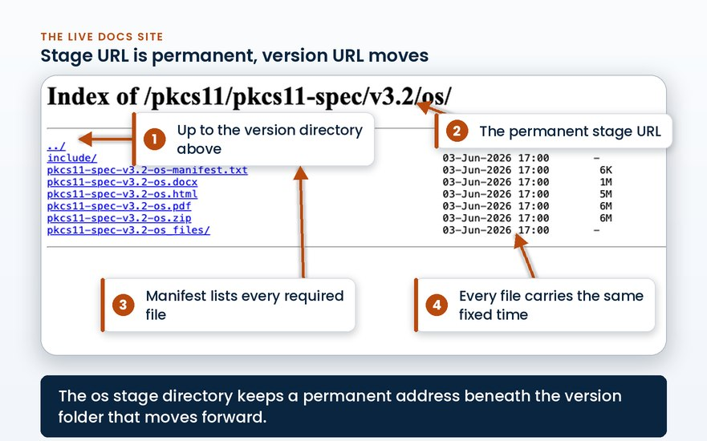
a published stage directory at its canonical stage URL alongside the version directory above it

3.4 Where staff involvement stops
The TC owns four kinds of decision, and OASIS touches none of them:
- what the specification says;
- the companion artifacts that travel with it;
- the per-specification publication preferences;
- and the TC-wide publication defaults.
OASIS operates the publication infrastructure. The TC does not need to maintain the rendering toolchain, the render filters, the PDF configuration or the deployment pipeline; those are operated by OASIS and refined behind the contract. A TC that never wants to think about how its PDF is produced does not have to.
The delivery boundary stops at the document portal or email. TC editors deliver the final package through the TC document portal or by email. Staff move the delivered package into the internal publishing repositories.
The delivery boundary
A TC is never instructed to upload to the internal publishing repositories, because those repositories are OASIS bookkeeping rather than part of the TC's workflow.
The package may arrive in whatever form the TC produces, either fully rendered final artifacts or authoritative source for the pipeline or staff to render. TCs author in Markdown, Word, DocBook or XML, LaTeX and ODT among others. Whatever the intake form, the published result must conform to the same rules, because the bar is the output rather than the input.
OASIS supplies the templates and the TC fills them in. The Board approved a master template and delegated format versions, derivative templates and maintenance to the Board Process Committee.
Template | Approval status
OASIS Standard, Committee Specification, Committee Specification Draft | Board-approved master, 24 April 2025
Committee Note | delegated derivative, released 3 June 2025
Technical Report | does not appear in the Approvals record [VERIFY]
On quality, responsibility divides inside a single package:
Responsibility | Owner
Conformance to the acceptance criteria | mechanical, and OASIS owns it
Content | the TC's, and OASIS does not review it
The visual QA pass before final stage publication | shared: the TC editor and OASIS publication staff both do it
- Owner: TC editors deliver; the TC Administrator moves the package into the internal repository.
- System: the TC document portal, or email.
- Permission: the requester needs no repository access.
- Record: the delivered package in the internal publishing repository.
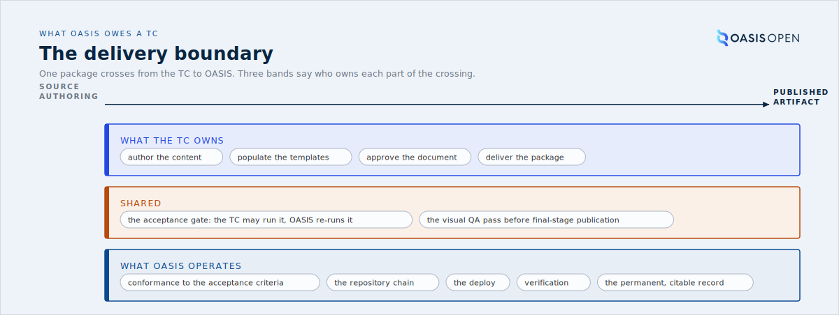
the delivery boundary from source authoring to published artifact, with three bands: what the TC owns, what is shared, and what OASIS operates
Everything to the left of that boundary follows a published rhythm of its own. The public TC Handbook describes it as the Work Product lifecycle: the drafting rounds, working-draft approvals and ballot cycles a TC runs internally before a package is ever handed across for publication. The next figure reproduces that lifecycle as a state machine, so the reader can place each handbook chapter against the state a Work Product is in when the operation touches it.
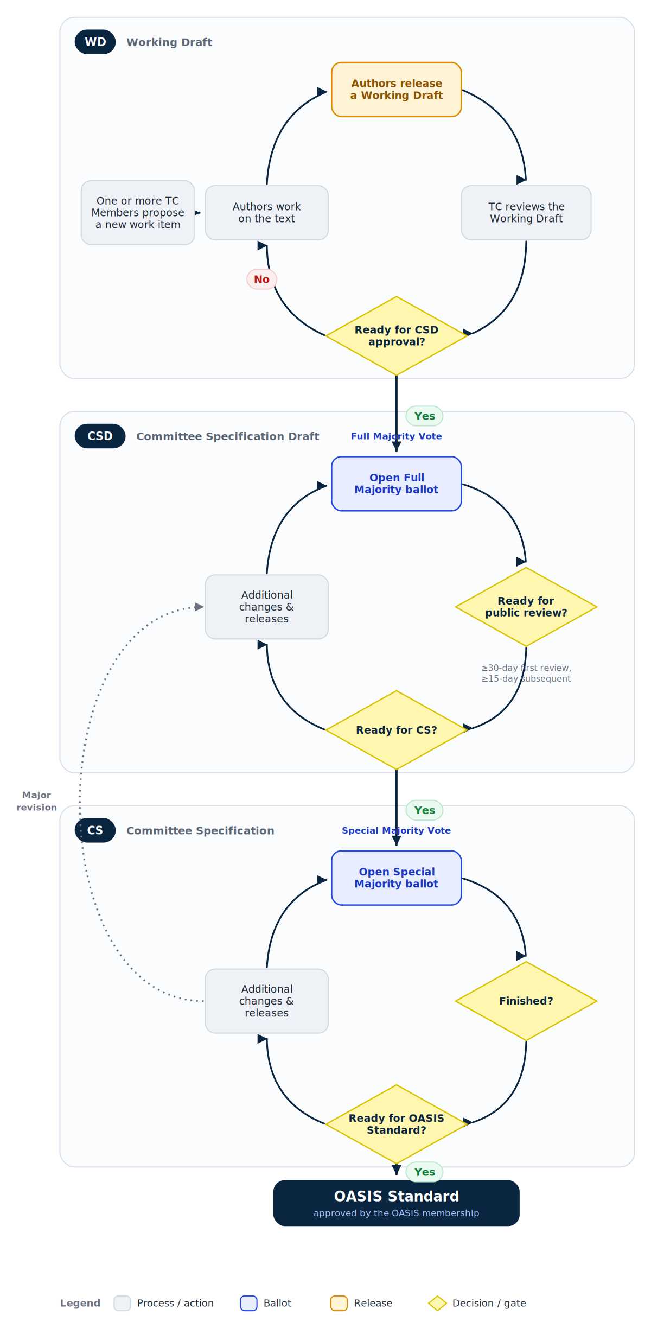
the Work Product lifecycle as a state machine, the drafting and ballot cycles a TC runs on its own side of the delivery boundary before anything crosses to the operation, as published in the public TC Handbook Work Product Lifecycle reference
Where the same boundary falls in ballots and public reviews is covered in the balloting and public-review chapters.

3.5 The IPR framework and why it lets a TC collaborate safely
The publication machinery in 3.1 to 3.4 is what OASIS does with a finished specification. The OASIS IPR Policy is what makes the work leading up to it possible. It is a large part of what OASIS provides a TC. It fixes, in advance, the licensing terms that will attach to the finished standard, so competing companies can sit on the same committee and build one standard without unexpected patent exposure after implementers have committed.
The framework is built on one defined term. An Essential Claim is a patent claim that a compliant implementation of the standard necessarily infringes. Obligations attach only to Essential Claims, and a member's wider patent portfolio stays outside them, which is what keeps the commitment limited and knowable.
The IPR Mode is chosen once, at charter, and fixed. Every TC operates under exactly one of four modes, named in its charter, and a TC cannot change mode without closing and re-chartering. The mode decides how Essential Claims must be made available:
IPR Mode | How Essential Claims are made available
RAND | licensed on fair, reasonable and non-discriminatory terms, with a reasonable royalty permitted
RF on RAND Terms | licensed royalty-free, with other fair, reasonable and non-discriminatory conditions allowed
RF on Limited Terms | licensed royalty-free, with only a limited, fixed set of permitted conditions, such as reciprocity and defensive suspension, and no others
Non-Assertion | no licence, but a covenant not to assert Essential Claims against implementers of covered products
Because the mode is set at formation and cannot drift, the TC Administrator reads it from the charter rather than renegotiating or guessing it, and it is the mode named in the IPR reference every public-review Invitation to Comment carries.
Two obligations bind members, and one attaches by membership alone.
- The Contribution Obligation is incurred by submitting material: the contributor must license, or covenant over, any of its patents that become Essential Claims when that contribution is folded into the standard.
- The Participation Obligation is incurred by membership, with no contribution required, once a party has been a member for at least 60 days, is still a member at least 7 days after a draft is approved for publication, and that draft goes on to become a final standard. It then covers every Essential Claim in that standard.
Both survive the work. A party that withdraws sheds future Participation Obligations but keeps every obligation already incurred, so a commitment made cannot be walked back by leaving.
Disclosure is a good-faith duty. A participating member must disclose patents it actually knows may contain Essential Claims. It is not required to conduct a patent search, and OASIS does not compile or guarantee a complete patent landscape. The one operational task is in the review: a call for disclosure goes out with the public-review copies of a Standards-Track deliverable, which is one more reason the public review in chapter 6 is required and not a formality.
The Feedback License is why non-member comments route where they do. A non-member who comments does so under the OASIS Feedback License, which binds any Essential Claims in that feedback to the same mode the TC operates under. That is the reason the comment routing in chapters 6 and 7 is not optional: a comment submitted through the TC's public comment facility arrives under the Feedback License, while one sent by some other channel does not carry that commitment and cannot be accepted.
What the IPR framework provides
Competing companies can collaborate on one standard because the licensing terms are fixed in advance by the chartered mode, disclosure is required before final approval, and every contribution and comment carries a binding commitment that survives withdrawal.
The distinction this chapter draws still holds: the IPR framework is binding, clause-backed policy rather than earned practice. OASIS's part in it is small and specific: it confirms the chartered mode, makes sure the disclosure call goes out with each public review, and routes comments through the facility that carries the Feedback License. The framework itself is administered by OASIS legal and governance, outside the publication operation.
- Owner: OASIS governance and legal own the IPR Policy; the TC Administrator runs the operational hooks (the disclosure call with a review, the comment routing).
- System: the TC charter for the mode; the public review and comment facility for the disclosure call and the Feedback License.
- Record: the chartered IPR mode; the disclosure call published with the review; the comments received under the Feedback License.

4. The publishing operation
Publishing puts a Technical Committee's approved Work Product on the OASIS documents site as a permanent, citable record at https://docs.oasis-open.org. Staff perform every task in this chapter. The TC's part is to approve the document and deliver the package; the TC is never asked to touch the internal repositories or run a deploy.
The operation is two human tasks and one screen. You confirm the request and stage the delivered files in the TC's publication repository. The publication console then runs the whole pipeline for you: rendering, packaging, the acceptance check, and the production deploy. Every console action runs as a recorded workflow carrying your name, and dry run is on until you deliberately switch it off.
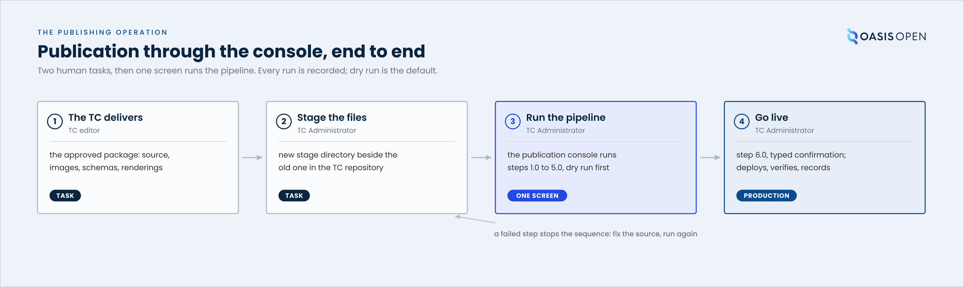
publication through the console, end to end: the TC delivers, staff stage the files, the console runs the pipeline, 6.0 goes live

4.1 What publishing is and the standing rules
A published document has its own address and does not move from it. Published artifacts are immutable at their stage-specific URL; a substantive correction requires a new stage, and nothing is edited in place. Each stage publishes into its own stage directory under the version directory, and the version directory carries a latest-stage copy of the source, the HTML and the PDF that moves forward as new stages publish. The document itself presents This stage, Previous stage and Latest stage URIs as display metadata (Naming Directives section 6.2, policy:template_cover_uris).
Three formats are mandatory. TC Process section 2.2.2 requires every approved OASIS Deliverable published as:
- editable source (Markdown, DOCX, XML or ODT; each TC is slightly different)
- HTML or XHTML
- PDF
Naming has three rules:
- Current stage suffixes only. wd, csd, cnd, cs, cn, os and errata. The os stage never carries a revision number. csprd, cnprd and cos were retired by Naming Directives v1.7 effective 2 January 2024 and survive only in older published trees. A document in public review keeps its stage name.
- Lower case. The stage abbreviation with its revision number is lower case as a path component, in the document URI and in the principal filenames (Naming Directives section 5.2). The publication origin is case-sensitive with no fallback, so a case mismatch returns not-found.
- No case twins. A directory must not contain two names differing only in case (Naming Directives section 4).
A defect becomes part of the record
A broken link, a wrong citation date or a wrong-case filename in a published version is permanent at that URL and cited by other documents. That is why the pipeline gates before deploy and why the operation ends in verification, and not at the moment the files reach the server.
- Owner: TC Administrator
- System: the documents site and the delivery network in front of it
- Record: the published files at their permanent stage URL, plus the latest-stage copies in the version directory

4.2 Intake: confirm five things before you touch anything
A publication starts with the TC's request to TC Administration, usually as a ticket in the request tracker at https://issues.oasis-open.org (project TCADMIN). TC editors deliver through the TC document portal or by email; the requester needs no repository access at any point.
Before staging anything, confirm five specifics with the request:
1. the authoritative source file
2. the document date the TC wants stamped on the publication (often not the publication date; the TC's call wins)
3. the stage, in current naming (csd02, cs01, os)
4. the spec short name used in filenames
5. every companion artifact the document cites (schemas, XSDs, images)
A cited companion artifact that does not publish at the cited URL makes the citation block return not-found. Confirm the list at intake.
Who renders follows from the source format:
Source format | Who renders
Markdown | the console pipeline (steps 1.0 and 2.0)
Word | TC Administration, in Microsoft Word, matching the TC's published precedent
DocBook, XML, LaTeX and other formats | the TC's own toolchain; the renderings travel with the source
- Owner: TC editors deliver; the TC Administrator confirms the specifics
- System: the TC document portal or email for delivery; the request tracker for the record
- Timing: confirmation happens before anything is staged; no fixed turnaround is committed anywhere, and working practice for the whole request is acknowledgement on receipt and fulfilment within one to five days
- Record: the request ticket, carrying the confirmed specifics and the approval link

4.3 Stage the files in the TC's repository
This is the one manual repository task, and the console's only precondition: the spec directory must exist in the TC's OASIS-Docs publication repository before the console can see it.
Every TC has a publication repository at github.com/OASIS-Docs/<tc-name>, laid out exactly as the live site: the repository root is the TC directory, then the version directory, then one directory per stage. To stage a new publication:
1. Open the version directory in the TC's repository on GitHub, for example csaf/v2.1.
2. Create the new stage directory beside the previous one: where csd01 exists, the new submission goes in csd02. Use Add file, then Upload files, and drag the whole stage folder in so the directory and its contents arrive together. Use lower case and current stage names.
3. Upload exactly what the TC delivered: the source, images under their own subdirectory, and any cited schemas or companion artifacts. Do not rename, reformat or edit anything at this point.
4. Commit to the default branch. The commit message can be plain; the pipeline records everything else.
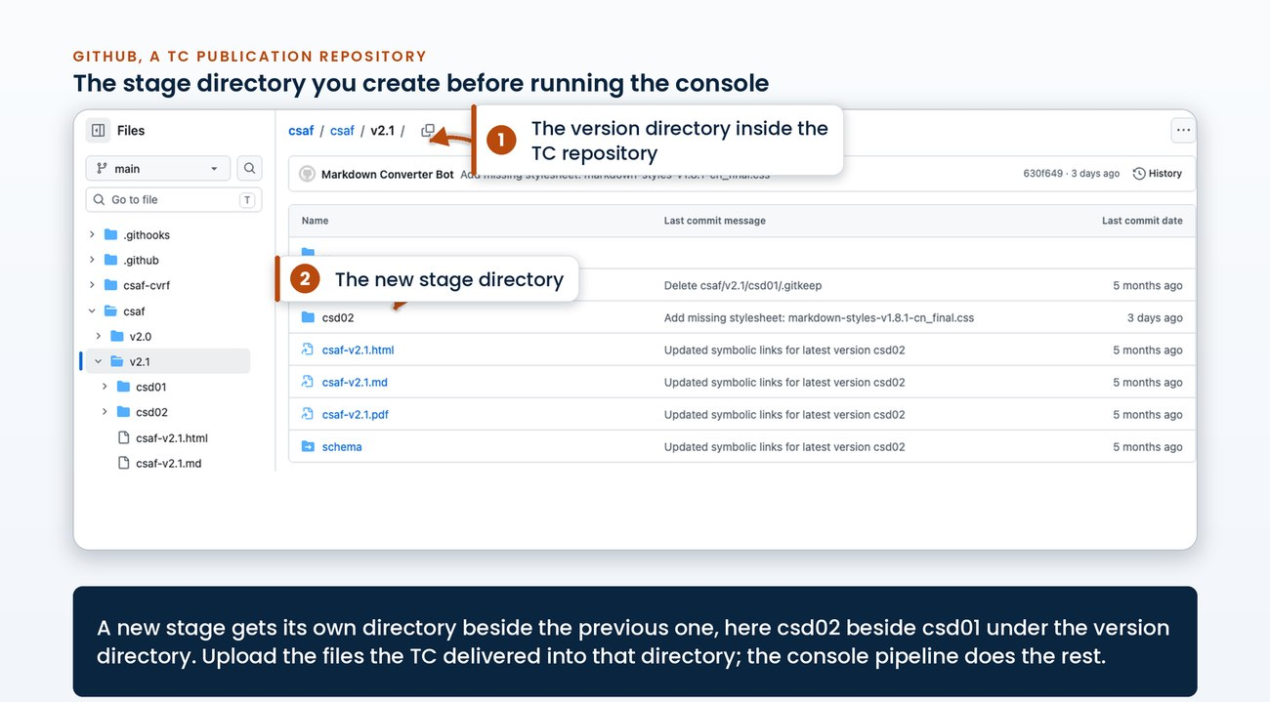
a TC publication repository version directory with the new csd02 stage directory beside csd01 and the latest-stage copies alongside
For a brand-new version (a v2.1 where only v2.0 exists), create the version directory the same way, with the stage directory inside it. A new TC's repository is provisioned by OASIS and starts private; making it visible is a separate, later decision.
The picker only offers what exists
The console's spec directory picker reads the live repository tree, so a directory that has not been created and pushed cannot be selected. If your new stage does not appear in the picker, the upload has not landed.
- Owner: TC Administrator
- System: the TC's publication repository, through the GitHub web interface
- Permission: write access to the OASIS-Docs organisation
- Timing: after intake confirmation, before the console runs
- Record: the commit that added the stage directory

4.4 Run the pipeline from the console
The publication console at https://publish.oasis-infra.net is the one screen for the rest of the operation. It is staff-only, behind Cloudflare Access with your OASIS Google account. Every button dispatches a recorded workflow attributed to you; nothing on the page runs unlogged.
Two choices, then the pipeline:
1. Choose the specification. Pick the spec directory one level at a time; the picker offers only directories that exist, newest versions first. Pasting the docs URL or the GitHub URL of the directory fills the whole path in.
2. Set the publication date. The console's date field carries the document date confirmed at intake and is stamped on every published file. Leave dry run on for the first pass.
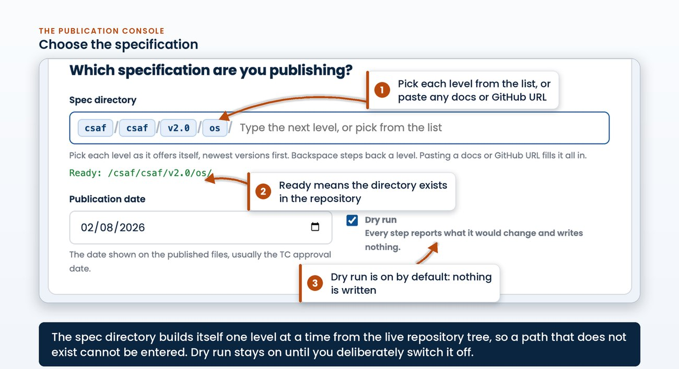
the console's first panel: the spec directory built from chips, the ready line, the publication date and the dry run default
The pipeline is one row per step, numbered in run order:
Step | What it does | Writes anything?
1.0 | Converts the Markdown source to HTML and commits it back | to the TC repository
2.0 | Converts the HTML to PDF, with layout checks before and after | to the TC repository
2.5 | Checks Word-exported HTML; only for DOCX-native specs | read-only
3.0 | Builds the ZIP download package | to the TC repository
4.0 | Builds manifest.json and the Work Product Manifest | to the TC repository
5.0 | Runs every acceptance check (oasis-pub-check) | read-only
6.0 | Deploys to docs.oasis-open.org, refreshes caches, verifies | to production
For a standard Markdown publication, press Select standard publication, which ticks 1.0 to 5.0, then Run checked steps in order. The steps run top to bottom and the sequence stops at the first failure. The console also ticks 2.5 in the preset when it detects a Word file in the target directory. For a Word-track publication, untick 1.0 and 2.0 yourself before running: the renderings are made in Word, matching the TC's precedent, and the rest of the sequence runs identically. For the other source formats (DocBook, XML, LaTeX), the TC's delivered renderings are staged as they arrived and the sequence runs from 3.0.
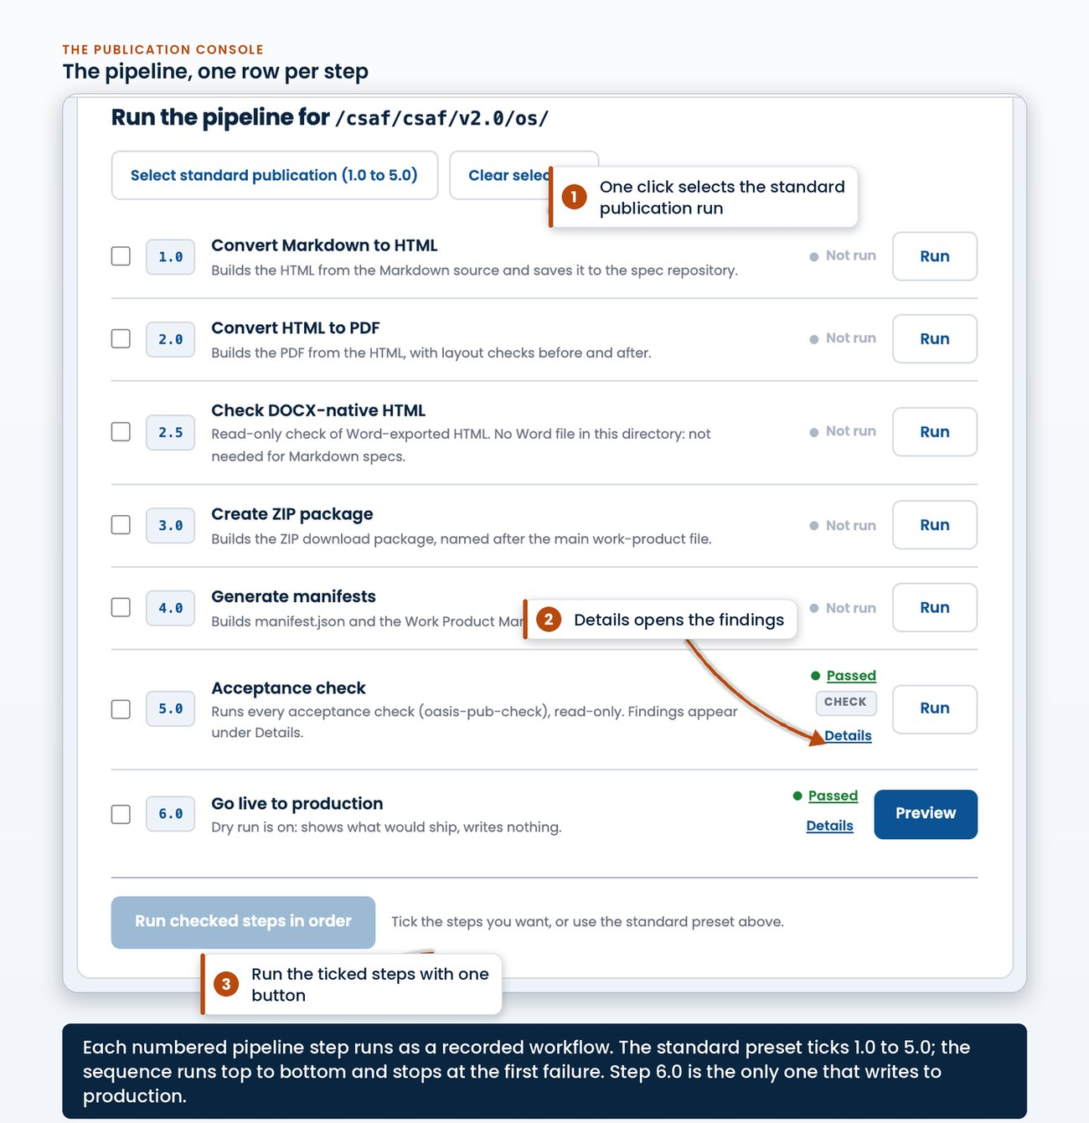
the pipeline panel: the standard preset, one row per numbered step with its last result, and the auto-run button
Run everything with dry run on first. A dry run of every build step reports exactly what it would change, writes nothing, and attaches its outputs (the rendered HTML, the PDF, the ZIP) to the run as preview artifacts you can download and review. When the dry pass is clean end to end, switch dry run off and run the same sequence again to commit the artifacts to the TC's repository.
Step 5.0 is the acceptance gate, the same executable criteria a TC can run in its own build before the vote (github.com/OASIS-Docs/publication-assurance, public). Its findings appear under the step's Details in the console: severity, the check that fired, and the exact correction. Blockers stop the publication; warnings ask for a judgement.
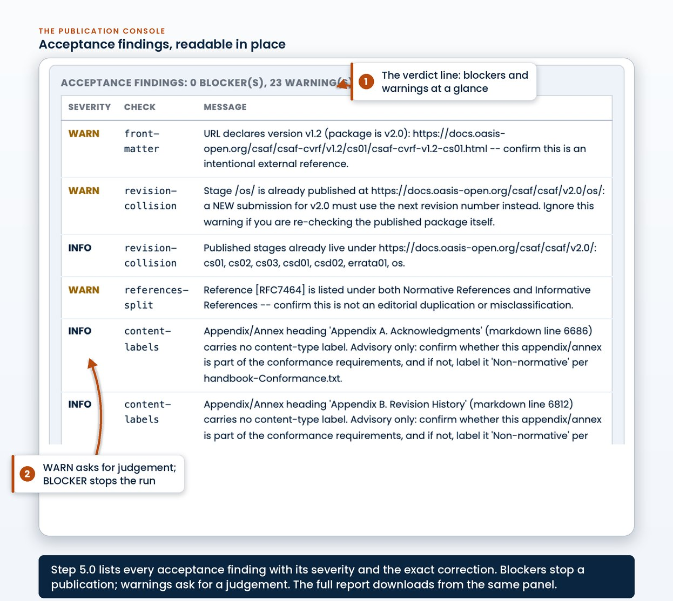
the acceptance findings table under step 5.0's Details: the verdict line, then severity, check and corrective message per finding
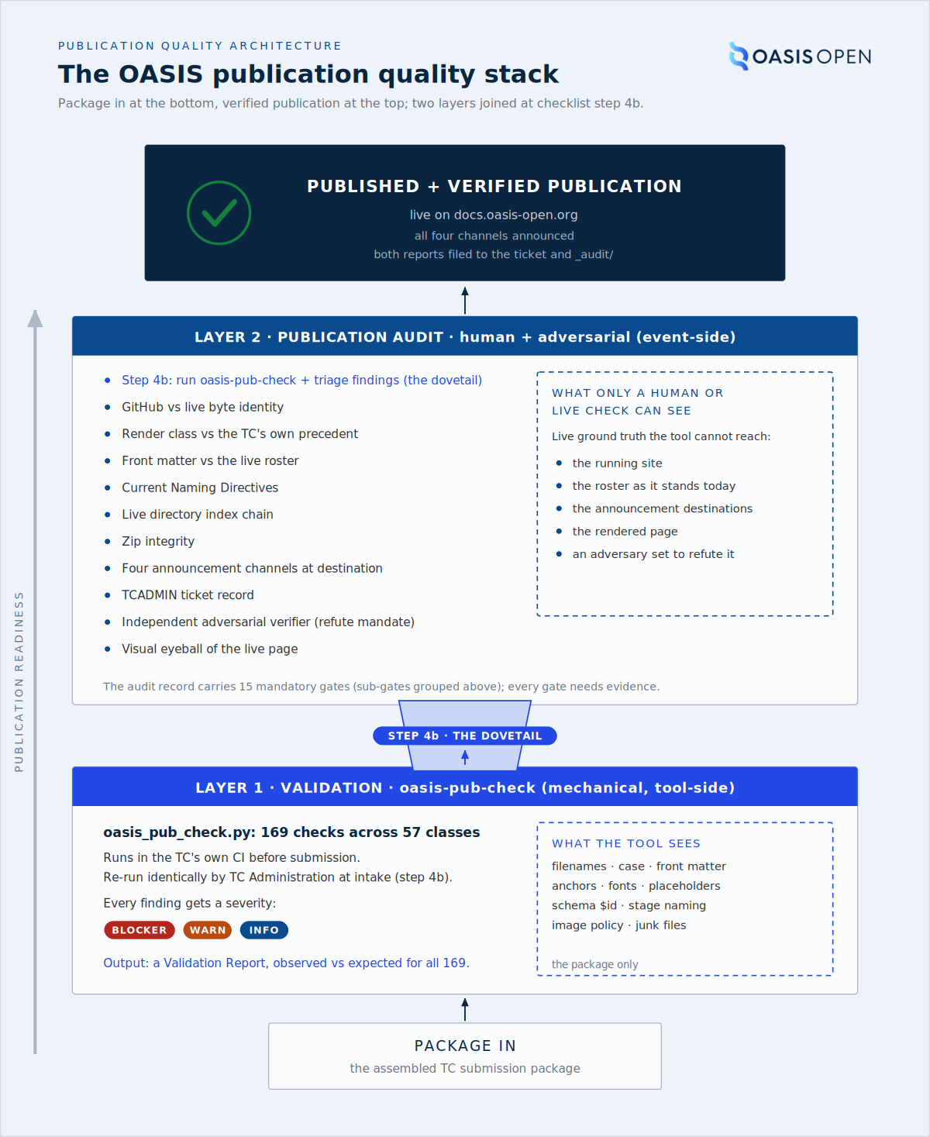
the validation layer the TC can run against the audit layer only OASIS can run
- Owner: TC Administrator
- System: the publication console; each step runs as a recorded workflow
- Permission: an OASIS Google account behind Cloudflare Access; no local toolchain
- Timing: dry pass first, then the same sequence for real; the sequence stops at the first failure
- Record: every run in the console's history and in the publication record, attributed to the person who ran it

4.5 Go live
Step 6.0 is the only step that writes to production. It re-runs the acceptance gate one final time, stages the package, syncs it to production, refreshes the cache layers, verifies the live bytes against the pushed repository state, and audits the directory index chain. Published files carry the publication date at 17:00 UTC, the OASIS convention.
Step 6.0 runs from its own button on the pipeline's last row: the button reads Preview while dry run is on and Go live when it is off. With dry run on, 6.0 reports exactly what would change on the live site and writes nothing. Run that first, read the change list, and only then switch dry run off.
A real go-live opens a confirmation dialog. It shows the exact directory about to publish, and the deploy button stays disabled until you type that directory back. A real go-live is also limited to a configured allowlist of staff; anyone else on the console still has every dry run and every check.
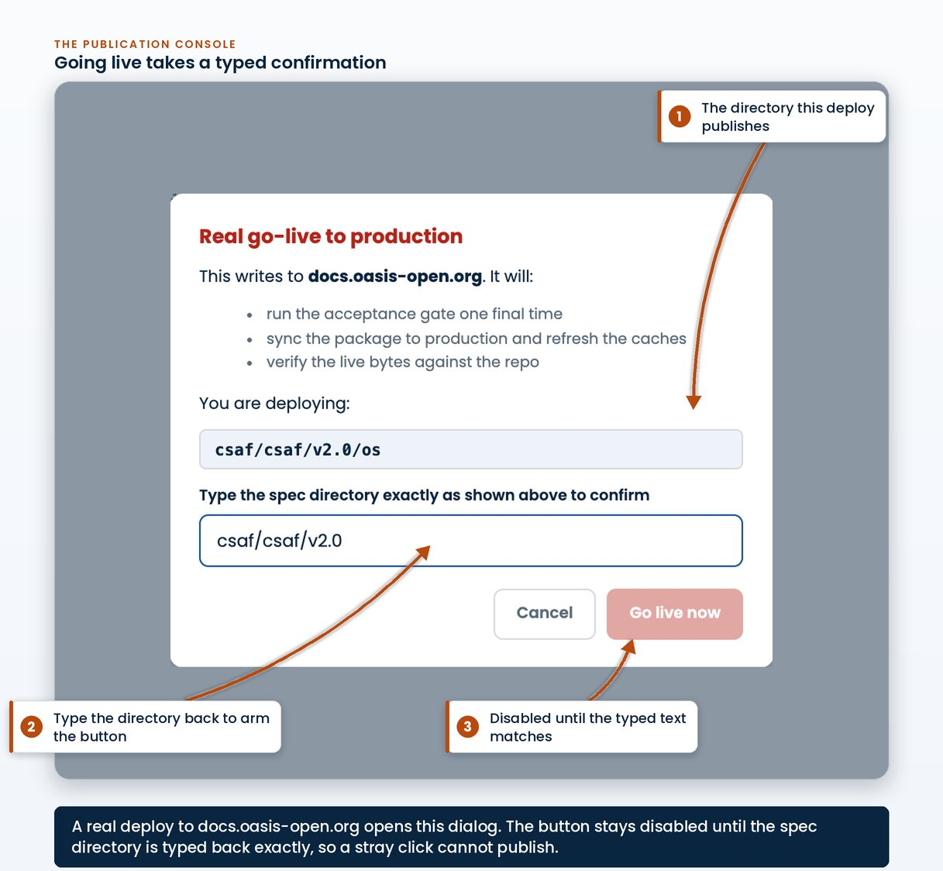
the go-live confirmation: the target directory shown, the typed-confirmation field, and the deploy button disabled until the text matches
- Owner: TC Administrator, on the go-live allowlist
- System: the console's 6.0 step: acceptance gate, production sync, cache refresh, byte verification
- Timing: dry preview first, then the real run; wait for the run to finish before verifying
- Record: the 6.0 run and its change list, in the console history and the publication record

4.6 Verify on the live site and file the record
A publication is judged by what the live site serves a reader, so verification happens against https://docs.oasis-open.org after the caches refresh. Confirm, in a normal browser:
1. the stage directory lists the source, HTML, PDF and ZIP with the publication date
2. the document's cover URIs (This stage, Previous stage, Latest stage) resolve
3. the latest-stage copies at the version level serve the new content
4. every cited companion artifact and image loads from the published HTML
Two reports are produced for every publication and attached to the TC's ticket: the validation report, itemizing every acceptance criterion with the value read from the package, and the publication audit report, recording the publication event against the mandatory audit gates with evidence. The 5.0 run's findings and its machine-readable report artifact feed the first; chapter 9 covers how the audit verdict is computed.
The console keeps the durable trail on its own. Every run appends itself to the specification's publication record: the step, the outcome, dry or live mode, who ran it, and the run log link. The record is readable in the console itself, so no one needs a GitHub account to answer what happened and when.
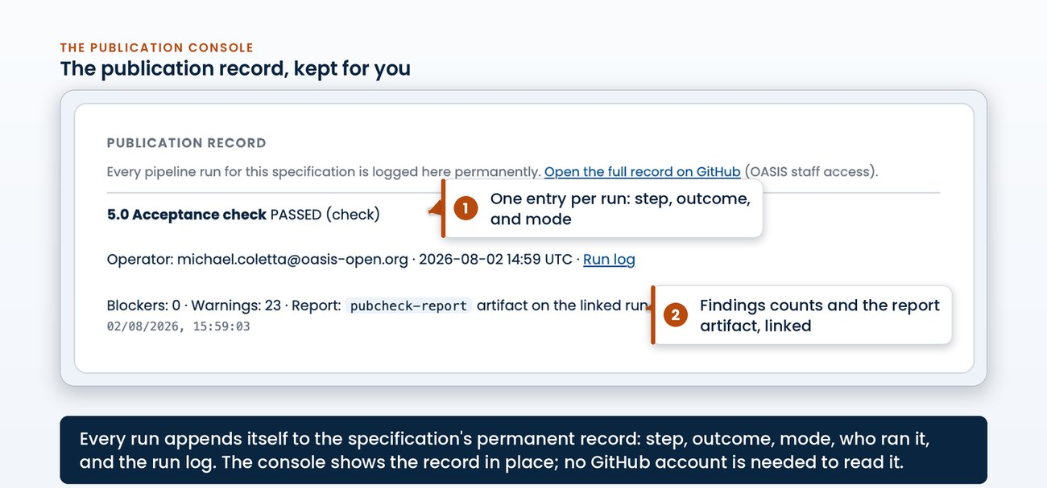
the publication record panel: one entry per run with outcome, mode, the counts and the report artifact link
- Owner: TC Administrator, plus an independent reviewer on the live state
- System: the live documents site; the request tracker for the ticket; the publication record for the run trail
- Timing: after 6.0 completes; repeat the pass if it finds a defect
- Record: the two reports attached to the ticket, the publication record, and the verified live URLs

4.7 When a step fails
The sequence stops at the first red step so a defect cannot reach production. To recover:
1. Open Details on the failed step. The console shows which part failed, the tail of its log, and for 5.0 the full findings table. Every finding names the file and the correction.
2. Fix the source, not the output. Corrections go into the staged files in the TC's repository (or back to the TC editor when the source itself is wrong). Never hand-edit a generated HTML, PDF or ZIP; the next run would overwrite it.
3. Run the sequence again. Any change to the source or stylesheet re-runs the chain from 1.0, because the PDF and the ZIP must always reflect the current source. A partial re-run can leave the PDF older than the HTML beside it.
4. Judge warnings once. A warning that is intentional, for example an external reference to an older spec version, is noted in the ticket and left standing; a warning that is real gets fixed like a blocker.
The findings trace to real correction rounds in the published corpus: placeholder text left in URI blocks, stage names in the wrong case, dates that disagree between header and citation block, image paths with double slashes. The gate exists so these are caught in a dry run instead of at a permanent URL.
If a step fails in a way the Details panel cannot explain, the run log link opens the full workflow log, and the publication record shows every earlier run of the same specification for comparison.
- Owner: TC Administrator; the TC editor when the source itself needs the fix
- System: the console for the findings; the TC's repository for the corrections
- Timing: fix and re-run inside the same dry-run loop; nothing has shipped until 6.0 runs for real
- Record: the failed and repeated runs in the publication record, and the judgement on any standing warning in the ticket

5. Balloting operations
Four ballots sit on the standards path:
1. the Full Majority Vote that sends a draft to public review,
2. the Special Majority Vote that approves the Committee Specification once that review closes,
3. the Special Majority Vote that submits the Committee Specification as a Candidate OASIS Standard,
4. and the Call for Consent that turns the candidate into an OASIS Standard.
They all run on the member platform, Higher Logic, and each one is recorded in the request tracker. Balloting is routine platform work: the TC communities ran 83 ballots on the platform between March 2024 and July 2026. The TC casts the votes. The TC Administrator handles the ballot set-up, the reviews, the records and the follow-on work. For a Special Majority Vote, policy puts the conduct of the ballot with the TC Administrator on the chair's request.
This chapter is written for the administrator doing the work. Each section identifies:
- the area of the member platform where the task happens,
- the fields that carry the decision,
- what the platform enforces,
- and what it does not.
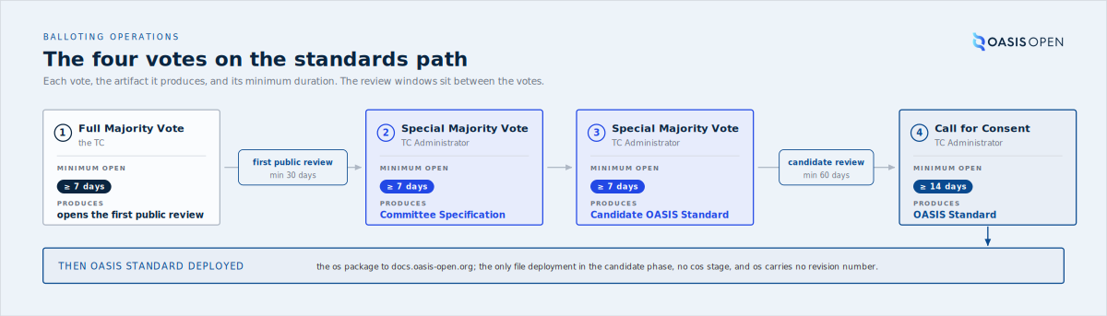
the four votes in order with the artifact each one produces and the minimum duration of each, from Full Majority Vote through Call for Consent to the OASIS Standard deployment
Those four votes are steps on a longer ladder. The public TC Handbook publishes the full Standards Track lifecycle, Working Draft to OASIS Standard, with the develop, review, approve and publish phases and the minimum time each stage takes. The ladder below is that published reference, and the rest of this chapter works through the votes that move a Work Product up it.
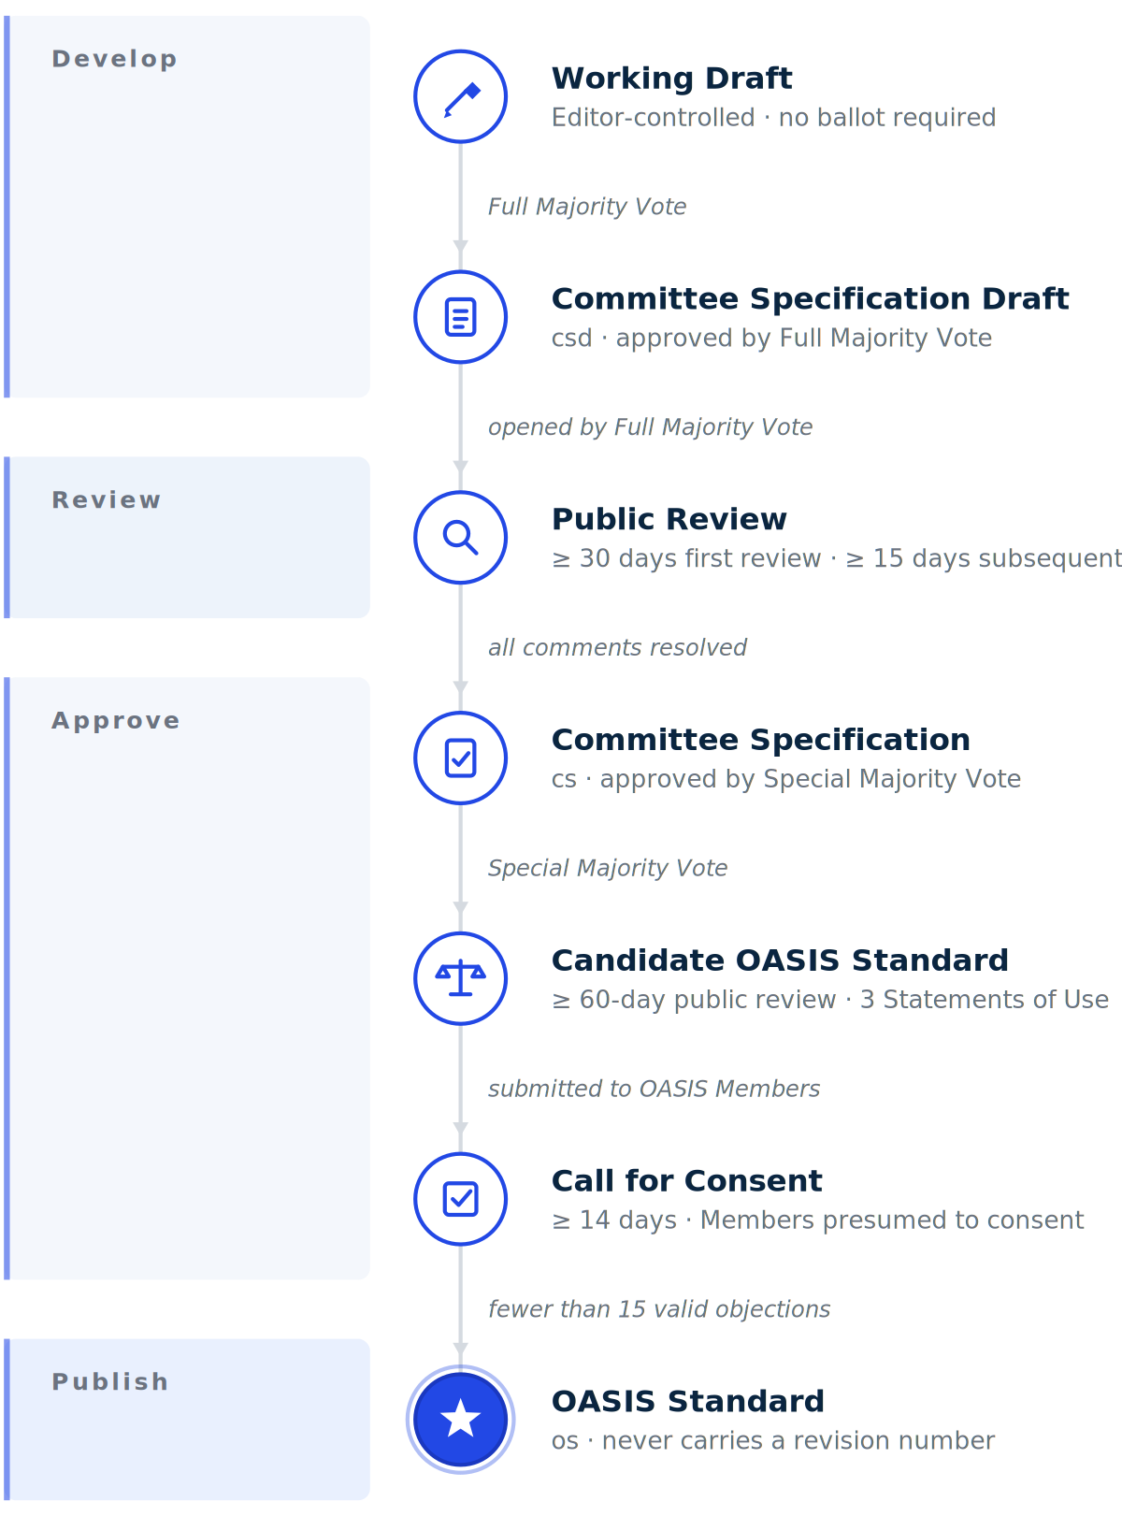
the full Standards Track stage ladder the four votes climb, Working Draft to OASIS Standard, with the develop, review, approve and publish phases and the minimum duration at each stage, as published in the public TC Handbook Work Product Lifecycle reference

5.1 Ballot types and when each is used
Three thresholds cover the path:
- A Full Majority Vote passes when more than 50% of all eligible voters vote Yes, whether present or not.
- A Special Majority Vote passes when at least 2/3 of eligible voters vote Yes and no more than 1/4 vote No.
- A Call for Consent is not a TC vote at all: it is an opt-out consent process in which each eligible OASIS Organizational Member at the time of the call is entitled to express consent.
The Call for Consent has three outcomes, and 5.6 covers them in full:
- no valid objections and it becomes an OASIS Standard;
- fewer than 15 valid objections and the TC has 30 days to resolve them or withdraw, with one attempt at Material changes;
- 15 or more valid objections and it is deemed rejected.
The old shortcut that treated anything under 15 as a pass was retired on 22 July 2026 and marked do not use. It misses the middle case, which exists as soon as there is a single valid objection.
The Full Majority Vote opens a public review. The Special Majority Vote approves the Committee Specification after the review. This is the most common mix-up because both votes can attach to the same specification within weeks of each other. The Full Majority Vote is the committee's own ballot: the TC runs it and records it in its minutes. The TC Administrator confirms that it is in the approved minutes before opening the review. The Special Majority Vote is conducted by the TC Administrator on the chair's request.
The most common error
The Full Majority Vote opens a public review. The Special Majority Vote approves the Committee Specification after it. Both can attach to the same specification within weeks of each other, which is why this is the most common mix-up.
Vote | What it decides | Threshold | Who conducts it
Full Majority Vote | approves the draft and the decision to go to public review | more than 50% of all eligible voters vote Yes | the TC
Special Majority Vote | approves the Committee Specification after a successful review and resolution of all comments | at least 2/3 of eligible voters vote Yes and no more than 1/4 vote No | the TC Administrator
Special Majority Vote | submits that Committee Specification as a Candidate OASIS Standard | at least 2/3 of eligible voters vote Yes and no more than 1/4 vote No | the TC Administrator
Call for Consent | turns the candidate into an OASIS Standard | three outcomes, set out in 5.6: no valid objections approves it, fewer than 15 valid objections opens a 30-day resolution window, 15 or more valid objections rejects it | the TC Administrator, to eligible OASIS Organizational Members at the time of the call
- Owner: the TC runs its Full Majority Votes; the TC Administrator conducts every Special Majority Vote and the Call for Consent.
- System: the member platform, Ballots area of the TC workspace, for the TC votes; the all-members voting facility for the Call for Consent.
- Record: the ballot on the platform, and the request ticket that carries the advancement sequence.
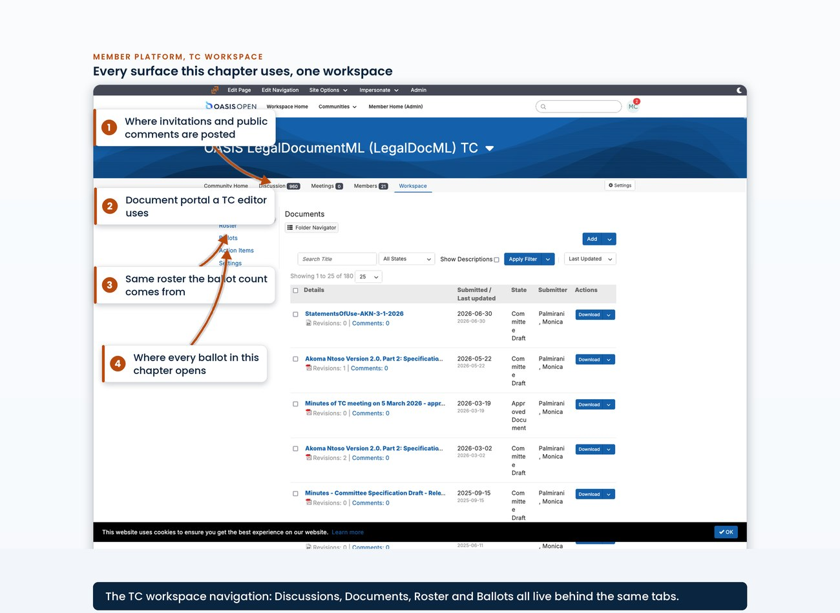
the TC workspace navigation with the Ballots, Roster, Documents, Discussions and Action Items areas visible in one frame

5.2 Roster math and thresholds
Both TC thresholds use N, the number of eligible voters at the moment the ballot opens. They do not use the number of votes cast. Once N is set, the arithmetic is:
- Yes votes required is 2/3 of N rounded up,
- and the maximum No votes allowed is 1/4 of N rounded down.
N comes from the Eligible Voters report in the TC's Roster area. The report names the calculation method it used. The row count is N. The spreadsheet export is kept as the ballot's audit trail. Before opening, confirm with the chair that the voting roster is current. A one-line question and reply is enough. It is not a separate approval.
Eligibility freezes when the ballot opens. Voter management is set to not automatically manage so the eligible set is fixed at open. A roster change during the ballot then does not change N.
N freezes at open
Both TC thresholds are measured against N, the number of eligible voters at the moment the ballot opens; turnout plays no part. Set voter management to not automatically manage so the eligible set freezes at open, and a roster change during the ballot then leaves N alone.
N, eligible voters when the ballot opens | Yes votes needed to pass (2/3 of N, rounded up) | No votes that still allow a pass (1/4 of N, rounded down)
4 | 3 | 1
5 | 4 | 1
6 | 4 | 1
9 | 6 | 2
12 | 8 | 3
Read a row as a worked example: with 9 eligible voters, the ballot needs at least 6 Yes votes, and a third No vote sinks it even if the Yes count is met.
The report computes eligibility, but the voting rights behind it are maintained by people. Committees track gains and losses of voting rights from meeting attendance under their standing rules, and they do it in their minutes: SAM's minutes record a Quorum declaration computed by hand from its attended-3-of-the-last-5-meetings voting rule at every meeting. The platform does not do that arithmetic for a committee, and OpenC2's minutes record that members cannot mark their own attendance on the platform and that voting-rights edits are restricted to staff. The Eligible Voters report is therefore only as current as the attendance bookkeeping behind it, which is one more reason the chair confirmation above is asked before every ballot rather than assumed.
- Owner: TC Administrator determines N; the chair confirms the roster is current.
- System: the member platform, Roster area, Eligible Voters report.
- Permission: roster access in the TC workspace.
- Timing: before the ballot opens, because eligibility freezes at open.
- Record: the exported eligible-voter spreadsheet, kept with the ballot's audit trail.
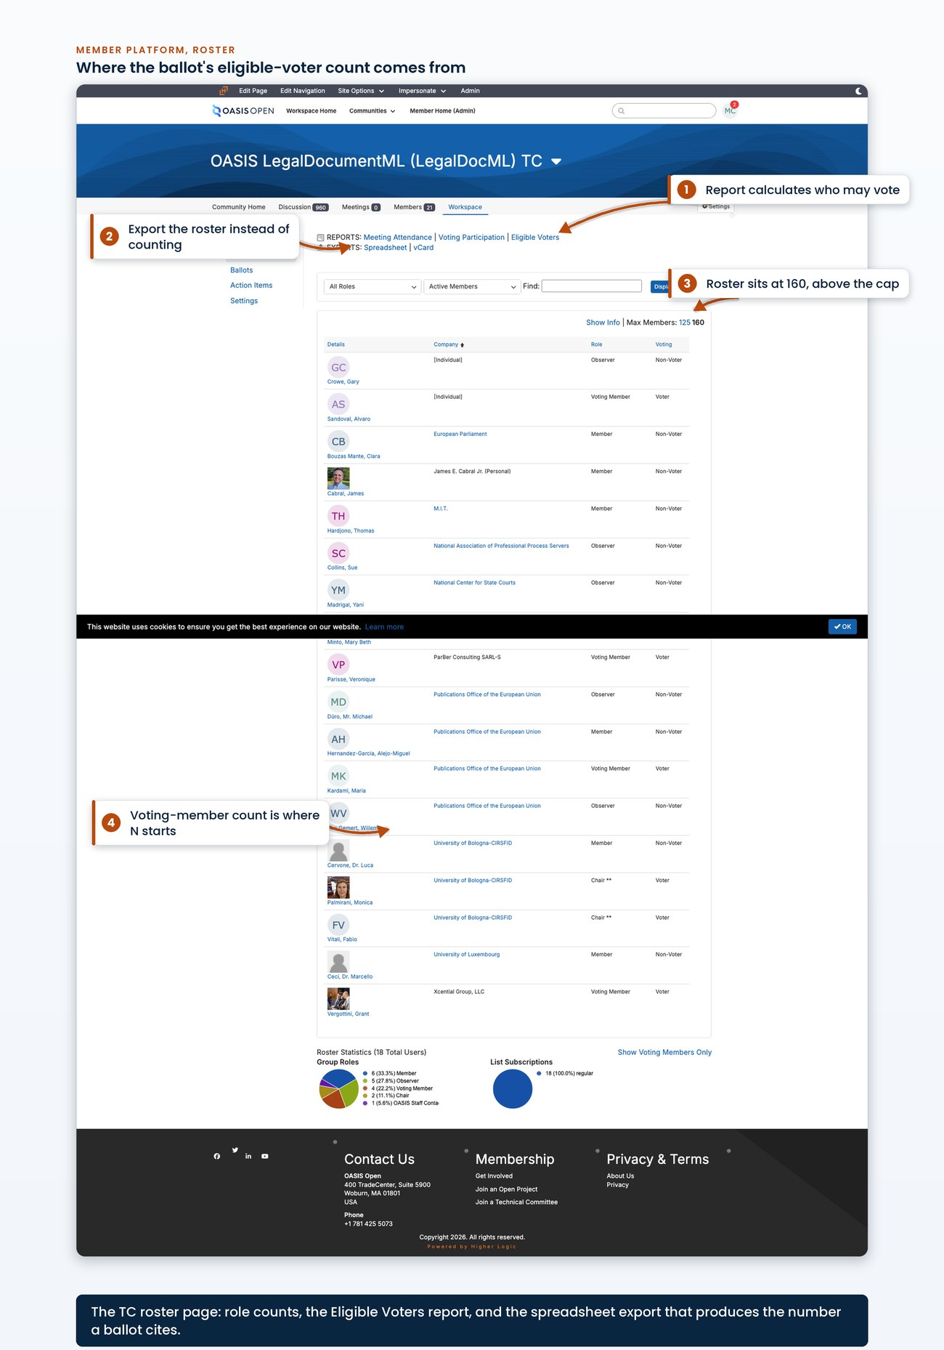
the Eligible Voters report showing the calculation method it used, the voter rows, and the spreadsheet export control, with the row count legible
The export control on that report produces the spreadsheet filed as the ballot's audit trail.
[Evidence captured in draft 0.7: an exported eligible-voters spreadsheet from a real Special Majority Vote]

5.3 Opening a ballot
The request ticket comes first, then the ballot. The record should show the request before the vote, even when the same person handles both. Current practice keeps one ticket open through the whole advancement chain and comments each transition on that ticket instead of opening a new ticket for each stage. The PKCS#11 v3.2 run is the model: TCADMIN-4695 carried the ballot, the 60-day review and the Call for Consent, and was closed at the end.
Ballot work is done signed in to the member platform with administrator rights.
The ballot is created in the TC workspace's Ballots area through the Add Ballot form. There is no external balloting tool. The form's defaults already match a seven-day OASIS vote:
- dates from today to seven days out,
- US Eastern time,
- Yes and No options,
- Voting Members only,
- voter management not automatic,
- and email to eligible voters on open and on close.
The fields normally changed are:
- the title,
- the question and description,
- and the official-ballot checkbox.
For the description, the visual editor escapes the angle brackets, so work in source view and enter the roster-math fractions as character entities. The usual window opens at 1:00 PM US Eastern and closes seven or eight days later at 11:59 PM in the same zone. Seven days is the floor for an electronic ballot held outside a meeting and eight is the established precedent. Continue leads to an eligible-voter confirmation page. That is the last chance to read N against the roster before the ballot exists. Accept creates the ballot, opens it and emails the voters. The ballot text cannot be edited afterwards.
Field on the Add Ballot form | What goes in it
Title | Approve [specification title] [stage] as a Candidate for OASIS Standard
Question and description | the block below, filled with N, the Yes count and the No maximum
Ballot options | Yes and No, see the first defect note at the end of this section
Opening date, time, timezone | the opening day, 1:00 PM US Eastern
Closing date | opening plus 7 or 8 days, 11:59 PM in the same zone
Voter eligibility | Voting Members only, which yields the N-voter set
Voter management | not automatically managed, which freezes eligibility at open
Official ballot | checked, for anything binding
Revoting | the setting used to date is voters may vote once, see the second defect note at the end of this section
Referenced items | the rendered ballot document; optionally the Statements of Use entry in Documents
Results and sharing | available as the ballot opens, detailed voter list, shared to the general membership and the general public, which is what Committee Operations Process 1.5 requires
Email notifications | eligible voters on open and on close
This is the post that goes into the description field, and it is the only place the roster math is stated to the voters:
Do you approve [SPECIFICATION TITLE] [STAGE] as a Candidate for OASIS Standard?[1]

This ballot requires a Special Majority Vote [2]. The TC roster currently lists
[N] voting members. In order to pass, at least [X] <2/3 x [N]> members have to
vote Yes and no more than [Y] <1/4 x [N]> members may vote No.

[1] URI for the specification:
[CANONICAL STAGE URL]

[2]
https://www.oasis-open.org/policies-guidelines/oasis-defined-terms-2018-05-22/#dSpecialMajority
Filled for the LegalDocML submission ballot of July 2026, that reads: a roster of 6 Voting Members, at least 4 members have to vote Yes, no more than 1 member may vote No, and the specification URI is https://docs.oasis-open.org/legaldocml/akn-core/v2.0/cs01/. Statement of Use links do not go in the ballot body. They belong on the ticket and in the Documents area.
Three things the form does not do:
- No minimum-turnout field. There is no minimum-turnout field anywhere on it, and none is needed. Quorum is defined as more than 50% of Voting Members present and governs meetings only, while both TC thresholds are measured against eligible voters rather than against turnout, as 5.2 sets out. No Quorum requirement attaches to an electronic ballot, so there is nothing on this form to look for. Any Quorum language that does appear sits in the free-text description as prose and the system never enforces it. If a description ever claims one, confirm turnout by hand against whatever it claims.
- No public results by default. Results visibility defaults to administrators of the group, with sharing to the general membership and the general public both off. The sharing settings in the table above are therefore not a preference. Committee Operations Process 1.5 requires that all web pages, documents, ballot results and email archives of all committees and subcommittees shall be publicly visible, and a ballot left on the platform default is non-conforming.
- No lock on the eligible-voter list. Eligible voters can be edited while a ballot is open, and every such edit is written to the ballot history log.
Two defects need filing rather than copying as practice. Both sit in the same field map and both are against TC Process 1.11:
- The first is the ballot options. The operating procedure sets them to Yes and No with no Abstain, following current practice and the immediately prior ballot on the same TC, while TC Process 1.11 requires that any Work Product Ballot conducted as an electronic ballot permit each voter to choose yes, no or abstain. TC Process 1.11 controls. The open question is whether a ballot submitting a Committee Specification as a Candidate OASIS Standard is a Work Product Ballot within the meaning of that clause. [VERIFY]
- The second is revoting. The setting used to date is that voters may vote once, while TC Process 1.11 requires that eligible voters may change their vote up until the end of the voting period. A single-vote control removes exactly that right. TC Process 1.11 controls here too. This one may not be a defect at all: if the platform's vote-once control still permits a voter to re-open the ballot and change a cast vote, the operation conforms and only the label reads wrong. That has to be established on the live Add Ballot form. Prior ballots used the same setting, so precedent only shows that the same setting was used before. [VERIFY]
- Owner: TC Administrator.
- System: the member platform, Ballots area, Add Ballot form; the request ticket opened immediately beforehand.
- Permission: ballot-creation rights in the TC workspace; access to the request tracker.
- Timing: open at least 7 days, in practice 7 or 8; the platform emails eligible voters on open and on close.
- Record: the ballot with its own identifier and history log; the request ticket carrying the requester, the specification URL and the Statement of Use links.
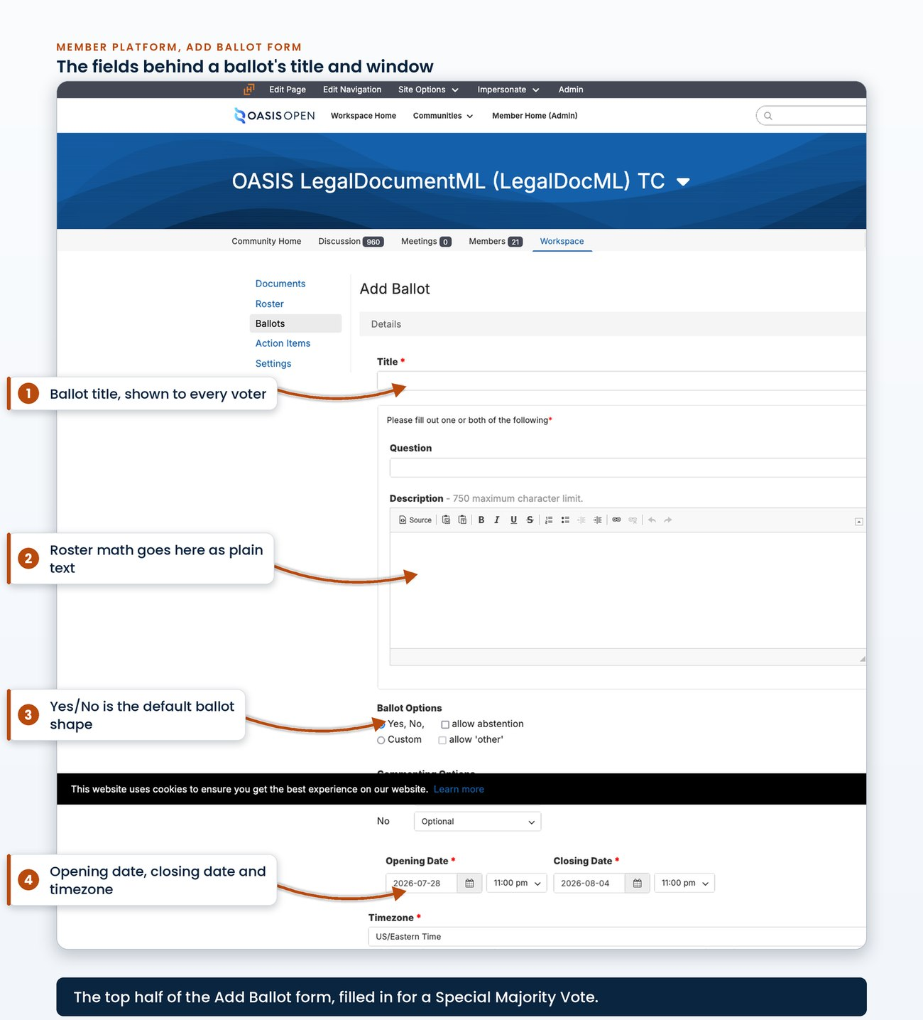
the top of the Add Ballot form: Title, the question and description editor, Ballot Options, Opening Date with time and timezone, Closing Date, and the start of Voter Eligibility
The lower half of the same Add Ballot form holds the remaining settings.
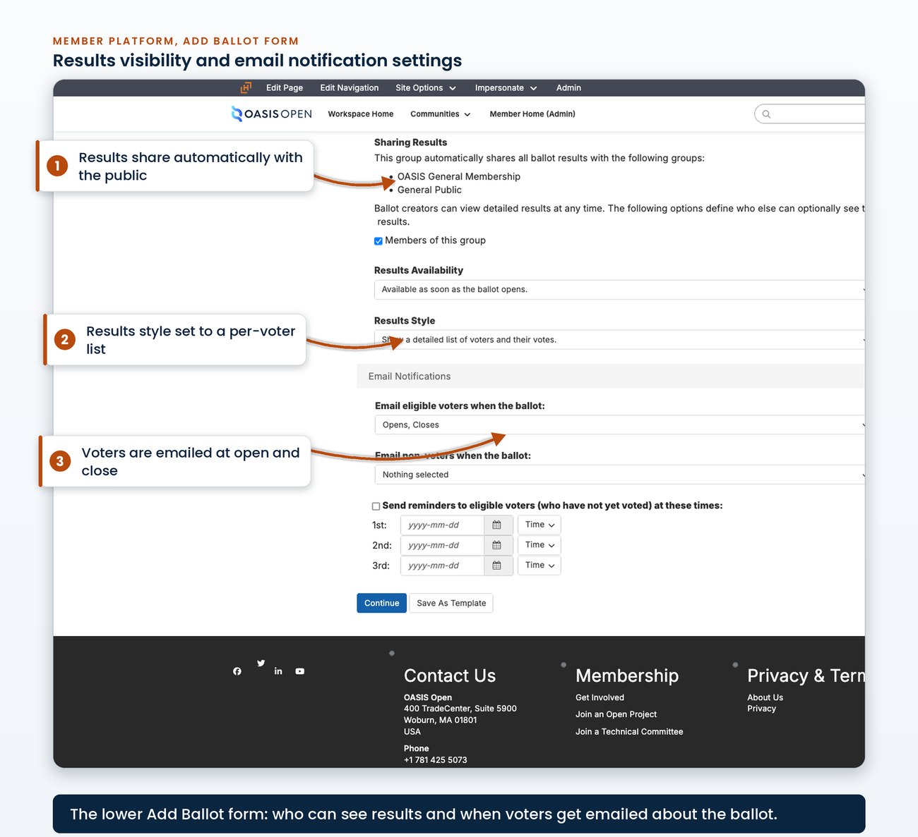
the lower half of the Add Ballot form: Voter Management, the official-ballot checkbox, Revoting, Referenced Items, Results and Sharing Results, and Email Notifications
The request ticket opened before the ballot carries the whole advancement chain.
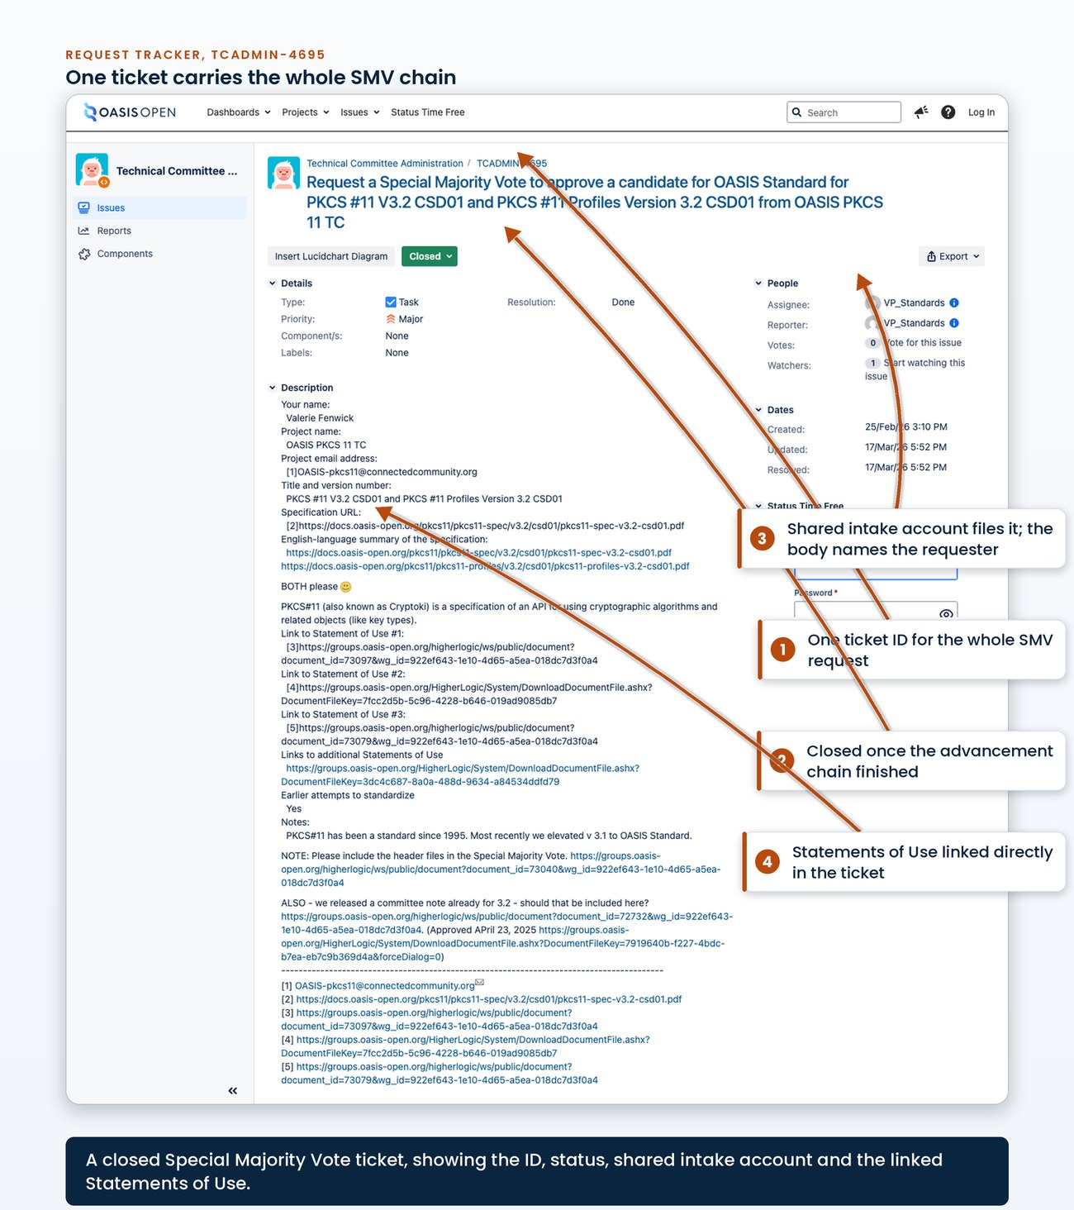
a request ticket for a Special Majority Vote showing the summary line, the components, and the transition comments recording the ballot opening, the 60-day review opening and the Call for Consent
The body of that same ticket records the filled request field map.
[Evidence captured in draft 0.7: the request ticket body showing the filled request field map: requester, project, specification URL, plain-English summary, Statement of Use links, earlier standardization attempts]

5.4 Statements of Use
A Special Majority Vote to submit a Committee Specification as a Candidate OASIS Standard requires three Statements of Use referencing that Committee Specification, at least one of them from an OASIS Organizational Member. A Statement of Use is a written statement that does three things:
1. it states successful use or implementation consistent with the Work Product's conformance clauses,
2. it identifies which of those clauses apply,
3. and it states whether interoperability was demonstrated.
It must also be made to a specific version of the Specification and carry that Specification's approval date. Implementation alone qualifies. The binding text treats successful use or implementation as enough. Members upload their statements to the TC's Documents area on the member platform, commonly as a single archive. Non-members submit through the TC's public comment facility.
One precondition sits ahead of the ballot and the platform does not prompt for it. A Statement of Use submitted to the TC must be approved by TC Resolution as an acceptable Statement of Use with respect to the Specification. That approval has to be in place before the vote opens. A Special Majority Vote opened on statements the TC never resolved to accept is not valid. Confirm the accepting resolution is in the TC's approved minutes at the same time as the roster confirmation, and cite it on the request ticket.
The TC must accept the Statement of Use before the vote
A Statement of Use submitted to the TC must be approved by TC Resolution as an acceptable Statement of Use with respect to the Specification. The approval has to be in place before the vote opens. A Special Majority Vote opened on statements the TC never resolved to accept is not valid. Confirm the accepting resolution is in the TC's approved minutes at the same time as the roster confirmation, and cite it on the request ticket.
The administrator's review is narrow:
- Conformance is not audited,
- Primary Representative endorsements are not chased,
- and the comment facility is not policed as a prerequisite.
Take up those policy questions only if someone objects. For the ballot file, the routine is:
1. Count the statements,
2. confirm the accepting resolution,
3. confirm at least one member,
4. and record the wording defects.
The three that recur are:
- a wrong Committee Specification number in the prose,
- an unfilled placeholder in the conformance-level line,
- and a hyperlink that resolves to an earlier stage than the prose names.
The last two are recorded and are not disqualifying, because the prose identifies the specification.
The first one is a defect to file. Recording a wrong Committee Specification number and proceeding waives a Required rule: the Defined Terms say a Statement of Use must be made to a specific version of the Specification and must include that Specification's approval date, and a wrong number in the prose is the version identifier being wrong. The Defined Terms rule controls. The limited review described above is not in question, and nothing here asks for an audit. What is in question is that this one waiver contradicts a Required rule and has not been visible anywhere. The reading needed is what a wrong number in the prose does to the statement when the links and surrounding text otherwise identify the specification, and it needs answering before the next Special Majority Vote opens. [VERIFY]
- Owner: the TC and its members supply the statements and the TC resolves to accept them; the TC Administrator counts and confirms.
- System: the member platform, Documents area, for member statements; the TC's public comment facility for non-member statements; the TC's approved minutes for the accepting resolution.
- Permission: read access to the TC's Documents area.
- Timing: in hand and accepted by TC Resolution before the ballot opens.
- Record: the Documents entry, cited by its identifier in the request ticket, with the accepting resolution and any defects noted alongside the count.
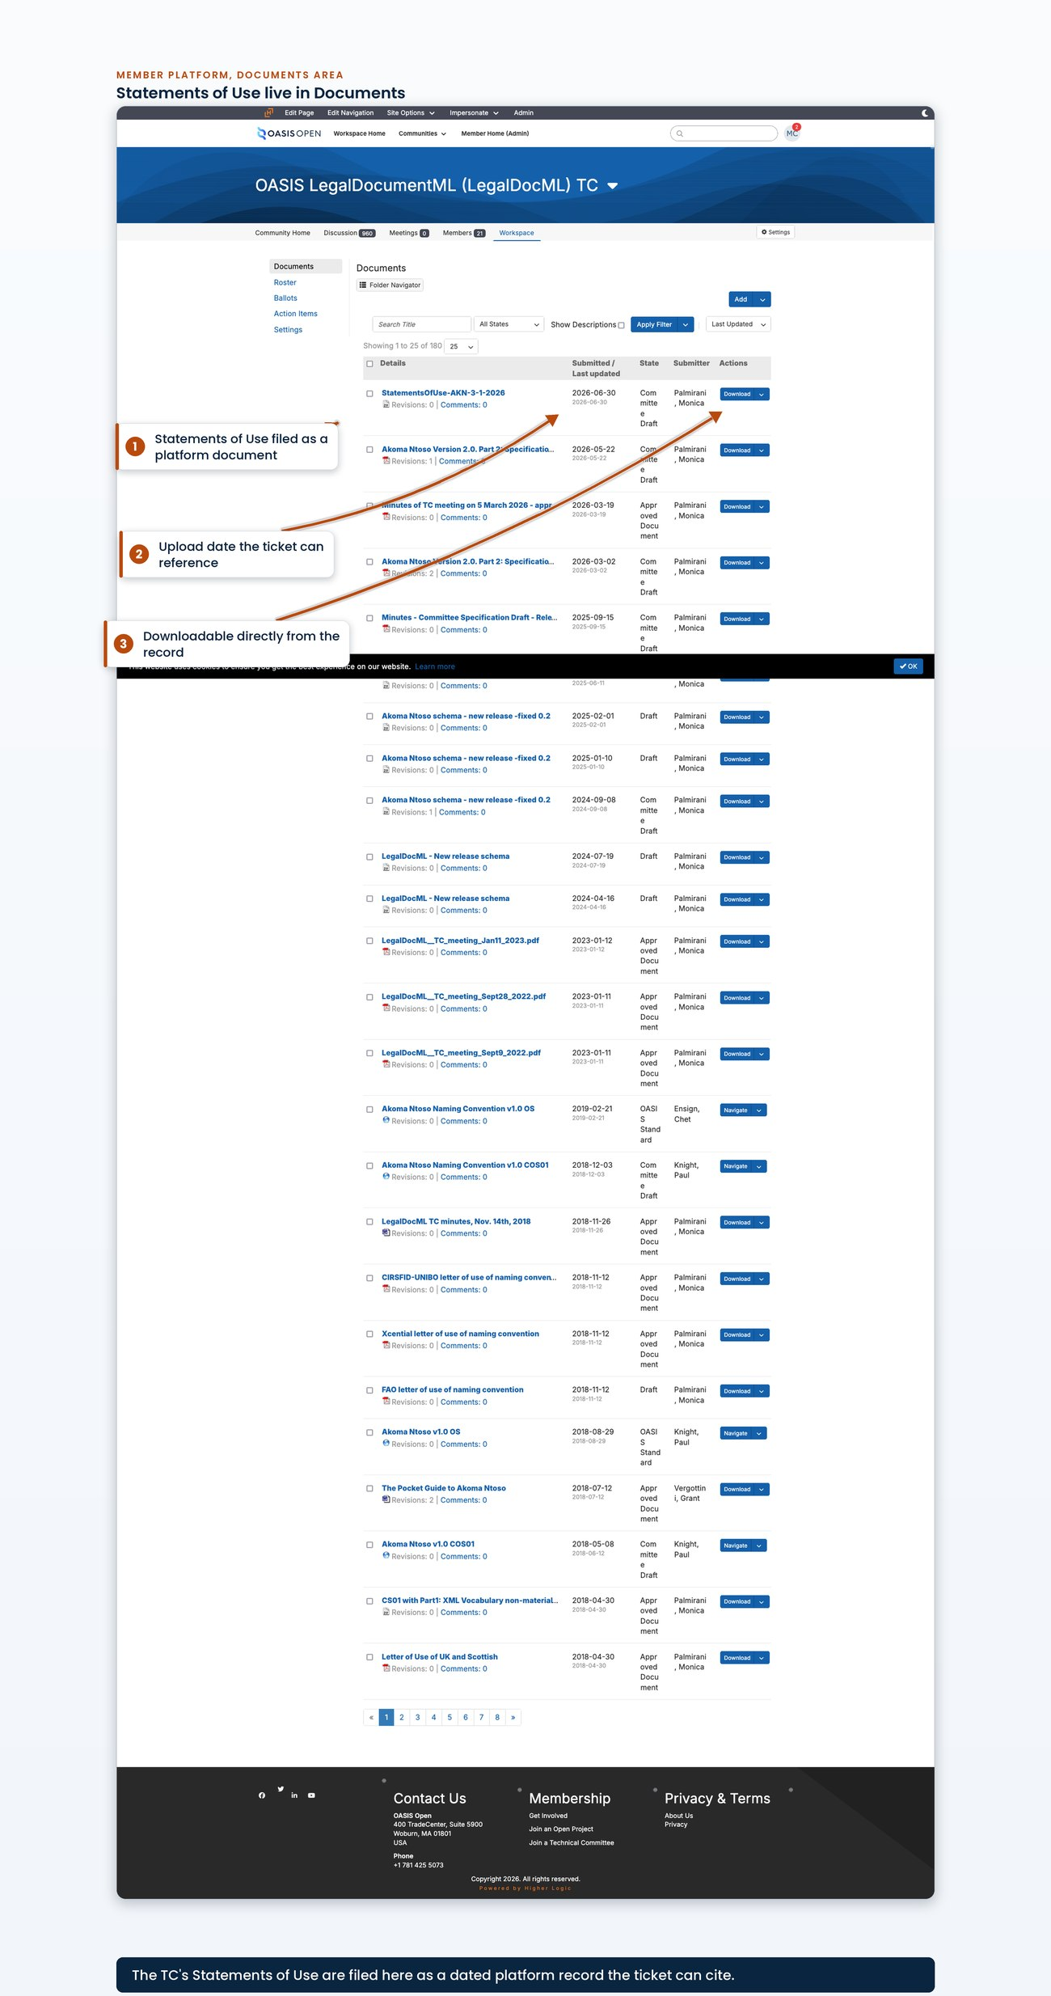
the TC's Documents area showing the Statements of Use entry with its title, its identifier and its upload date

5.5 Closing a ballot and recording the result
The platform handles the close. At the scheduled closing time it:
- flips the ballot to closed,
- locks the voting controls,
- and sends the close notification.
The ballot passes when it closes with at least the required Yes count and no more than the allowed No count. Both are measured against the N frozen at open. Record the outcome by commenting the result and the close date on the request ticket and transitioning it. Put the close day on a calendar or set a scheduled reminder. The next task in the chain starts on that day and the platform will not prompt for it.
Nothing prompts the next task
Put the close day on a calendar or set a scheduled reminder. The next task in the chain starts on that day and nothing on the platform will prompt for it.
6  roster edits inside the open voting window, 2025 board election | 4  traceable to one documented Primary Representative change | 120  closed ballots in the public archive | 93  attributed to these Technical Committees | 42  per-issue resolution votes among them
The Special Majority Vote itself carries no membership announcement. The platform has already emailed the eligible voters on open and on close. Announcements on this path come after the vote passes. If the result is questioned, the answer is in the ballot history log. The log timestamps every vote and every eligible-voter modification and attributes each to an account. It has already caught real activity: on the 2025 board election the roster was modified six times inside the open voting window, four of those traceable to one documented change of a Primary Representative.
- Owner: TC Administrator.
- System: the member platform, Ballots area, for the result and the history log; the request tracker for the record.
- Timing: the platform closes the ballot at the scheduled time with no staff action.
- Record: the result and close date commented on the request ticket; the row updated in the Google Sheet work tracker (the "TC & Docs Tracker" tab), and the activity log.
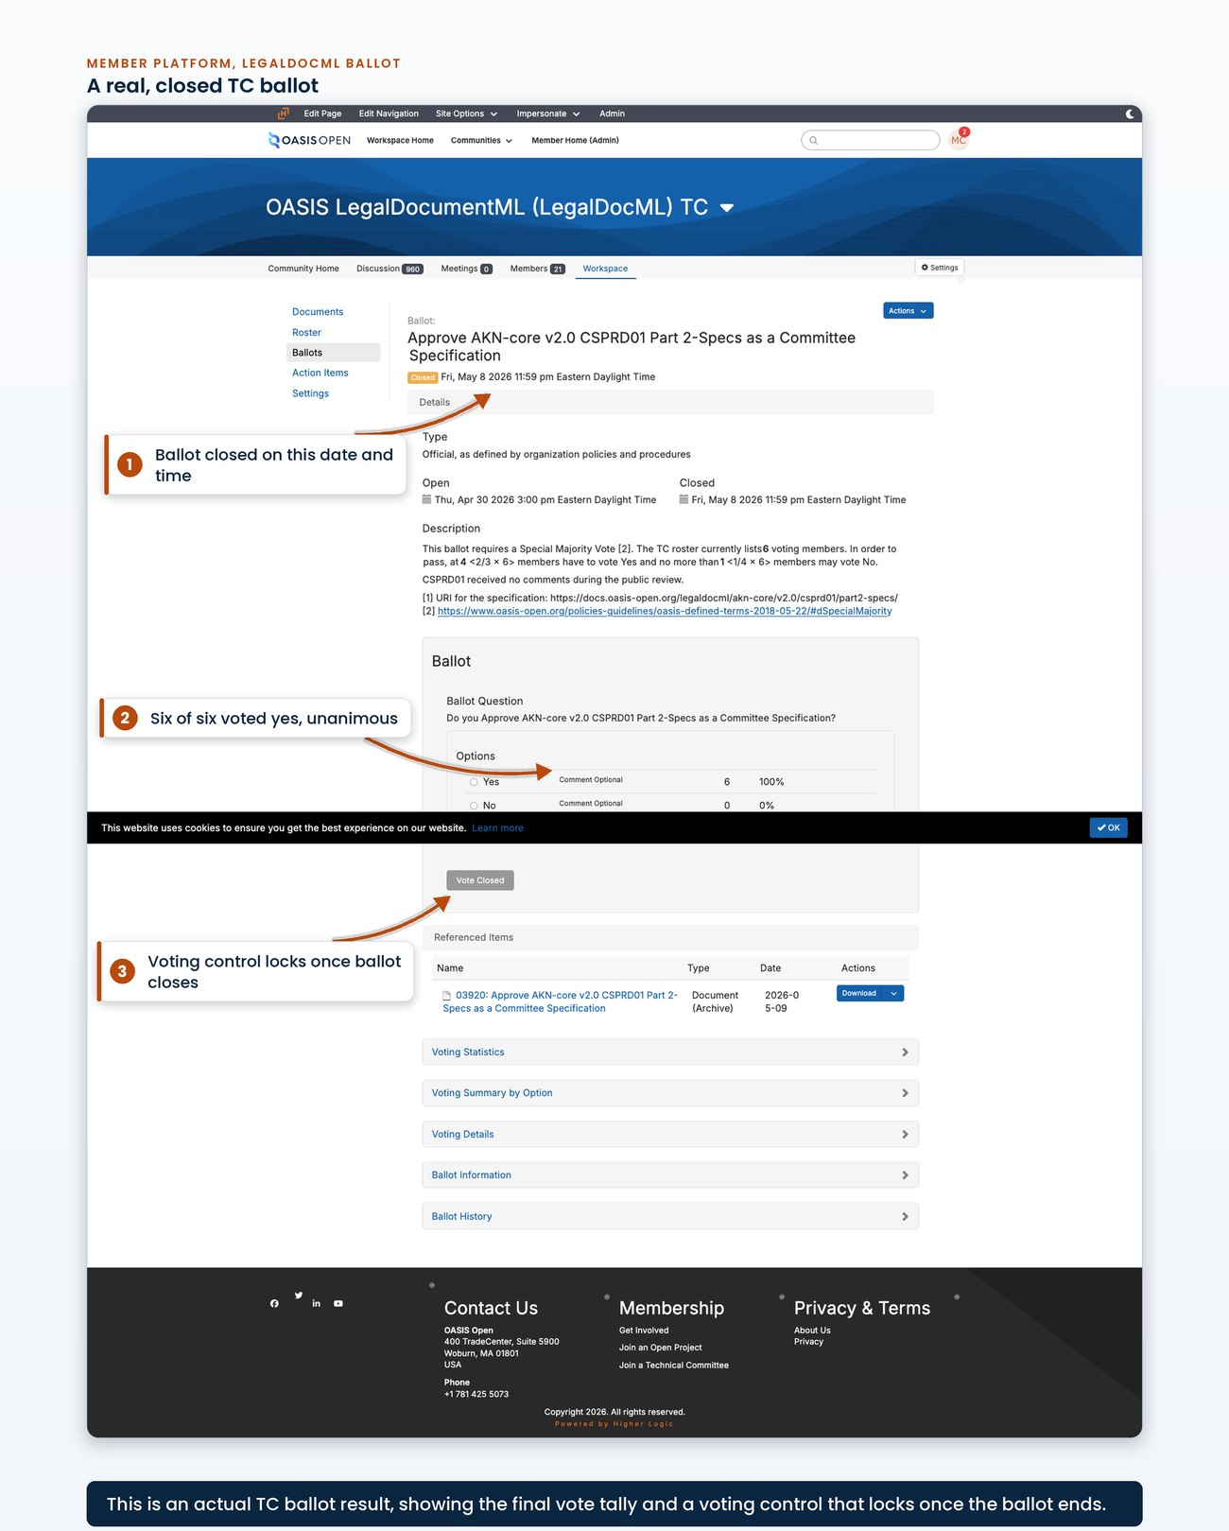
a closed TC ballot showing the per-option vote counts and the locked voting control
The ballot's history log is the audit trail that answers a disputed result.
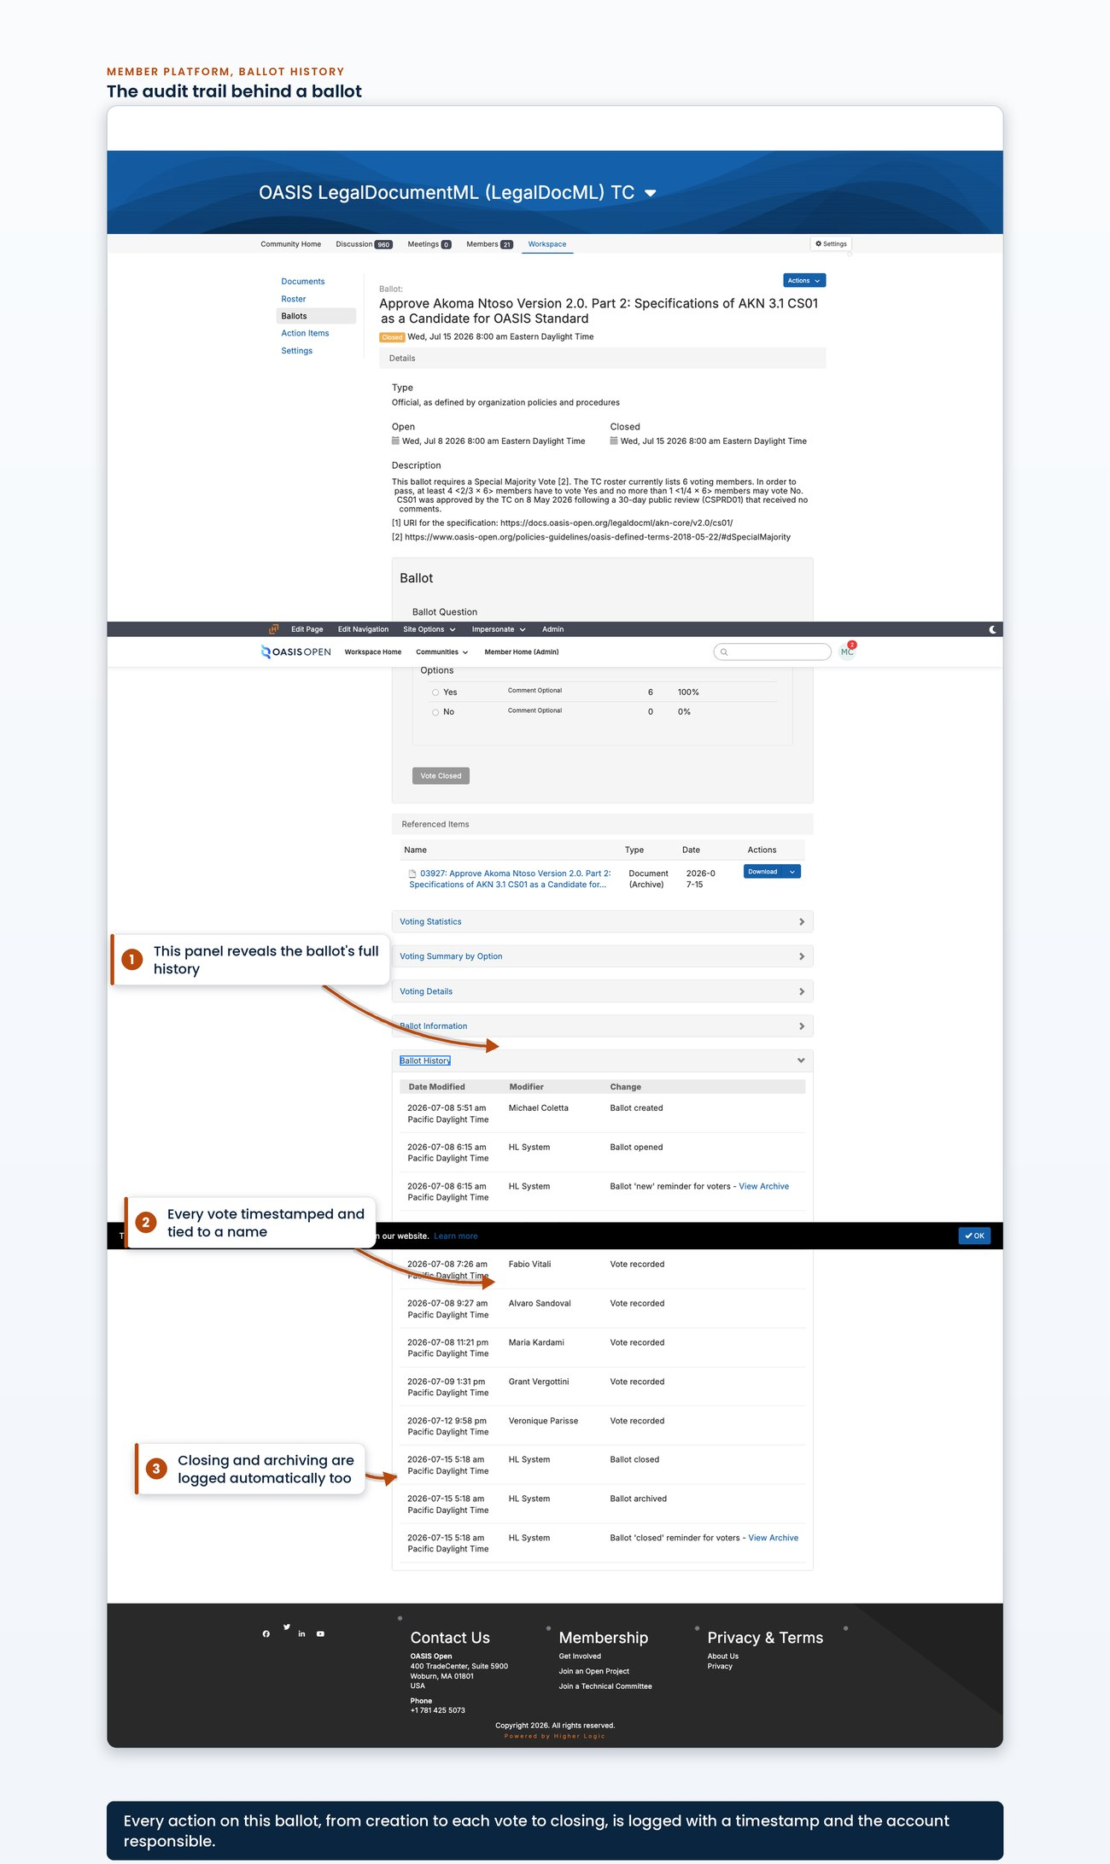
the ballot history log with timestamped vote entries and eligible-voter modification entries, each attributed to an account

5.6 From Candidate OASIS Standard to OASIS Standard
Once the ballot passes, the Committee Specification is a Candidate OASIS Standard and the submission is frozen: no part of it may be changed or altered in any way after being submitted to the TC Administrator. There is no cos stage and no Candidate OASIS Standard publication event. The candidate is the frozen Committee Specification package exactly as it was published, so the only publication event in the candidate phase is the Invitation to Comment post. The next file deployment is the OASIS Standard itself, and the os stage never carries a revision number. PKCS#11 v3.2 is the live precedent: its version directories carry csd01, cs01 and os only, and the 60-day review ran against the untouched cs01 tree.
The TC Administrator then opens the candidate review, which runs a minimum of 60 days (chapter 6 covers the opening itself). The completion date depends on what happens after the review rather than on review close plus 14 days. The chair notifies the TC Administrator of the results, with no deadline set on the chair. The TC Administrator opens the Call for Consent within 7 days of that notification; the review close date itself starts no clock. A prompt chair means the Call for Consent can open the next day. Track the chair's notification separately because it has no deadline. If any comment arrives during the candidate review, a Special Majority Ballot is required before the Call for Consent. That ballot is begun within 7 days of the chair's request, with the Call for Consent following within 7 days of that ballot passing, which adds roughly two to three weeks. The comment position therefore determines the date, and it can be confirmed in the comment facility before any date is quoted to anyone.
60 days  candidate review, minimum | no deadline  chair notifies the results | 7 days  notification to Call for Consent open | 14 days  Call for Consent, minimum | 7 days  results published after close
The task with no deadline
The chair notifies the TC Administrator of the results with no deadline set on the chair, and the TC Administrator opens the Call for Consent within 7 days of that notification; the review close date itself starts no clock. Track the chair notification separately because it controls the Call for Consent opening date.
The Call for Consent runs in the all-members voting facility to eligible OASIS Organizational Members at the time of the call and is open at least 14 days. It is opt-out: eligible members are assumed to agree to consent and must explicitly use the voting facility if they wish to record an objection. Results are publicly visible during the consent period, an eligible member may change their opinion up until the end of it, and results are published to the membership and the TC within 7 days after the close. There are three outcomes:
- With no valid objections the Committee Specification shall become an OASIS Standard the moment the Call for Consent closes.
- With 15 or more valid objections from eligible OASIS Members it is deemed rejected.
- With fewer than 15 valid objections it does not become an OASIS Standard on the close at all: the TC has 30 days to resolve them or withdraw, and gets only one attempt during the consent process to make Material changes.
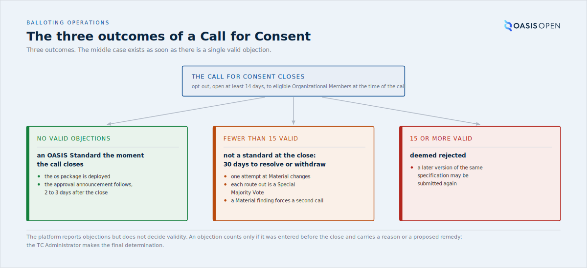
the three outcomes of a Call for Consent as a decision tree, with the follow-on work each one creates and the validity note under the tree
The third case is the one that creates follow-on work. The platform reports objections, but it does not decide validity. An objection counts only if it was entered on the ballot before it closed and carries a reason or a proposed remedy. The TC Administrator makes the final determination on whether it is valid, so the valid-objection count that decides the outcome comes from that determination rather than from the platform total. After the TC has decided how to resolve the objections it shall prepare a comment resolution log, approve it by Full Majority Vote and submit it to the TC Administrator.
The TC then has 30 days to act, and each of the three routes open to it is a Special Majority Vote:
- withdraw the submission;
- where no changes were made, ask the TC Administrator to approve the submitted Committee Specification as an OASIS Standard despite the objections;
- or submit an amended Committee Specification, asking for approval directly where the changes are Non-Material and for a second call for consent where they are Material.
The TC Administrator also decides whether changes to an amended candidate are Material or Non-Material. A Material finding requires a second call. A second call runs as the first did with two exceptions:
- A valid objection from the first call that is substantively repeated is not counted as valid for the second.
- And if Material changes are deemed necessary to satisfy valid objections to the second call, the candidate shall not become an OASIS Standard.
Failure for any reason does not prevent a later version of the same specification from being submitted again.
Two date points matter:
- The document date on the OASIS Standard is the day the Call for Consent closed with no objections, and the TC is offered an explicit override whose call wins.
- And approval is not publication: the specification is a standard the moment the Call for Consent closes clean, but the package is not on the docs site until it is deployed, so allow two to three days between the close and any announcement or press activity. Tell marketing that is what the padding is for.
Do not build a forecast from observed precedent. Measured review-close to OASIS Standard intervals were 17, 28, 29 and 56 days across four specifications, so nearly all the variance comes from the administrative gap, and a forecast built on those medians reflects other TCs' administrative delays rather than the mechanics themselves. The clean path is about 21 days.
The operating procedure records the Call for Consent as running 12 to 15 days, but the 12-day figure matches no ballot open-and-close pair on record and a 12-day window would breach the 14-day minimum that section 2.8.3 sets. Keep the range out of forecasts until A.5 settles it. [VERIFY]
Send the approval announcement with the publication as one batch, because scheduling it separately is how it gets missed.
- Owner: TC Administrator opens the Call for Consent, publishes the package and writes the approval announcement; OASIS staff post that announcement to the all-members list.
- System: the request tracker; the publishing operation for the os package; the all-members voting facility and the all-members community on the member platform.
- Permission: access to the request tracker; publishing access; posting rights on the all-members community.
- Timing: candidate review a minimum of 60 days; Call for Consent opened within 7 days of the chair's notification and open at least 14 days; results published within 7 days of close; 2 to 3 days between close and announcement.
- Record: the single request ticket carrying the chain; the published os package; the approval announcement.
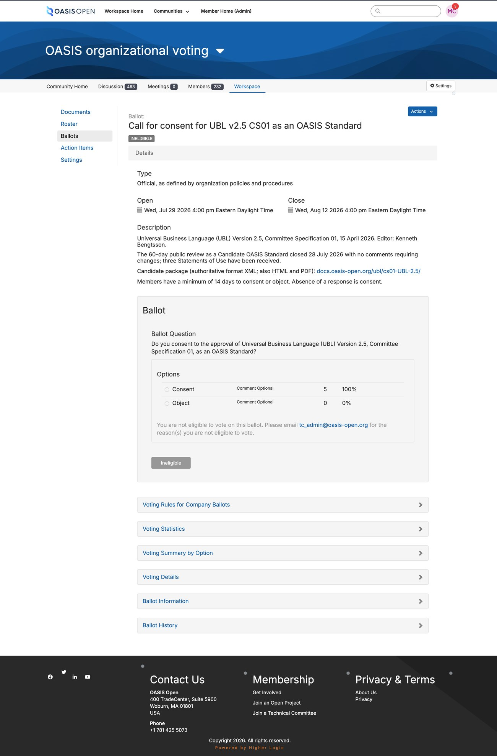
the Call for Consent ballot in the all-members voting facility, showing the opt-out wording and the objection control
The same all-members community holds the message composer used to post those announcements.
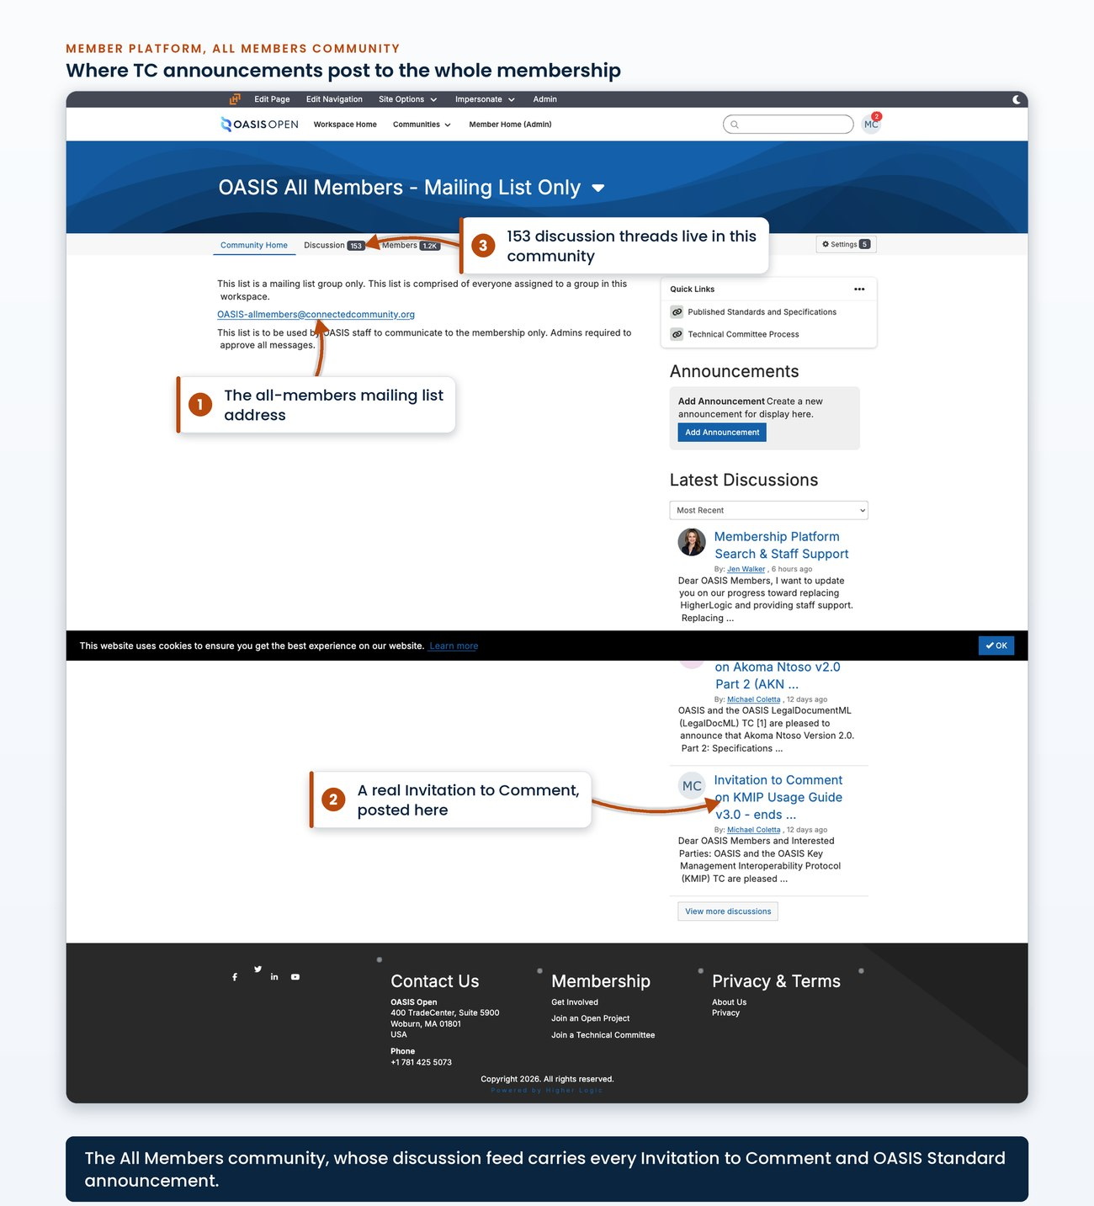
the message composer on the all-members community
A real Call for Consent announcement shows what that post looks like.
[Evidence captured in draft 0.7: a real Call for Consent announcement as posted to the all-members community]
A real OASIS Standard approval announcement is the companion posted to the membership once the Call for Consent closes clean.
[Evidence captured in draft 0.7: a real OASIS Standard approval announcement as posted to the membership]

6. Public reviews
A public review publishes a frozen document for the membership and the public for a fixed window, collects comments through channels that already exist, and requires the TC to dispose of every comment before the specification advances. The work is to publish the documents, set the window and post the announcement. The announcement opens the review and starts the clock; there is nothing else to set up.
Before posting the announcement, make sure every linked item is live and correct. The package does not change once the review is open.
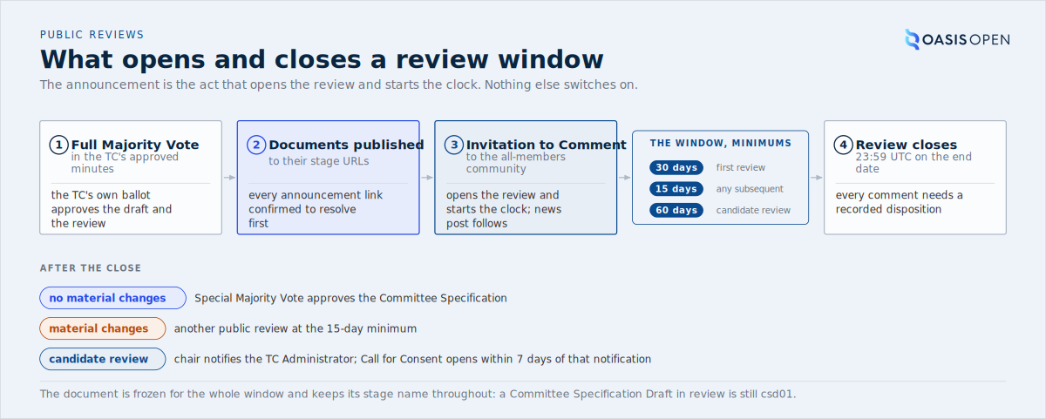
what opens a review, the three window lengths, and the three tasks that can follow the close, from the approving Full Majority Vote through the Invitation to Comment to the disposition of every comment

6.1 Review types and durations
There are three windows, set by the specification's current stage, and the document is frozen for the whole window in every case.
Review | Statutory minimum
First public review of a draft | 30 days
Any subsequent review of the same specification | 15 days
Candidate OASIS Standard review | 60 days
Count the window from the start date
The window is counted as the start date plus the minimum number of days. A review announced on 14 July for 30 days ends on 13 August at 23:59 UTC; counting the days inclusively gives 12 August and puts the review under the statutory minimum.
The document keeps its stage name throughout. A Committee Specification Draft in public review is still csd01; there is no separate public-review stage. The suffixes csprd and cnprd were removed by Naming Directives v1.7, effective 2 January 2024, along with cos, and they must not appear in the filenames, URIs or cover pages of a new publication. They remain in older published trees, which the permanence rule keeps exactly where they are. The acceptance criteria catch the retired tokens at intake.
Review | Minimum period
First public review | a minimum of 30 days
Any subsequent public review | a minimum of 15 days
Candidate OASIS Standard review | a minimum of 60 days

6.2 Opening a review
A review opens only after the TC has approved the draft and the decision to go to public review by a Full Majority Vote. That is the committee's own ballot, so confirm it is in the approved minutes. The Special Majority Vote comes later; it approves the Committee Specification after the review.
Full Majority Vote opens, Special Majority Vote closes
Confusing the ballot that opens the review with the Special Majority Vote that approves the Committee Specification after the review is the most common error in this work.
Four tasks follow, in order:
1. Publish the documents to their stage URLs through the publishing operation, and confirm every link that will appear in the announcement works before anything is posted.
2. Set the window: the start is the day of the announcement and the end is the start plus the minimum for the review type, at 23:59 UTC, with explicit times given.
3. Post the Invitation to Comment to the all-members community on the member platform, which sends it out to the membership. The TC Administrator issues it rather than the chair, and that post is what opens the review.
4. Publish a matching news post on the website; the post is the public record, and there is no standalone listing page to edit.
Do not look for an open-reviews category to apply. As of 22 July 2026:
- the website has no category with that slug at all;
- the dedicated listing URL returns not found;
- the category alias redirects to the news page with a filter the page ignores.
The four categories the filter offers are blog, press release, project news and recent post; an Invitation to Comment goes under project news. The announcement links the specific post or the news feed. The filter listing URL and the older public-reviews slug, which redirects to a 2016 post, both stay out of announcements.
The announcement includes:
- the title, version, stage and date of each document;
- links to every published format;
- the review start and end with UTC times;
- the comment routing with the statement that comments made by any other means cannot be accepted;
- the TC Administration contact address;
- the governing intellectual property policy and feedback licence with an invitation to disclose;
- the TC home page.
Review dates live in the announcement only
The review dates go in the announcement only. They never go on the specification cover.
- Owner: the TC supplies the approving Full Majority Vote; the TC Administrator issues the review.
- System: the publishing operation for the documents; the all-members community on the member platform for the Invitation to Comment; the website's news system for the listing.
- Permission: posting rights on the all-members community, author access to publish a news post under that category, and publishing access. The all-members posting right sat with a staff member who left in June 2026, so confirm it before the review opens.
- Timing: the announcement starts the clock; the window is the minimum for the review type.
- Record: the published documents; the Invitation to Comment post; the news post; the request ticket updated with review opened, the start and end dates and the link to the announcement, plus the work tracker row, the activity log and the close date on a calendar.
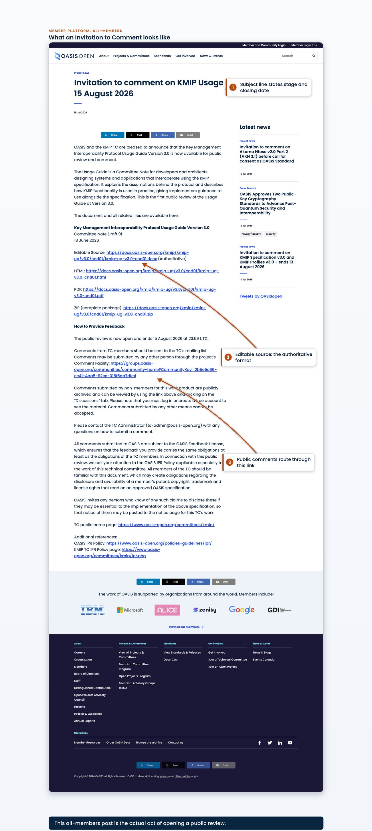
a posted Invitation to Comment on the all-members community, showing the subject line carrying the stage and the closing date, and the body's format links and comment-routing paragraph
A real 30-day Invitation to Comment as posted is available to download.
[Evidence captured in draft 0.7: a real 30-day Invitation to Comment as posted]
A second download gives an Invitation to Comment for a 60-day candidate review, which names the Call for Consent that follows.
[Evidence captured in draft 0.7: a real Invitation to Comment for a 60-day candidate review, which names the Call for Consent that follows]

6.3 Comments and the resolution log
Comments come in through the member platform, and the public has exactly one way to submit them. The legacy TC mailing lists (lists.oasis-open.org) no longer carry mail, so TC members post their comments to the TC's own Higher Logic community instead. Comments from everyone else, including the public, must be made via the TC's comment facility and shall not be accepted via any other means (TC Process 1.7, policy:public_comment_facility), and the announcement must say so in those terms. The public form that submits into the facility is the facility's own entry point; there is no second channel.
Who comments | Where they post
TC members | the TC's own Higher Logic community
Everyone else, including the public | the TC's comment facility
Announce the comment facility key
The comment facility is a separate community from the TC's own community and has a different key, so the announcement must point to the comment facility. Putting the TC community key in an announcement points the public at a place they cannot post.
Review the comment position before quoting anyone a completion date: a single comment on a candidate review forces a further ballot and moves the date by weeks.
- Read the comment facility's digest view sorted by most recently updated, and read it against the TC community, whose default scope covers subcommunities.
- Read the dates rather than the titles.
- There is no working feed and the digest view paginates, so read it page by page.
Confirm the comment route before reading zero comments as clean
Zero comments counts as a clean result only once the route is confirmed live, for example by finding a real comment that arrived through it recently. One CSD review drew zero comments because the comment form link was broken, recorded as TCADMIN-4683.
Keep the comment resolution log alongside the Work Product as comments arrive. The log records, for each comment:
- a link to the original message in the archives;
- who raised it;
- how it was resolved.
A log kept as comments arrive turns the disposition task at close into recording decisions rather than reconstructing them.
- Owner: commenters submit; the TC resolves; the TC Administrator points the channels correctly in the announcement and reads the position during the window.
- System: the TC's own Higher Logic community for members; the TC's public comment facility community for everyone else.
- Permission: administrator of the per-TC public comment facilities.
- Timing: checked before any completion date is quoted to anyone.
- Record: the comment resolution log kept alongside the Work Product.
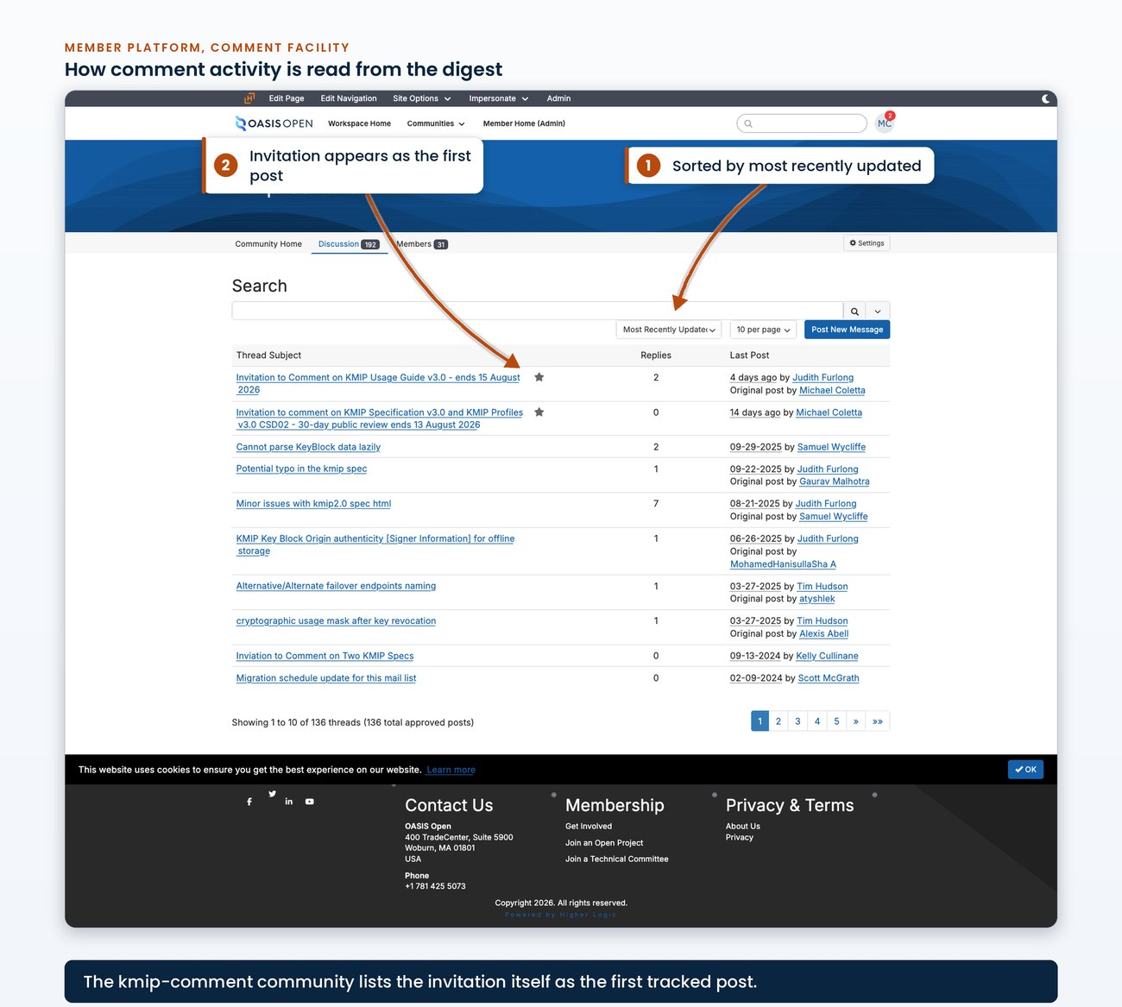
the comment facility community's digest view sorted by most recently updated, with the date column legible and the Invitation to Comment visible as a post in the sequence
The TC community's own digest view corroborates that reading, and its scope control shows that it covers the community and its subcommunities.
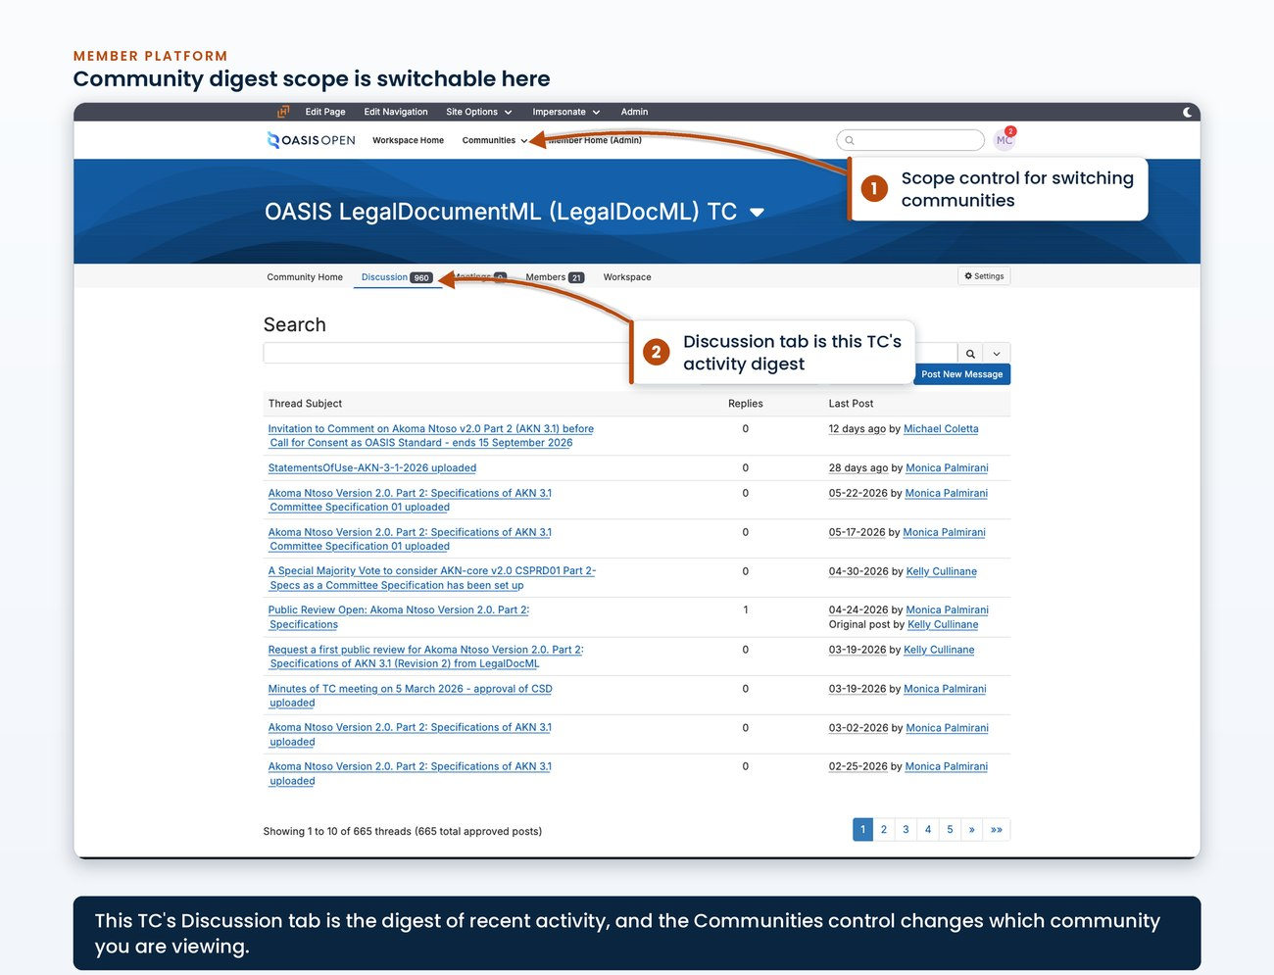
the TC community's digest view with its scope control showing that it covers the community and its subcommunities
The public reaches the comment facility through a single entry point, the form a member of the public submits through.
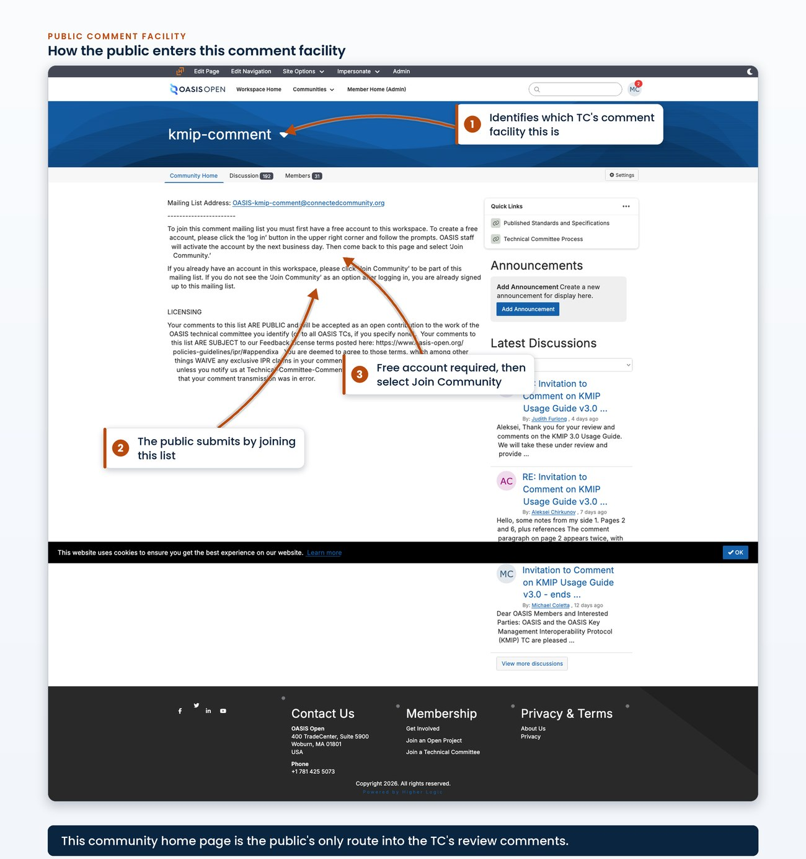
the public entry point into a TC's comment facility, the form a member of the public submits through, with the facility it posts into identifiable
The published comment resolution log from a real specification directory is available to download.
[Evidence captured in draft 0.7: a published comment resolution log from a real specification directory]

6.4 Closing a review
At the close the TC must acknowledge every comment and post a disposition for each one to the TC's own community and its comment facility community; the legacy mailing lists no longer carry mail.
Not finished until every comment has a disposition
The review is not finished until every comment has a recorded disposition.
After the review closes, the next task depends on whether it changed the document:
- If the review produced no material changes, the specification proceeds to the Special Majority Vote that approves the Committee Specification.
- If it produced material changes, the changed document goes to another public review at the 15-day minimum as the next public review draft.
A candidate review closes differently, because what follows it is the Call for Consent rather than a ballot. There the chair notifies the TC Administrator of the results and the 7-day clock to open the Call for Consent runs from that notification rather than from the review closing, so follow up for the notification. Section 5.6 sets out that chain.
Record the outcome on the request ticket, the work tracker row and the activity log, and set the follow-up date.
- Owner: the TC dispositions the comments; the TC Administrator records the outcome and starts the next task.
- System: the TC's own community and the comment facility for the dispositions; the request tracker and the work tracker for the record.
- Timing: begins the day the window closes.
- Record: the dispositions posted to both communities; the comment resolution log; the request ticket and tracker updated.

7. Communications
Every operation in chapters 4 and 5 ends with a public announcement. This chapter covers where each announcement is posted, what one looks like, who is copied, and where the result appears on the public website.

7.1 Announcement channels and who is copied
Three announcements go out on the path from Committee Specification to OASIS Standard, and all three follow the Special Majority Vote rather than preceding it:
- The Invitation to Comment that opens the candidate review.
- The Call for Consent announcement.
- The OASIS Standard approval announcement.
The vote itself carries no membership announcement, because the member platform emails the eligible voters when a ballot opens and again when it closes. A public review opened under chapter 6 uses the same Invitation to Comment, and there the announcement is the act that opens the review and starts the clock.
Each of the three has a fixed destination:
- The Invitation to Comment is posted to the all-members community on the member platform and published again as a news post on the public website.
- The Call for Consent runs in the all-members voting facility as an opt-out ballot in which each eligible OASIS Organizational Member at the time of the call is entitled to express consent, and it is announced to the same all-members community. Results of the Call for Consent are published to the membership and the TC within 7 days after it closes.
- The OASIS Standard approval announcement is written by the TC Administrator and posted to the all-members list by OASIS staff, alongside the deploy of the os package.
Distribution method affects whether an announcement reaches members. Distribute member-wide through the community's web interface rather than by mailing it from the OASIS mailbox (Google Workspace), because a post submitted by email is silently dropped when the sender is not subscribed to that community. The legacy mailing-list host (lists.oasis-open.org) that used to carry TC and comment traffic is unreachable, and mail sent to it fails silently for roughly two days before bouncing, so an announcement sent that way appears to have gone out until the bounce arrives.
The distribution route
Distribute through the community's web interface only. A post submitted by email is silently dropped when the sender is not subscribed to that community, and mail to the retired list host fails silently for roughly two days before bouncing, so both failures appear successful before they show.
Every public news post copies the marketing communications lead and the Chief Operating Officer. Where a notification is already going out, such as the note telling a chair a ballot has closed, the copy goes in that message rather than arriving separately.
- Owner: TC Administrator
- System: the member platform, all-members community discussion; the all-members voting facility for the Call for Consent
- Permission: posting rights on the all-members community
- Timing: the post is live immediately and fans out to members from there; the Call for Consent is open at least 14 days
- Record: the community post and its URL, recorded on the request ticket
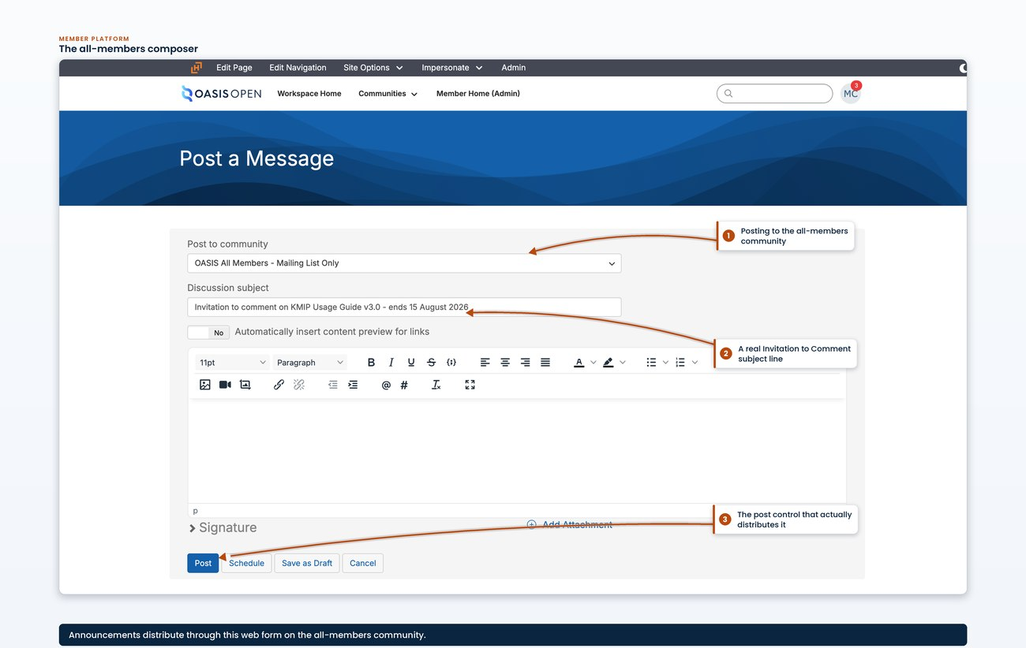
the Post a Message composer on the all-members community, the community selector reading OASIS All Members, the subject field filled with a real Invitation to Comment subject line, and the Post control in frame, captured without the address bar so no community key appears
Once posted, the Invitation to Comment appears in the all-members community discussion with its title, posting date, author, and the first screen of the body.
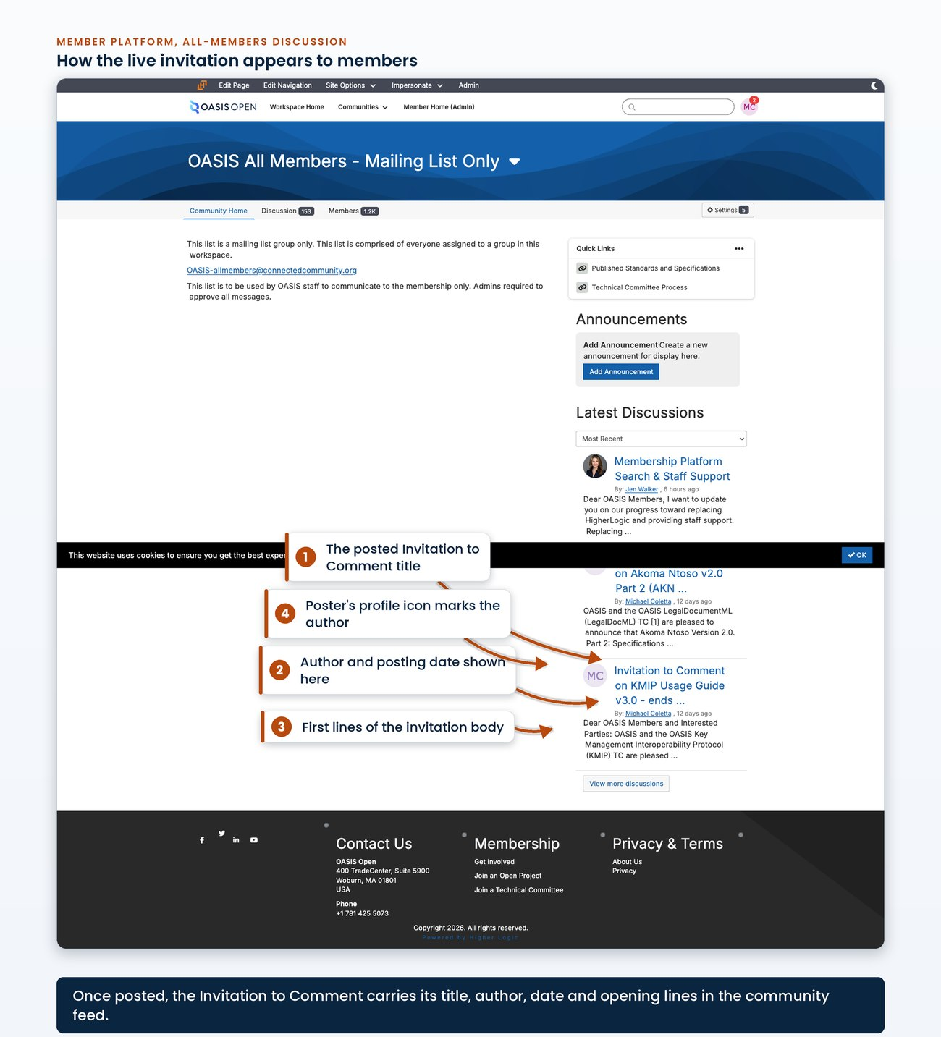
the posted Invitation to Comment as it appears in the all-members community discussion, showing the post title, the posting date, the author, and the first screen of the body including the labelled document links

7.2 News posts on the website
The public face of all of this is the news feed on the OASIS website (WordPress, https://www.oasis-open.org). Announcements appear there as ordinary dated posts under www.oasis-open.org/news/, in reverse date order, alongside press releases and blog entries. The news post is the review's public listing: publish it, categorise it, and link it.
The feed offers four categories: blog, press release, project news and recent post. An Invitation to Comment is filed under project news; an approval or launch is a press release. When an announcement elsewhere needs to point a reader at the website, link either the general news feed or the specific post itself. Those are the two stable link targets.
An Invitation to Comment post reads the same way whether it is on the member platform or the website. The title names the specification, its version and the closing date. The body follows a fixed structure:
- opens with the TC and OASIS jointly announcing the review;
- one paragraph of TC-supplied description;
- a labelled link block giving the editable source marked authoritative, the HTML, the PDF and the complete package as separate lines;
- the review window with opening and closing times in UTC;
- the comment routing;
- the IPR policy references;
- the TC home page link.
The approval announcement follows a different structure, covered in 7.3. Live examples of both are on the feed: the KMIP Usage Guide v3.0 invitation posted 16 July 2026, and the two-standard PKCS#11 approval posted 15 July 2026, which carried the Specification and the Profiles at version 3.2 together.
Every post states the comment routing, and the wording follows the TC Process:
- TC members comment on the TC's own discussion list;
- everyone else uses the public comment facility;
- comments submitted by any other means cannot be accepted.
The comment facility is separate
The comment facility is a separate community from the TC's own community and has its own key, which is the detail most often got wrong.
- Owner: TC Administrator drafts and publishes; the marketing communications lead edits or reposts
- System: the public website's content management system
- Permission: author access to the content management system
- Timing: same day, from draft to published post
- Record: the published post URL, circulated to the marketing communications lead and the COO
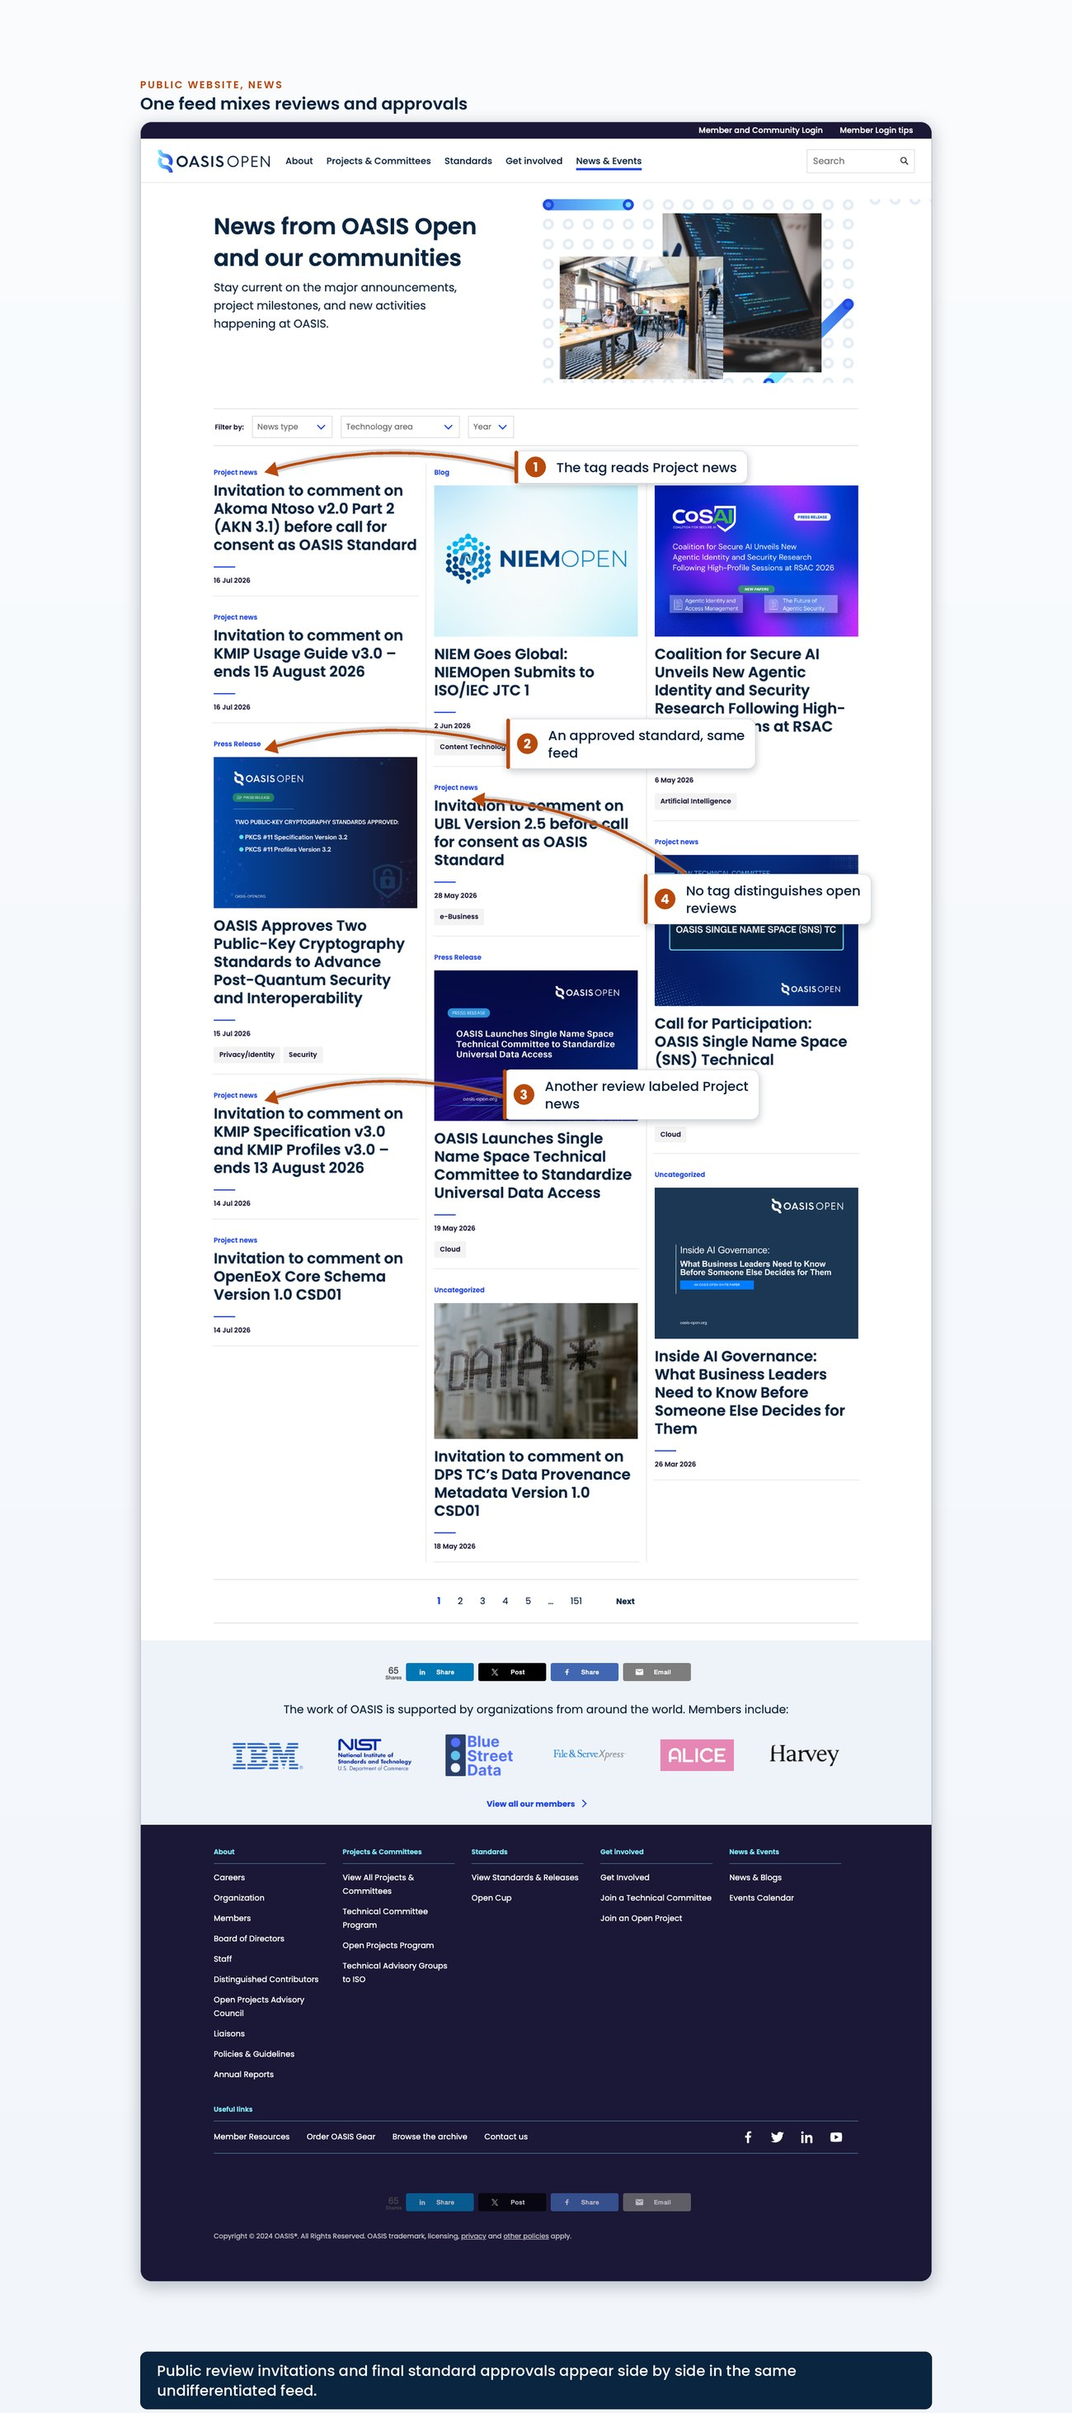
the public news index showing at least four consecutive posts in date order, with at least one Invitation to Comment and one approval announcement visible together, and each post's category label showing
One complete Invitation to Comment post is the worked example of the format described above, with its title, date, category label, the four labelled document links and the comment-routing paragraph all readable.
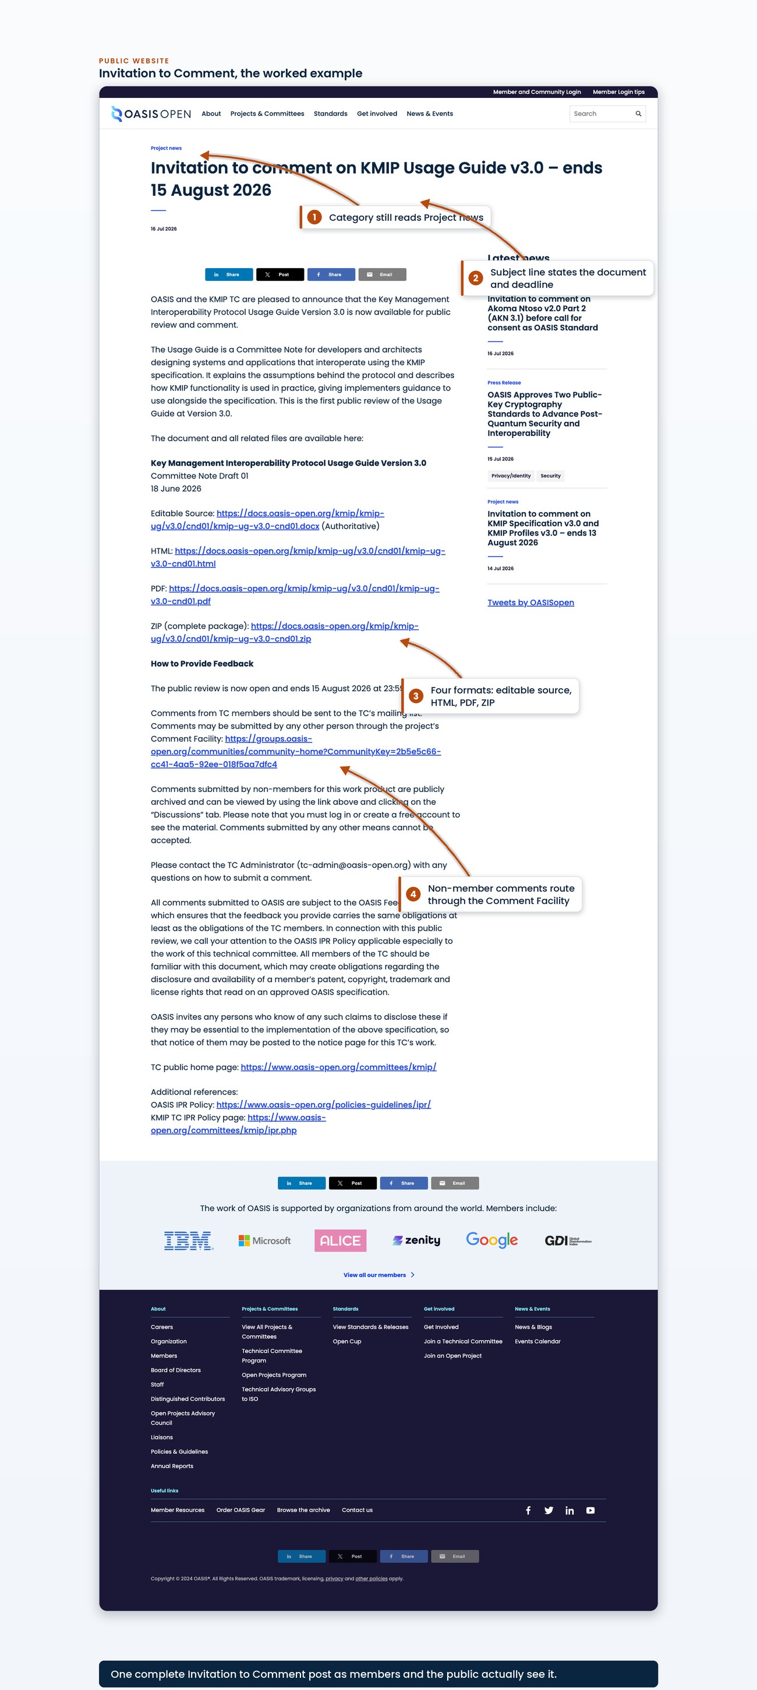
one complete Invitation to Comment post, scrolled or stitched so the title, date, category label, the four labelled document links and the comment-routing paragraph are all readable in a single image
The category itself is set in the news post editor, where the category panel lists the four selectable categories.
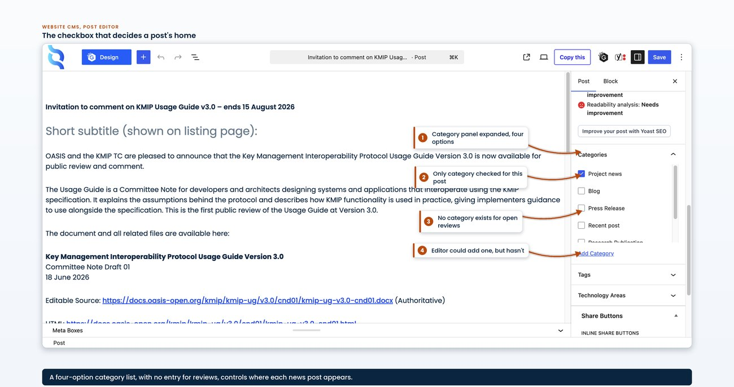
the news post editor with the category panel expanded, showing the four selectable categories and project news ticked
The reusable Invitation to Comment template, with its placeholders intact, is available to download.
[Evidence captured in draft 0.7: the reusable Invitation to Comment template with its placeholders intact]

7.3 Announcing and promoting a finished publication
When a Committee Specification or an OASIS Standard is finished, its public announcement follows a fixed sequence. The order exists for one reason: nothing is announced before the thing it announces is deployed and live.
1. Deploy and confirm it is live first. The package is published to docs.oasis-open.org and confirmed live, and staff compare the deployed files with the approved package before any announcement is drafted. A specification is an OASIS Standard the moment the Call for Consent closes clean, but it is not on the docs site until it is deployed.
2. Announce to the membership. The approval announcement is posted to the all-members community on the member platform, naming the specification, its version and its OASIS Standard date, a one-line description of the TC, a plain-language paragraph of what the version adds, the Statements of Use named by organisation, and a link block to every published artifact, the authoritative source, the HTML, the PDF and the complete package, on docs.oasis-open.org.
3. Post to the public website. A dated news post goes up on the OASIS website under the project news category, in the register described below.
4. Release and amplify where the work warrants it. For a marquee standard the marketing communications lead schedules a press release and supplies the link and the social posts for the TC and its members to amplify, two to three days after the membership announcement.
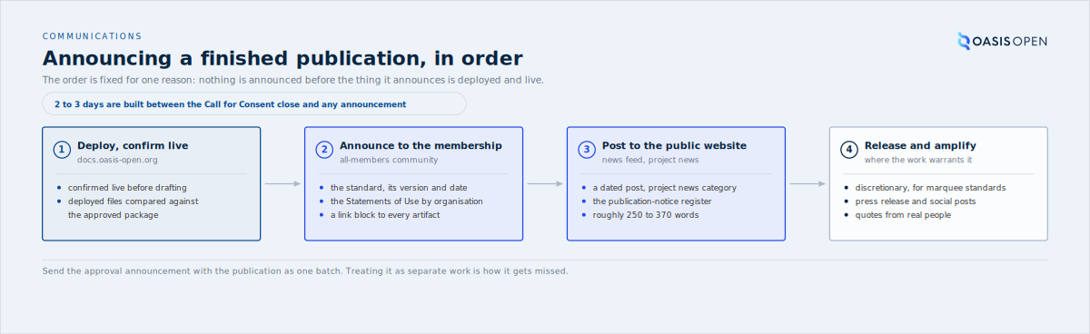
the four stages of announcing a finished publication in their fixed order, deploy first, with the 2-to-3-day pad between the Call for Consent close and any announcement
The worked example is PKCS#11. PKCS#11 Specification Version 3.2 and Profiles Version 3.2 became OASIS Standards on 3 June 2026 when the Call for Consent closed with no objections; the all-members announcement went out on 13 July 2026 and the public news post and press release followed on 15 July 2026, once the packages were confirmed live.
The register is chosen deliberately for each standard.
Register | Length | Contents
Default publication notice | roughly 250 to 370 words | the approval date, the TC's own description of itself, one substantive overview paragraph saying what the version adds, the Statements of Use named by organisation, the labelled document links and a fixed closing congratulation to the TC
Full press release | 800 to 1800 words | a significance paragraph and quotes from the chair and named member companies
The press release is discretionary and reserved for marquee standards, and its quotes are solicited from real people rather than written on their behalf.
Coordination beyond the sequence above is limited. The marketing communications lead issues the membership announcement, schedules the press release and edits or reposts the news posts, and the TC chair is given advance notice and confirms the release timing. Beyond the copy rule in 7.1, which copies the marketing communications lead and the COO on every public news post, and the shared drafting of news posts in 7.2, no formal press sign-off is recorded. [VERIFY] Until one is documented, the copy practice in 7.1 is the only coordination step for any release-day announcement.
The operation's dates come from deployment records, not the approval date, so a press release pinned to the approval date points at a page that is not deployed yet. Two to three days of padding sit between the Call for Consent close and any announcement. Do not quote the 12 to 15 day Call for Consent figure to marketing until 5.6 and A.5 settle it. [VERIFY]
On a clean Call for Consent the package is published and the approval announcement is sent to the membership as one batch. Treating the announcement as separate work increases the chance it is missed: PKCS#11 Specification Version 3.2 and Profiles Version 3.2 became OASIS Standards on 3 June 2026 when the Call for Consent closed with no objections, but the approval announcement to the membership was not sent at the time; it went out on 13 to 15 July 2026, roughly six weeks later, folded into the next batch. That gap is the reason the announcement is treated as part of the publication and not scheduled separately.
- Owner: TC Administrator writes the announcement; OASIS staff post it to the all-members list; the marketing communications lead handles press
- System: the all-members community, plus the website news feed
- Permission: as 7.1 and 7.2
- Timing: 2 to 3 days between Call for Consent close and any announcement or press activity
- Record: the all-members post and the news post, both referenced from the ticket
One real OASIS Standard approval announcement as posted to the membership is available to download in full.
[Evidence captured in draft 0.7: one real OASIS Standard approval announcement as posted to the membership, in full]

7.4 The announcement types on the public record
The publication and review announcements in 7.1 to 7.3 are the ones this operation writes, but they are a subset of what appears on the public feed. The TC Administrator scanning the news feed will find at least eight recurring announcement types across the two years to July 2026. Each uses one of the four post categories: an approval or a launch is a press release, a review or a Committee Specification is project news. The examples below are real dated posts, none of them the PKCS#11 approval used as the worked example in 7.3.
Announcement type | What puts it on the feed | A real example, 2024 to 2026
OASIS Standard approval | a Call for Consent closes clean and the os package is deployed | OASIS approves ODF v1.4, 3 December 2025; TOSCA v2.0, 9 September 2025
ISO/IEC submission or approval | a standard enters or clears the ISO/IEC JTC 1 route | CSAF v2.0 approved as an ISO/IEC International Standard, 20 May 2025; NIEMOpen submits to ISO/IEC JTC 1, 2 June 2026
Committee Specification approval | a TC approves a Work Product as a Committee Specification | CACAO Layout Extension v1.0, 7 June 2024
Public-review Invitation to Comment | a review opens and starts the clock | OpenDocument v1.4 before call for consent, 7 July 2025; XLIFF v2.2 CSD01, 9 September 2024
New TC launch and Call for Participation | a new Technical Committee forms | Single Name Space TC, 19 May 2026; OEMF, 30 October 2025
Milestone or anniversary | a standard reaches a landmark | CAP 20th anniversary, 7 October 2024
Governance election | the membership elects the Board of Directors | Board election, 24 June 2024
Recognition or award | a contributor or project is honoured | Distinguished Contributor Award, 15 August 2025
An Open Project announcement is not a TC announcement
The feed also carries Open Project news, which runs on a different cadence: sponsor and contribution posts rather than the review-ballot-publish rhythm of a TC. The Coalition for Secure AI is the running example, from its launch on 18 July 2024 through recurring sponsor and donation posts. Do not read an Open Project's cadence as a TC's, or apply a TC announcement task to it.
The point here is recognition. Most of these types are written by other people, but the TC Administrator reading the feed has to tell an OASIS Standard approval from a Committee Specification approval from a public-review invitation at a glance, because only the publication and review types in 7.1 to 7.3 start a clock this operation is accountable for.

7.5 Templates for the announcement at each stage
Four announcements go out on the path from a draft to an OASIS Standard, each with a reusable template, and a fifth template covers the Committee Specification approval that sits off that path. The ballot itself sends none: the member platform emails the eligible voters on open and on close, so there is no ballot-open announcement to write. The templates below are the working copy, reduced to placeholders in [SQUARE BRACKETS]. Fill every placeholder, and confirm every link works before posting, because a dead link in an announcement is a credibility defect on the public record.
The four path templates go out in this order:
1. Public-review Invitation to Comment opens a first or subsequent review.
2. Candidate-review Invitation to Comment opens the 60-day review after the Special Majority Vote.
3. Call for Consent announcement opens the opt-out consent process.
4. OASIS Standard approval announcement goes out with the deploy of the os package.
The Special Majority Vote's own ballot text is not an announcement but it is a template too, and it lives with the ballot mechanics in 5.3. The request-ticket body that precedes a vote is in 5.3 as well.
1. Public-review Invitation to Comment. Posted to the all-members community and published as an open-reviews news post. The announcement is the act that opens the review and starts the clock.
Subject: Invitation to Comment on [SPEC SHORT] [VERSION] - ends [END DATE]

Dear OASIS Members and Interested Parties:

OASIS and the [TC FULL NAME] are pleased to announce that [SPEC TITLE] [VERSION]
is now available for public review and comment.

[ONE PARAGRAPH TC-SUPPLIED DESCRIPTION]

The documents and all related files are available here:

[SPEC TITLE] [VERSION] - [STAGE LONG], [DOC DATE]
- Editable Source (Authoritative): [DOCX URL]
- HTML: [HTML URL]
- PDF: [PDF URL]
- ZIP (complete package): [ZIP URL]

How to Provide Feedback
The public review starts [START DATE] at 00:00 UTC and ends [END DATE] at 23:59 UTC.
Comments from TC members should be sent to the TC's mailing list. Comments may be
submitted by any other person through the project's Comment Facility:
[COMMENT FACILITY URL]. Comments submitted by any other means cannot be accepted.
Please contact the TC Administrator (tc-admin@oasis-open.org) with any questions.

All comments are subject to the OASIS Feedback License. We call your attention to the
OASIS IPR Policy [1] applicable especially [2] to the work of this technical committee.

TC public home page: [TC HOME URL]
[1] https://www.oasis-open.org/policies-guidelines/ipr/
[2] [TC IPR URL]
2. Candidate-review Invitation to Comment. The 60-day review of a Candidate OASIS Standard, posted the same two ways. Same structure as template 1 with the candidate framing.
Subject: Invitation to comment on [SPEC TITLE] [CS-STAGE] before call for consent
as OASIS Standard

OASIS and the [TC NAME] TC are pleased to announce a 60-day public review of the
above Candidate OASIS Standard.

Review period: [START] through [END] (minimum 60 days; give UTC times)
Specification and review materials:
[candidate stage dir URL: docx (Authoritative) / html / pdf / zip]
Comment routing:
- TC members: the [TC] general mailing list.
- Non-members: the public Comment Facility ONLY. Comments submitted via any
other channel shall not be accepted.
Comment Facility: [comment-facility community URL]
IPR: governed by the OASIS IPR Policy
(https://www.oasis-open.org/policies-guidelines/ipr/) and the Feedback License.
TC home page: https://www.oasis-open.org/committees/[tc]/
Contact: tc-admin@oasis-open.org
3. Call for Consent announcement. Posted to the all-members community when the consent ballot opens in the all-members voting facility. Its essential content is the opt-out instruction: silence is consent, so an objection is the only action.
Subject: Call for Consent: [SPEC TITLE] [VERSION] as an OASIS Standard

OASIS Members,

The [TC NAME] has requested that [SPEC TITLE] [VERSION] (Candidate OASIS Standard,
[CANDIDATE STAGE URL]) be approved as an OASIS Standard. A Call for Consent is now open.

This is an opt-out consent process. Each eligible OASIS Organizational Member at the
time of this call is assumed to consent. To record an objection you must use the voting
facility before the call closes; an objection must carry a reason or a proposed remedy.

Voting facility: [CALL FOR CONSENT BALLOT URL]
Open: [START DATE] 00:00 UTC Close: [END DATE] 23:59 UTC (minimum 14 days)

Specification and complete package:
[candidate stage dir URL: docx (Authoritative) / html / pdf / zip]

Results are published to the membership and the TC within 7 days after the call closes.
Questions to the TC Administrator (tc-admin@oasis-open.org).
4. OASIS Standard approval announcement. The house default is the publication-notice register: a fixed opening formula, the TC's own description of itself, one overview paragraph of what the version adds, the Statements of Use named by organisation, labelled links, and a closing congratulation. This is the real PKCS#11 v3.2 copy reduced to placeholders, and it is written for a single standard. Where one ballot approves two standards together, as the PKCS#11 Specification and Profiles were, pluralise the opening line and repeat the title block and the link block once per standard.
Subject: [OASIS Standard(s) Approved: SPEC TITLE(S) VERSION]

OASIS Members and other interested parties,

OASIS is pleased to announce the publication of its newest OASIS Standard, approved by
the members on [APPROVAL DATE]:

[SPEC TITLE] [VERSION]
OASIS Standard
[APPROVAL DATE]

[ONE PARAGRAPH: the TC's own description of what it develops]

[ONE PARAGRAPH: what this version adds, in plain language]

The TC received [N] Statements of Use from [ORG 1], [ORG 2], and [ORG 3].

The documents and all related files are available here:

[SPEC TITLE] [VERSION], OASIS Standard, [APPROVAL DATE]
Editable source (Authoritative): [DOCX URL]
HTML: [HTML URL]
PDF: [PDF URL]
ZIP of the complete set of files: [ZIP URL]

Our congratulations to the members of the [TC FULL NAME] on achieving this milestone.
5. Committee Specification approval announcement. Not every announcement concerns an OASIS Standard. When a TC approves a Work Product as a Committee Specification, the announcement uses the project-news register rather than the press register, and it is shorter than the OASIS Standard notice: there are no Statements of Use to name, because a Committee Specification is not a Candidate for OASIS Standard yet. The DMLex and CACAO Committee Specification posts in 7.4 are the model.
Subject: [SPEC TITLE] [VERSION] is now an OASIS Committee Specification

OASIS Members and interested parties,

The [TC FULL NAME] has approved [SPEC TITLE] [VERSION] as an OASIS Committee
Specification, [APPROVAL DATE].

[ONE PARAGRAPH: what the TC develops and what this Work Product is]

A Committee Specification is a stable, TC-approved deliverable. It may later be
submitted as a Candidate for OASIS Standard once Statements of Use are in hand.

The documents and all related files are available here:

[SPEC TITLE] [VERSION], Committee Specification [NN], [APPROVAL DATE]
Editable source (Authoritative): [DOCX URL]
HTML: [HTML URL]
PDF: [PDF URL]
ZIP of the complete set of files: [ZIP URL]

Our thanks to the members of the [TC FULL NAME].
These are working templates. A TC that has published before has a house phrasing of its own, so compare each template with the TC's most recent post in the same class before reusing it; the 7.4 examples span several TCs on purpose.
Fill the placeholders, then confirm every link
Every template ships with placeholders in square brackets and a link block. Fill each placeholder against the request and the deployed package, and confirm every link works before posting, because the announcement is the public record and a dead link in it is a defect other documents inherit.
- Owner: TC Administrator drafts each announcement; OASIS staff post it to the all-members community.
- System: the member platform, all-members community and voting facility; the public website for the news post.
- Record: the posted announcement and its URL, recorded on the request ticket.
[Evidence captured in draft 0.7: the four announcement templates plus the ballot and request-ticket templates as one fillable file]

7.6 Where a committee actually meets and talks
Every channel in this chapter is one OASIS controls. The committees' own conversation mostly is not. No committee meets on the member platform: the calendar books the meeting and the minutes are filed back to the workspace afterwards, but the call itself runs on tools the chairs bring. In the March 2024 to July 2026 record:
Committee | Meeting venue
DITA, LegalXML Court Filing, LVCSP | chairs' Zoom accounts
OData, LegalDocML | Microsoft Teams
OpenC2 | Lucid Meetings, attendance recorded on the platform by RSVP
ODF | Jitsi
TOSCA | Discord as a community channel
SARIF | external poll tools for votes
Two consequences follow for the person doing this chapter's work:
1. A meeting link belongs to the chair. Joining or observing a TC call goes through the chair, and a change of chair can change the meeting venue with no trace in any OASIS system beyond the next calendar entry.
2. Comment routing can record a review as comment-free when it was not. LVCSP closed a public review with zero formal comments while real comments arrived by private email, because the platform comment route was not the one members actually used. When a review closes with nothing in the comment facility, confirm with the chair that nothing arrived by another route before recording the review as comment-free.
Platform friction is on the record in the committees' own minutes: KMIP, OpenC2, ODF, OData, DITA and SAM all document it, and OpenC2's minutes assessed the member platform at about 80 percent feature complete at the migration. Read that as context when a chair reports that a message did not reach members: the complaint has documented precedent, so check the routing before assuming the sender erred.
- Owner: the chairs own their meeting venues; the TC Administrator owns the platform side of the record
- System: the member platform for the calendar, minutes and comment facility; the chairs' own tools for the meetings themselves
- Permission: none on the chairs' own tools; the platform-side rights are in 8.2
- Record: the minutes filed to the workspace, which are where the meeting venue and any platform friction are documented

8. Systems and access

8.1 The system map
The operation runs across seven systems, and none of them holds the whole record:
- **The member platform (Higher Logic, in use since March 2024)** is where committees live: the community discussions that carry announcements and comments, the ballots, the roster that supplies the eligible-voter count, and the document portal through which a TC editor delivers a finished package.
- **The request tracker (Atlassian Jira, project key TCADMIN, at https://issues.oasis-open.org)** holds one ticket per request and is the record of what was asked and what was returned.
- The internal publishing repositories hold the artifacts and are the authoritative record of what is deployed; a TC never touches them, because editors deliver through the document portal or by email and staff move the package in.
- The public website (WordPress) with its content management system carries the news feed and the pages a member reads before making a request.
- Mail, the OASIS mailbox (Google Workspace) is where TC-facing correspondence is staged and sent.
- Publication runs through four layers rather than one. The rendered package moves through them in order, every time.
The four layers, in order:
1. The rendered package is copied to the origin server.
2. It is synced to the object store behind the content delivery network.
3. The delivery network distribution is invalidated.
4. The domain and cache layer above it is purged by path prefix.
The fan-out is by hand
The publisher's two deploy steps that once automated part of that chain no longer run, so the fan-out is done by hand.
The legacy mailing-list host that used to sit alongside mail is unreachable and nothing routes through it.
That is the staff side of the map. The committees sort by where their work actually lives, which tells the administrator which system a request belongs in:
Where the committee works | Committees | Where its record lives
The member platform itself | 14 | the platform
A mixed model | 10 | governance on the platform, specification text on GitHub
GitHub-native | 7 | GitHub, with the platform used for governance alone
No member-platform community | 6 (CES, DPS, OEMF, OSIM, SATIS, SNS) | GitHub or a microsite
Dormant or thin | 15 | the archive
The drafting layer for every GitHub-native and mixed committee is the oasis-tcs organisation, and the meeting layer sits outside every system on this map, on the chairs' own tools (7.6 records it).
Each of these systems has a member-facing view and an administrative view, and the two look nothing alike. Sections 8.2 and 8.3 are written from the administrative side, because that is the side the TC Administrator inherits.
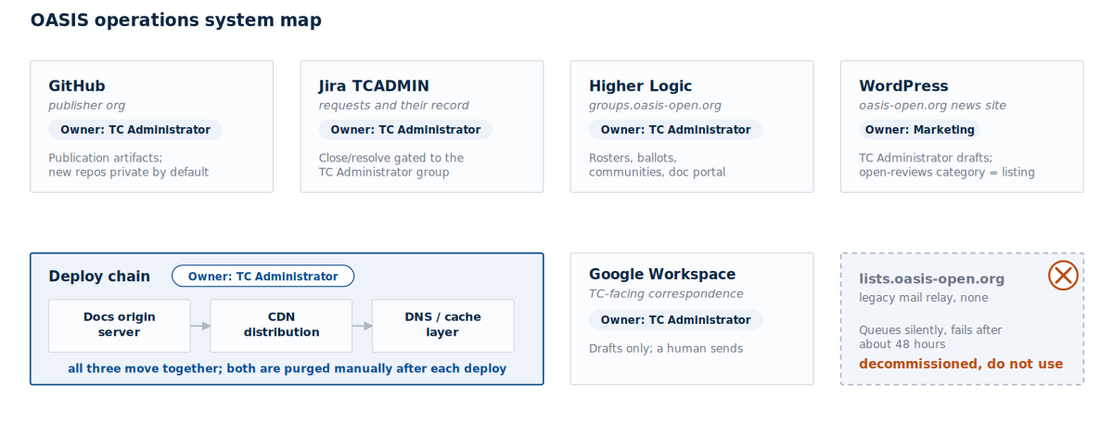
the seven systems as boxes with the artifact flow between them: TC editor to document portal to internal repository to the four publication layers to the public URL, with the request tracker and the work tracker drawn as records attached to the flow rather than as stages in it, and the legacy mailing-list host drawn struck through

8.2 Ownership and permissions per system
The table below is the inheritance list. Where a cell says [VERIFY], the system exists and is in use, but who administers it and who grants access to it has not been confirmed, and that gap is itself a finding as of 22 July 2026.
System | Administrative console | Permission the work needs | Who grants it
Member platform | An administrator entry point separate from the member view, plus per-community administration | Posting rights on the all-members community, and administrator rights on each per-TC public comment facility | [VERIFY]
Request tracker | The project's own queue, ticket and permission-scheme screens | Membership in the TC Administrator permission group, which is what carries close and resolve | Held today by the TC Administrator, who also holds tracker administration
Internal publishing repositories (GitHub, the OASIS-Docs organisation) | The repository and organisation settings | Organisation membership able to create and write repositories | [VERIFY]
Docs origin box, then AWS S3, AWS CloudFront and Cloudflare (object store, CDN, domain and cache layer) | Four separate consoles or command lines, one per layer | Deploy credentials for each layer, run today from a staff workstation | [VERIFY]
Public website | The content management system's page editor and post editor | Author access | [VERIFY]
Work tracker | The spreadsheet itself | Edit access to the tracker | [VERIFY]
Mail | The mailbox, with drafts staged over IMAP | Mailbox access | [VERIFY]
Four administrative consoles need a fuller description than the table gives, because that is where the work happens.
Signing in to the member platform. You sign in with your OASIS account through single sign-on.
The member platform's administrative side. Signed in with the administrative role, the platform adds a distinct entry point in the navigation beside the ordinary member links:
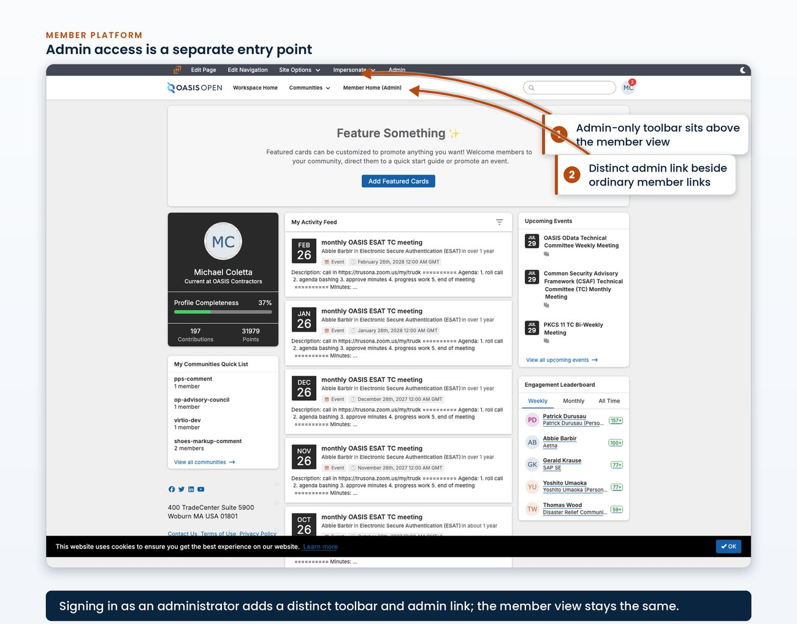
the platform landing page while signed in as an administrator, with the administrative entry point visible in the navigation next to the ordinary member links
Ballots are created from a form that takes these values as free text, so the roster arithmetic is typed into a field rather than computed by the platform:
- the title
- the specification link
- the summary
- the Statements of Use
- the opening and closing dates
- the passing threshold
Chapter 5 shows the form itself, filled for a real vote.
The roster view supplies the eligible-voter count that arithmetic depends on, fixed at the moment the ballot opens. It is read here:
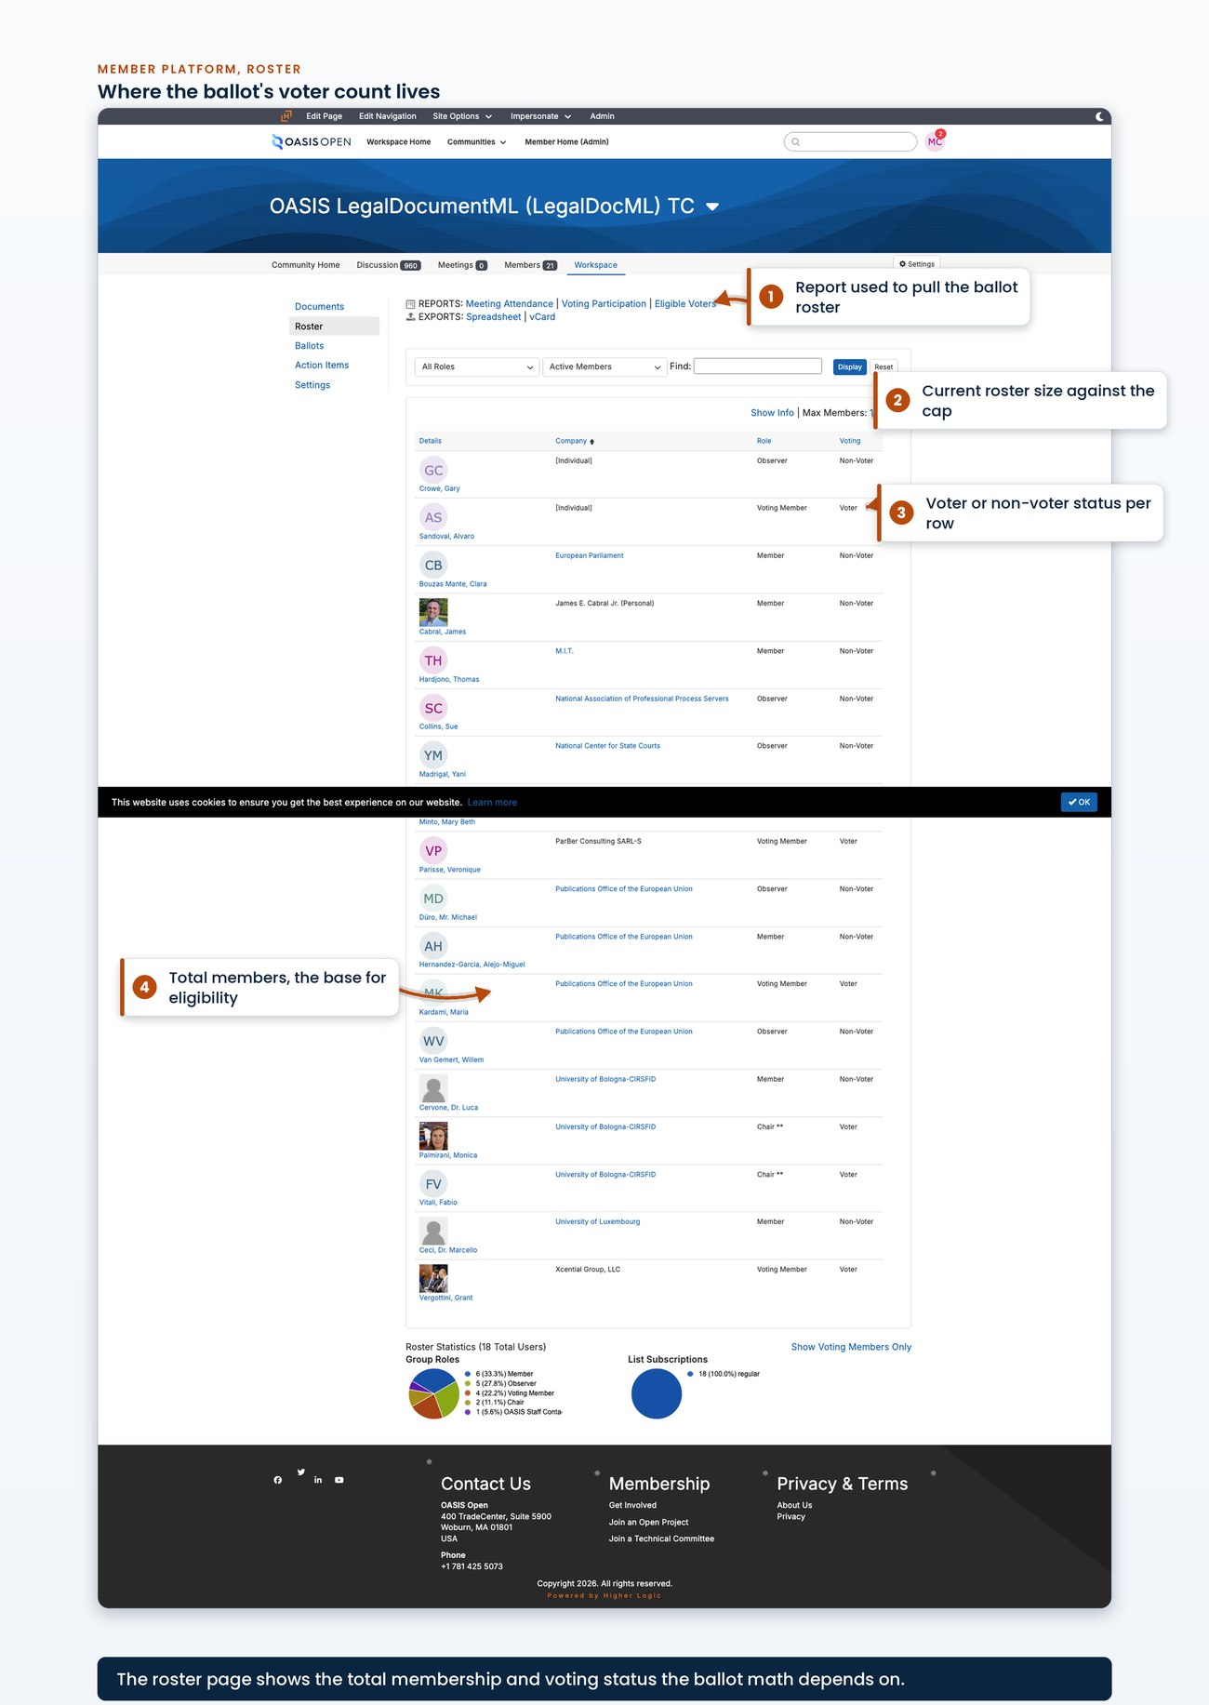
the roster or eligible-voters view for one TC with the total count visible on screen
Results sharing is set in the same form, at creation, and is easy to overlook:
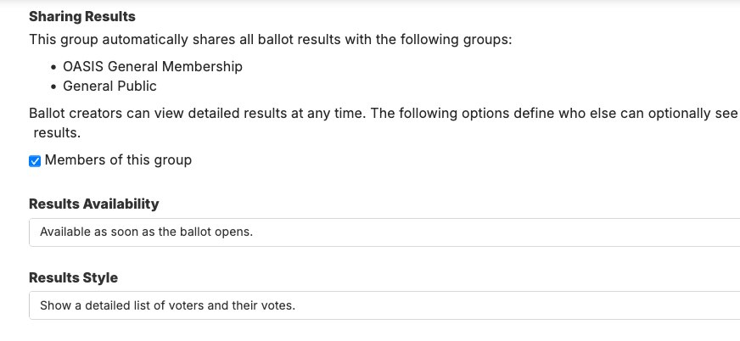
the Sharing Results section of the ballot form: the groups this group automatically shares results with, the option governing who else may see detailed results, and the availability and style controls, as captured mid-creation during a real ballot opening at the platform's own form width
Results visibility defaults to administrators of the group, with sharing to the general membership and to the general public both off, so publishing a result outside the group is a separate deliberate task. Community administration is where the per-TC comment facilities are configured, and a comment facility is a separate community from the TC's own with its own key. The document portal sits on the same administrative side: it is where a TC editor delivers a package, as a portal upload rather than a repository commit.
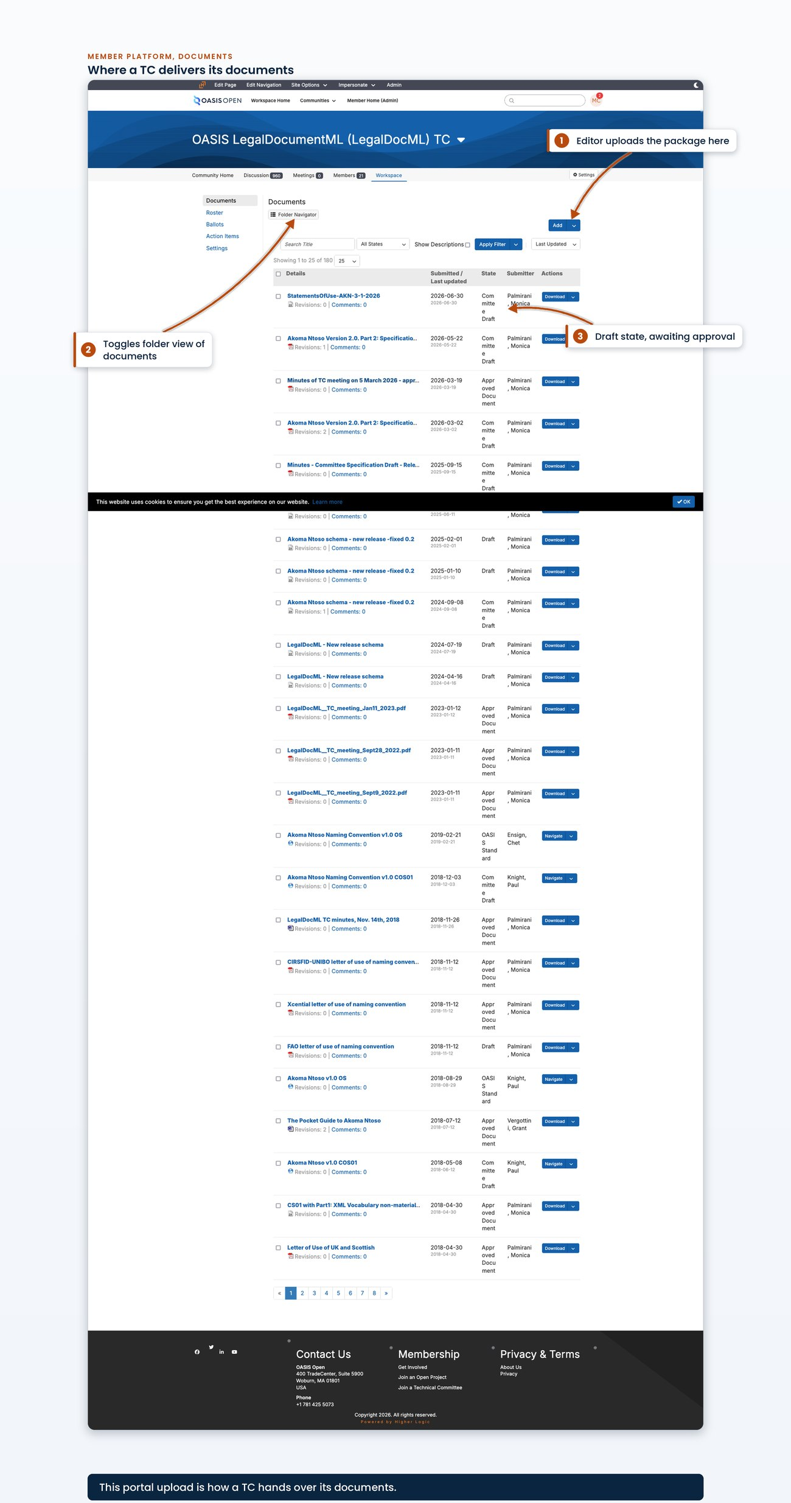
the document portal upload view for one TC, showing the folder structure and the upload control a TC editor uses to deliver a package
The website's content management system. A page is edited by opening it in the editor, changing the content in place and republishing it. A news story is created as a post in the same system, given a category from the four the site offers, and published.
A save is a publication
There is no staging copy and no review queue in the path, so a save is a publication.
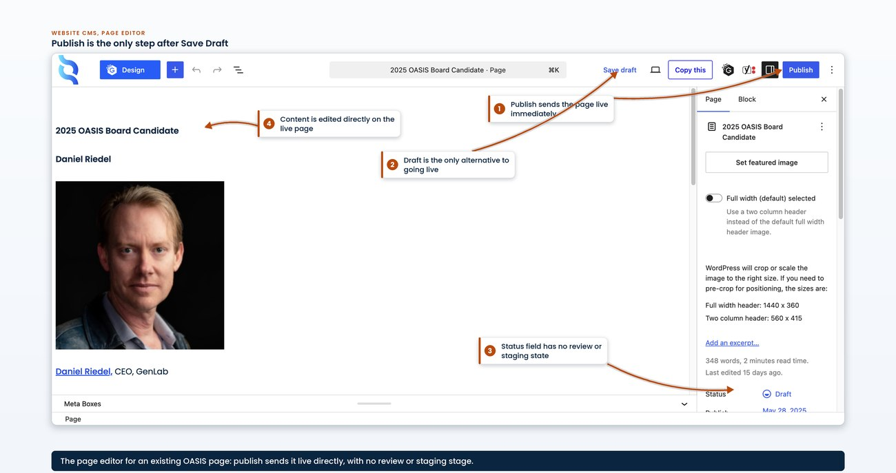
an existing page open in the content management system's editor, showing the content area, the publish or update control and the absence of any review or staging stage
Three things are not yet established:
- whether news stories arrive through a submission form of any kind
- who moves a draft to published when the author is not the publisher
- whether the author role can publish directly or only submit for review
[VERIFY]
The public request form, where requests arrive. A Gravity Forms public request form writes directly into the request tracker as a service account and creates a TCADMIN ticket. It does not post as the person submitting, which is why the ticket record does not carry the requester's identity. The form is open to anyone, which is how a wave of 20 spam submissions reached the queue in the year to 20 July 2026.
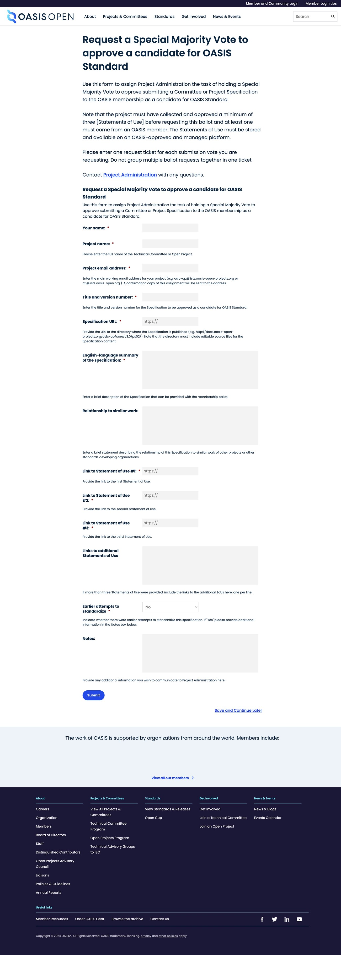
the public request form as an unauthenticated visitor sees it, showing every field the submitter is asked to fill and the submit control
The request tracker's own screens. The queue list shows every request in the project; as of 22 July 2026 every recent ticket reads as a generic task, so the type column carries no information and the request kind survives only as free text in the summary.
A ticket's detail screen holds the record: the inbound package from the TC and the two reports OASIS returns.
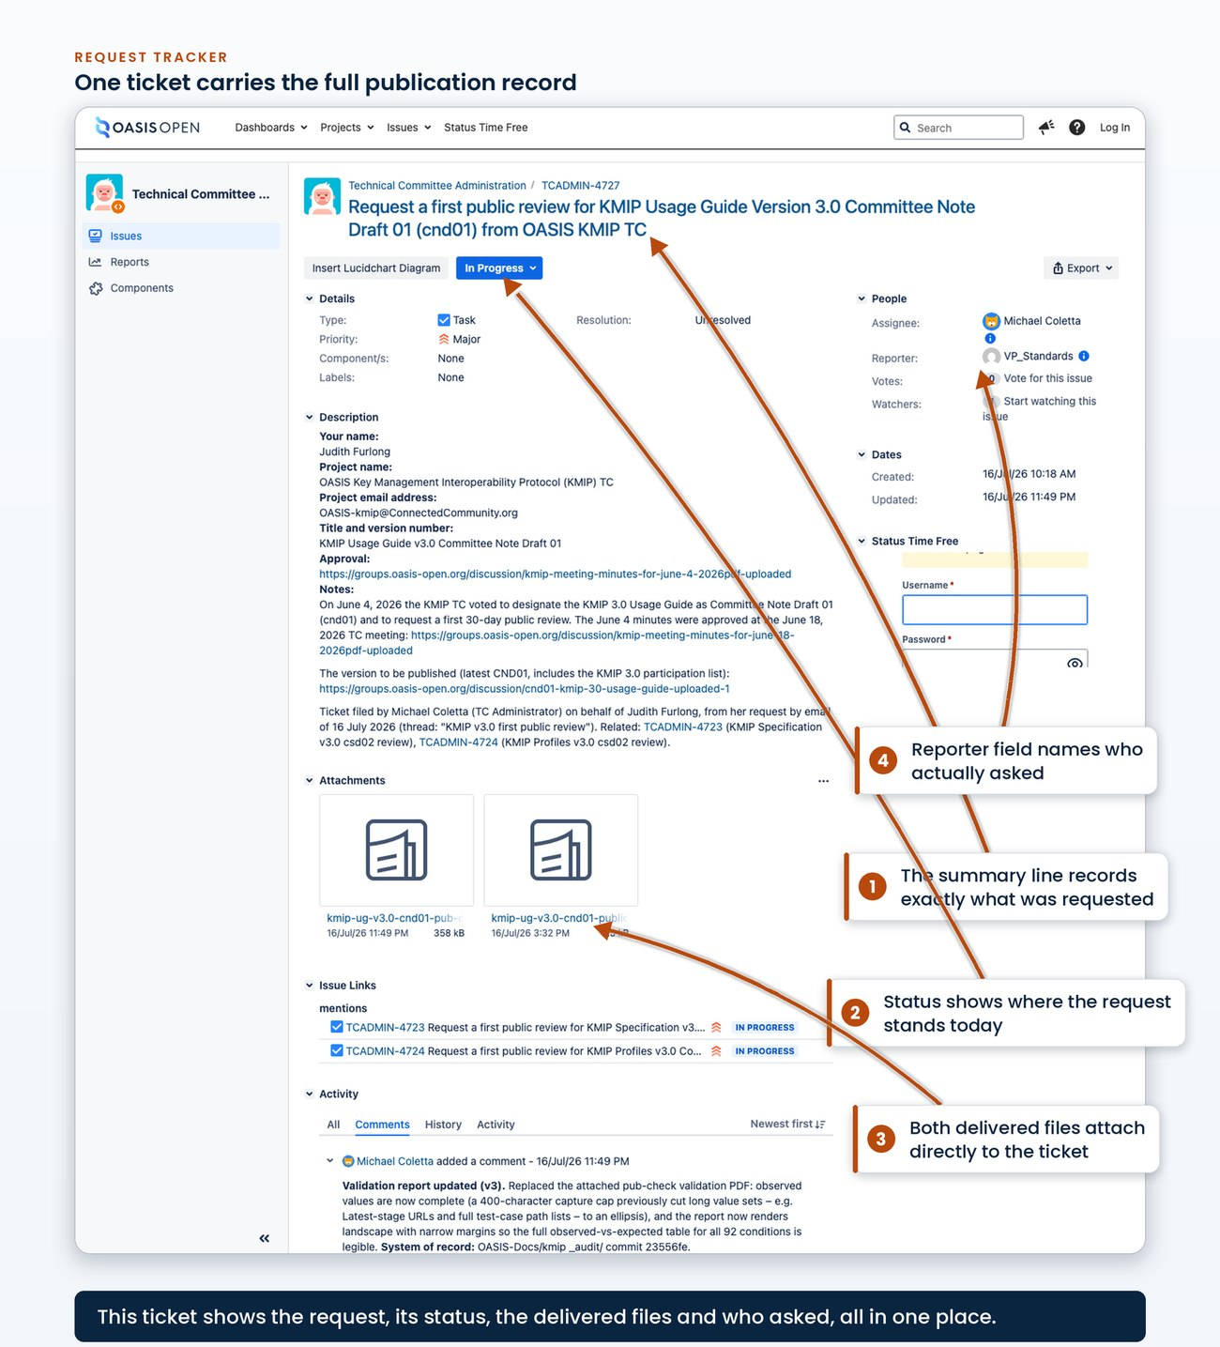
one real publication ticket showing the summary line, the status, the inbound attachment from the TC and the two returned report attachments named in the audit convention
The permission-scheme screen is easy to overlook. That gap was found and closed on 10 July 2026 by adding the account to the group. The scheme and the group that holds the grant look like this:
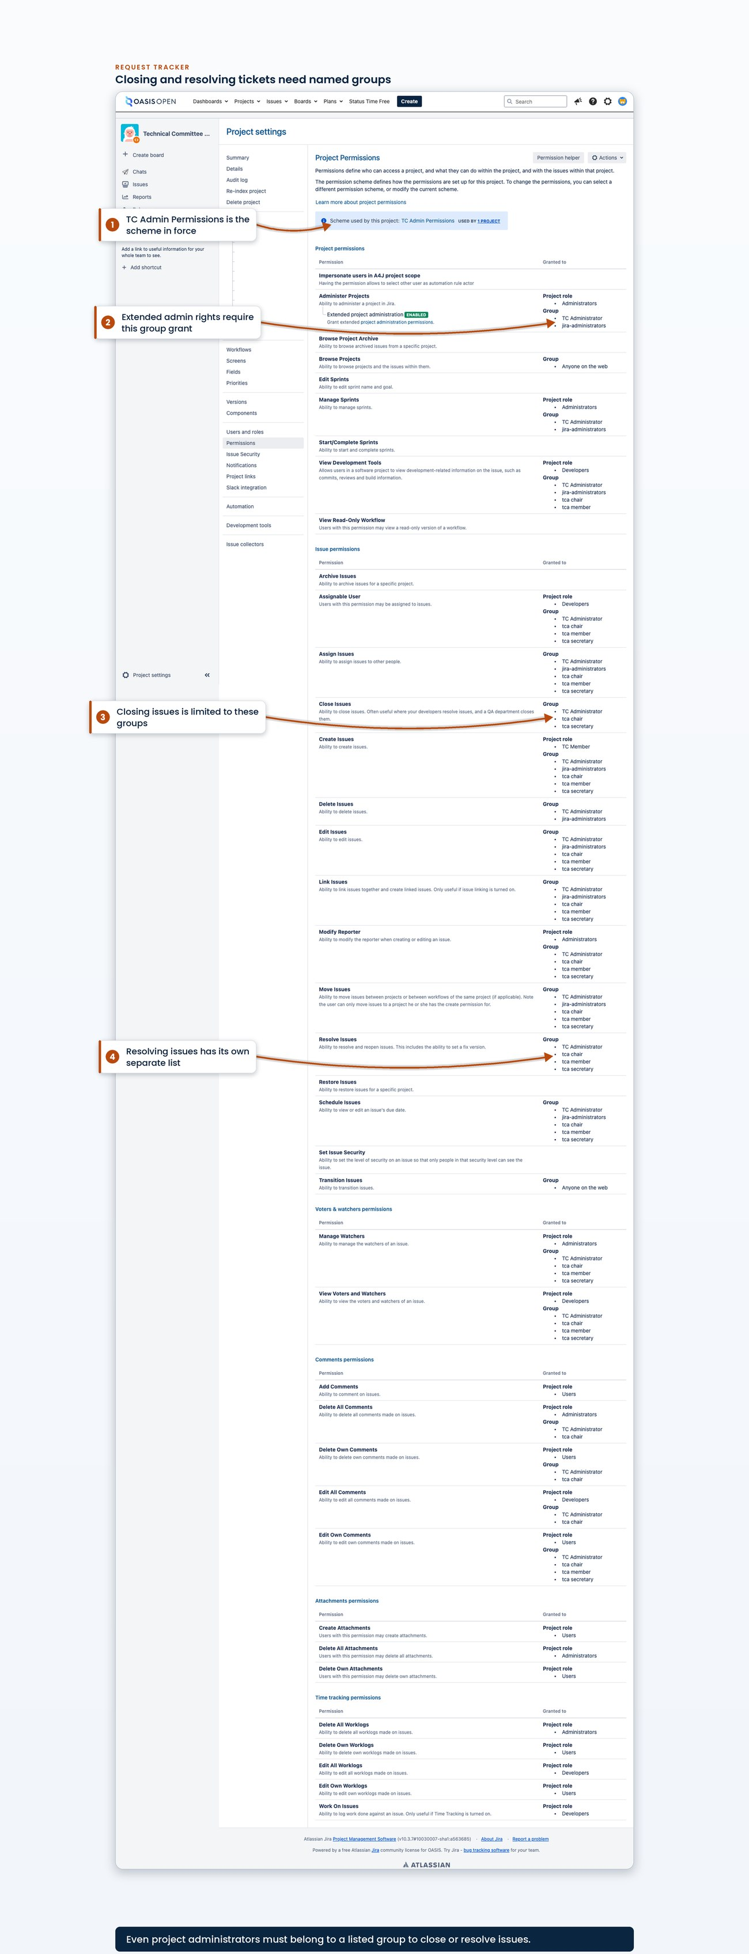
the project's permission scheme screen scrolled to the close-issue and resolve-issue entries, showing the named groups that hold them
Administration does not bypass the group
Close and resolve are granted to named groups, and holding global or project administration does not bypass that grant, so an administrator who is not in the group sees only start progress and stop progress.
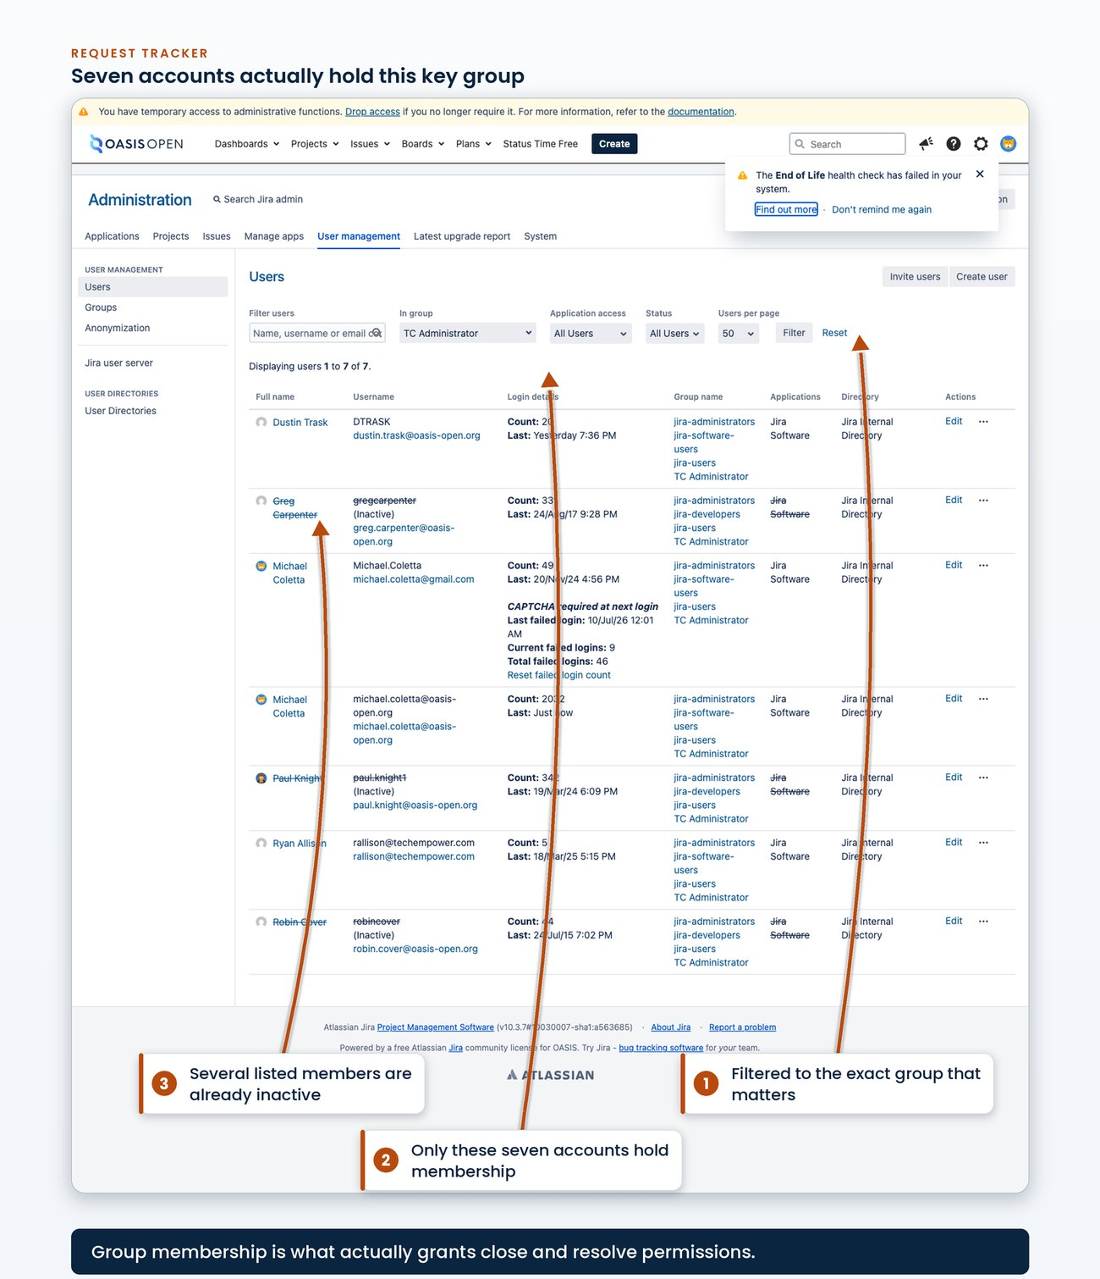
the request tracker's user management filtered to the TC Administrator group, listing the accounts that actually hold it

8.3 Onboarding a new staff member
A person taking over any part of this operation needs seven separate grants, and none of them come bundled behind a single account. Work through the list below as a checklist on day one, and request each grant as a ticket so the grant itself is on record.
Grant | What it carries
Posting rights on the all-members community, plus administrator rights on each per-TC public comment facility | The all-members announcements from Committee Specification to OASIS Standard (chapter 7), and administration of the per-TC facilities where public reviews take comments
Membership in the request tracker's TC Administrator permission group | Close and resolve on tickets; project administration alone does not confer it
Organisation membership on the internal publishing repositories | Create and write access to the repositories
Deploy credentials for the four publication layers, held separately per layer | Copying a package to the origin box, the object store, the content delivery network, and the domain and cache layer, each with its own credential (chapter 4)
Author access to the public website's content management system | Publishing news posts, including the Invitation to Comment published there as a news post
Edit access to the work tracker | The work tracker
Access to the OASIS mailbox | TC correspondence
Two of the grants carry history worth knowing at handover:
- The member-platform posting right sat with a staff member who left in June 2026 and should be confirmed before a review is opened.
- The request tracker's group membership is separate from project administration: an incoming person can hold administration and still have no close or resolve transition until this membership is granted.
Who grants each of these is not yet recorded; establishing that list is item A.1 and should be settled before the next handover. [VERIFY]
- Owner: whoever holds each system today grants it to the incoming person
- System: every system in the 8.1 map
- Permission: administrative rights on each system to add a user
- Timing: no recorded turnaround target for any grant
- Record: a ticket per grant, or one ticket listing the full set where they are issued together
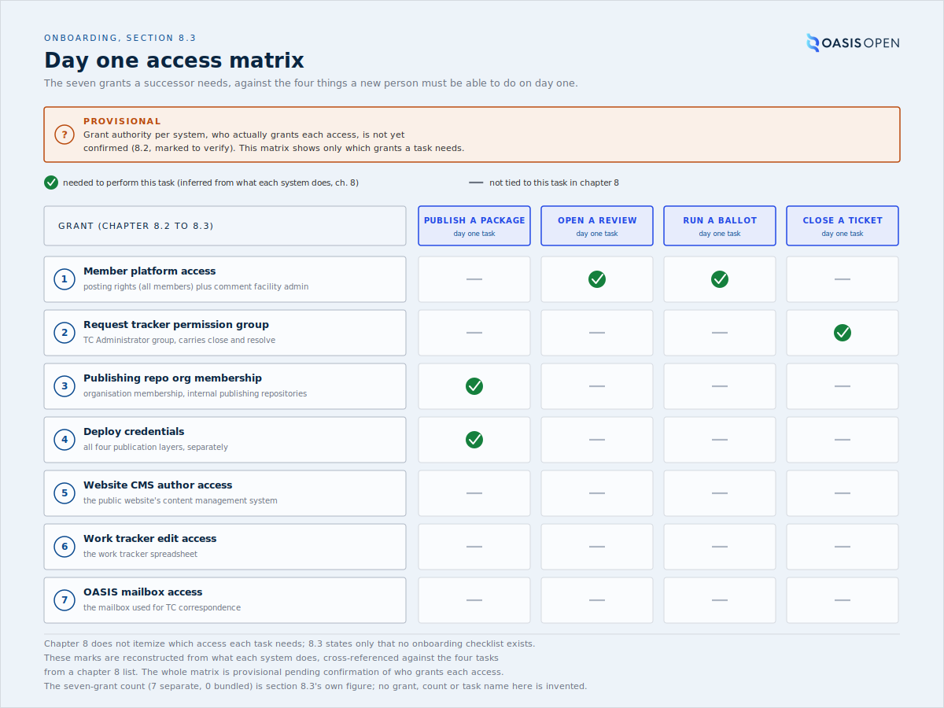
the seven grants as rows against the four things a new person must be able to do on day one, publish a package, open a review, run a ballot and close a ticket, with each cell marked required or not required

8.4 How this handbook is served
The handbook is one more system the TC Administrator inherits, so its own hosting is recorded here, with the links needed to change any of it.
The source. The authoritative copy is the markdown in OASIS-Docs/tc-operations-handbook, a private repository in the internal publishing organisation. To change the handbook, edit the chapter files in md/, one file per chapter; diagrams and screenshots live under site/assets/ and the renderers under build/. A push to main or to the current draft branch publishes it.
The deployment. The workflow deploy-pages.yml runs on every push: it rebuilds the master document from md/, renders the HTML, and deploys the site/ tree to the tc-operations-handbook Cloudflare Pages project with Wrangler. Every run is listed under the repository's Actions tab; a green run means the live site matches the pushed commit, and a failed run leaves the previous deployment serving. The two repository secrets the workflow uses (a Pages-scoped API token and the account identifier) are set in the repository's Actions secrets.
The serving and the gate. The site is served at ops-handbook.oasis-infra.net behind Cloudflare Access, all of it configured on the OASIS-Open Cloudflare account. The Pages project sits under Workers & Pages in the Cloudflare dashboard, and the custom domain is attached there. The gate is the Access application named TC Operations Handbook (internal) under Zero Trust, Access, Applications in the Zero Trust dashboard: a reader is sent straight to a Google sign-in, and the policy admits only accounts whose email ends in oasis-open.org. Cloudflare enforces the policy at the network edge, before the site is served, so there is no unauthenticated path to the content, and the handbook can be a real website for staff while staying off the public web.
- Owner: the TC Administrator maintains the markdown and the render; the deploy workflow and the access gate run on the OASIS Cloudflare and GitHub accounts.
- System: the source repository and its deploy workflow; Cloudflare Pages for hosting; Cloudflare Access with the Google Workspace identity provider for the gate.
- Permission: an oasis-open.org Google account to read; write access to the repository to change the content; Cloudflare account access to change the gate or the domain.
- Record: the repository history, the workflow run log, and the Cloudflare Access policy.
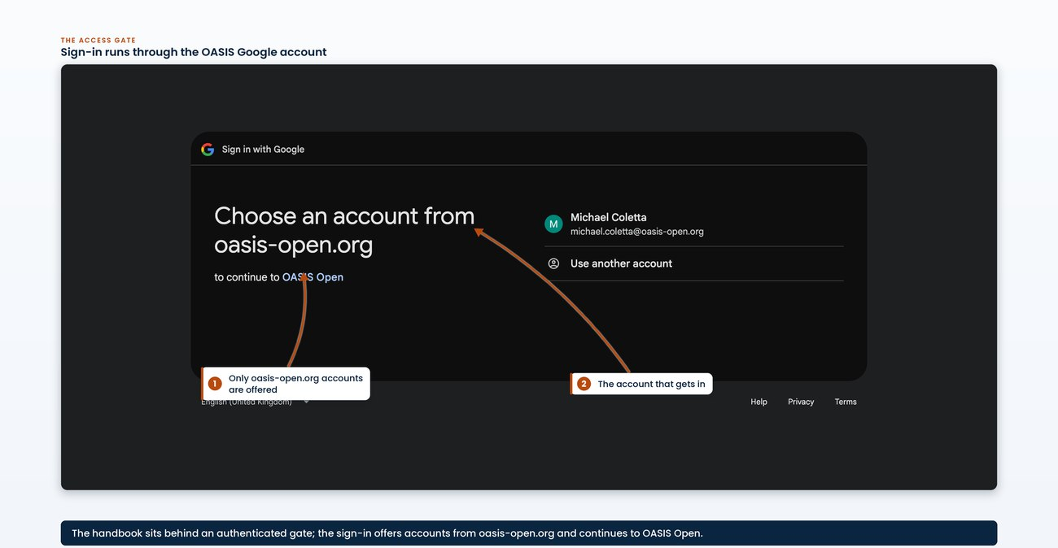
the Cloudflare Access sign-in the reader meets at ops-handbook.oasis-infra.net, showing the Google login and that only an oasis-open.org account is admitted

9. Records and accountability
Every fulfilled request leaves two records, and a publication leaves a third:
- the ticket that tracks it;
- the log and tracker row that account for the work;
- for a publication, the pair of reports that prove it was done correctly, which 4.7 covers with the rest of the publishing operation.
This chapter states what each record is, who writes it, and where it is kept. It closes with what those records cannot currently answer; that gap is a finding in itself, and the reason several figures in this handbook had to be assembled by hand.
The same rule applies to all three records. One linking-profiles request ran for seven months with no ticket in practice, and one publication had no ticket at all.
No ticket, no audit trail
The ticket is the system of record a TC can see, so a request fulfilled without one cannot be seen by the TC or audited afterwards.

9.1 Every request gets a ticket
Every fulfilled TC or publication request has a ticket in the request tracker. Requests arrive by several routes, so the first task at intake is to search the tracker for an existing ticket. Those routes include:
- the public web request form;
- email;
- the member platform;
- direct message.
Where none exists, staff open one before or while the request is fulfilled, recorded on behalf of the named requester.
The requester usually has no account on the tracker, so the ticket cannot be opened under their identity. The reporter is set to the shared intake identity that every web-form request already carries, and the first line of the description records that the ticket was opened by the TC Administrator on behalf of the named requester. The body captures their request in the house form:
- the requester's name;
- the TC;
- the Work Product title, version and stage;
- the link to the minutes recording the approving vote;
- the channel and date the request arrived on.
Related tickets are cross-linked. Reports are attached to the ticket as the work completes (4.7).
This convention stands in for the requester identity the tracker does not capture. Section 9.2 gives the numbers behind that.
Search first, then open on behalf
At intake, search the tracker for an existing ticket before doing anything else; where none exists, open one on behalf of the named requester rather than leave the request untracked.
- Owner: TC Administrator
- System: the request tracker
- Permission: create, edit and close tickets in the tracker's TC administration project (8.2 lists the grant)
- Timing: opened at intake, before or during fulfillment, and kept current through close
- Record: the ticket, carrying the request, the approval link, the cross-links and the attached reports
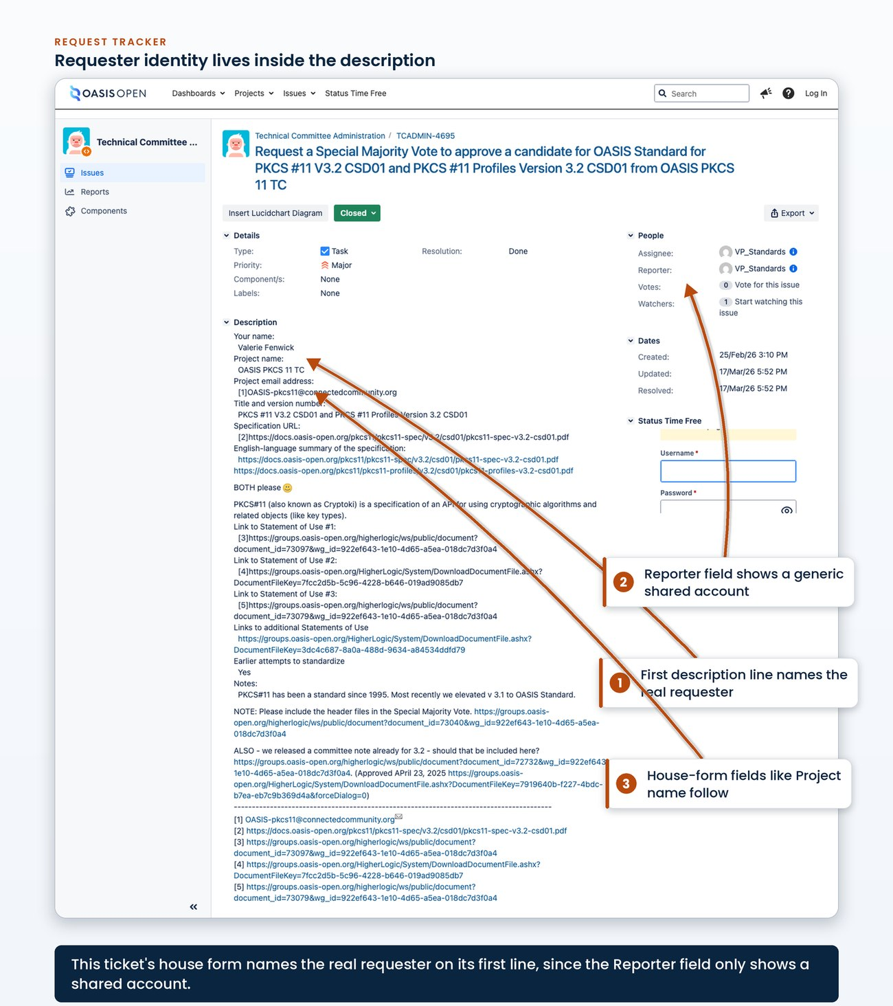
the description field of a ticket opened on behalf of a requester, showing the first line naming who it was opened for and the house-form field labels beneath it

9.2 What the record cannot currently tell you
4,381  tickets, all time | 142  raised in 24 months | 69  in the last 12 months | 41  in calendar 2026 | 127  of the 142 already closed
The request tracker holds 4,381 tickets all time. Of those, 142 were raised in the 24 months to 22 July 2026, 69 in the 12 months to that date, and 41 in calendar 2026 to date. Of the 142:
- 127 are closed;
- 9 are in progress;
- 6 are resolved.
The record is complete enough to count, but not to count by category.
The request taxonomy is no longer used. The tracker defines 20 purpose-built request types covering every kind of request a TC can make, from public reviews at each duration through ballots, charter submissions and document uploads to version control setup, and all 20 saw real historical use, led by document upload at 225 tickets and the 15-day public review at 107. Usage in the last 24 months is zero. Every one of the 142 recent tickets is filed as a generic task, so the request type survives only as free text in the summary line, in the form "Request a first public review for...". No report of the form "how many public reviews did we open last year" can be produced from the tracker without parsing prose, which is why usage figures for the operation are assembled by hand across several systems.
The tracker cannot count by category
The 20 purpose-built request types have zero use in the last 24 months and every recent ticket is a generic task, so any count by request type must be parsed out of free-text summaries by hand.
Requests do not arrive under the requester's identity.
142  tickets, 24 months | 83  filed by the shared intake account | 53  carry no reporter | 5  a named TC requester | 1  an administrative account
Of the same 142 tickets, 83 were filed by the shared intake account and 53 carry no reporter at all, so 136 of 142 arrive either through the shared account or anonymously. Only 5 tickets in two years carry a named requester from a TC. The web request form writes into the queue without creating or attaching a requester identity, and requesters have no accounts on the tracker to attach. So the tracker cannot answer which TCs ask for what, and the ticket record alone will not tell the TC Administrator who requested it. The house description convention in 9.1 exists to put the requester's name back into the ticket body by hand, which makes the identity readable but still not reportable.
A third limit applies to any timing figure taken from this record: those figures, and the constraints on quoting them, are set out in 4.8.
The form is open to anyone, which is why the 20 invalid tickets exist. All 20 fall inside the last 12 months, and six of them, TCADMIN-4716 to 4721, were raised consecutively in a single run and closed together. The six are a subset of the 20.
All four findings are dated 22 July 2026 and can be derived again. Each carries the query that produced it in the fact registry, so the TC Administrator can run the same sweep and get the same figures.
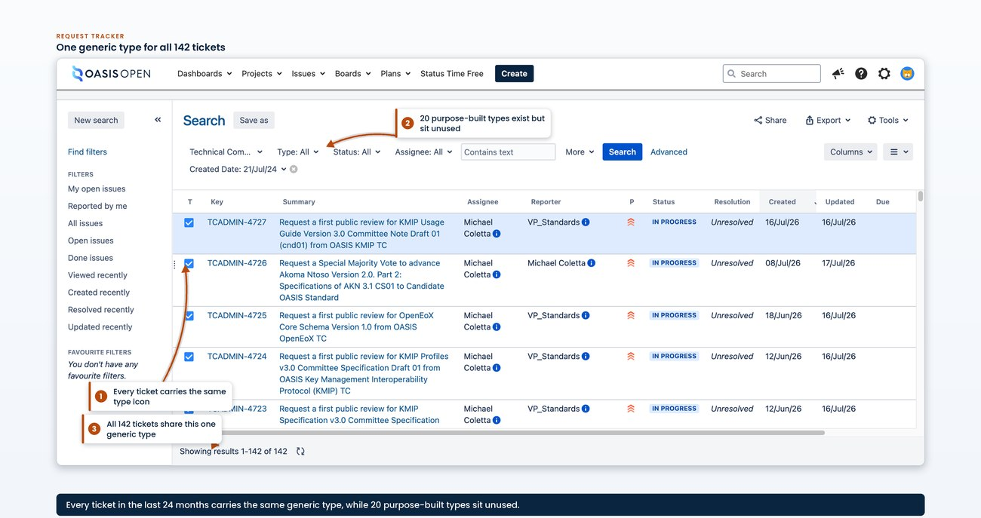
the request-type breakdown over the last 24 months, showing the 20 purpose-built types at zero use and all 142 tickets typed as a generic task
The reporter breakdown over the same window shows how much of the requester identity is lost at intake.
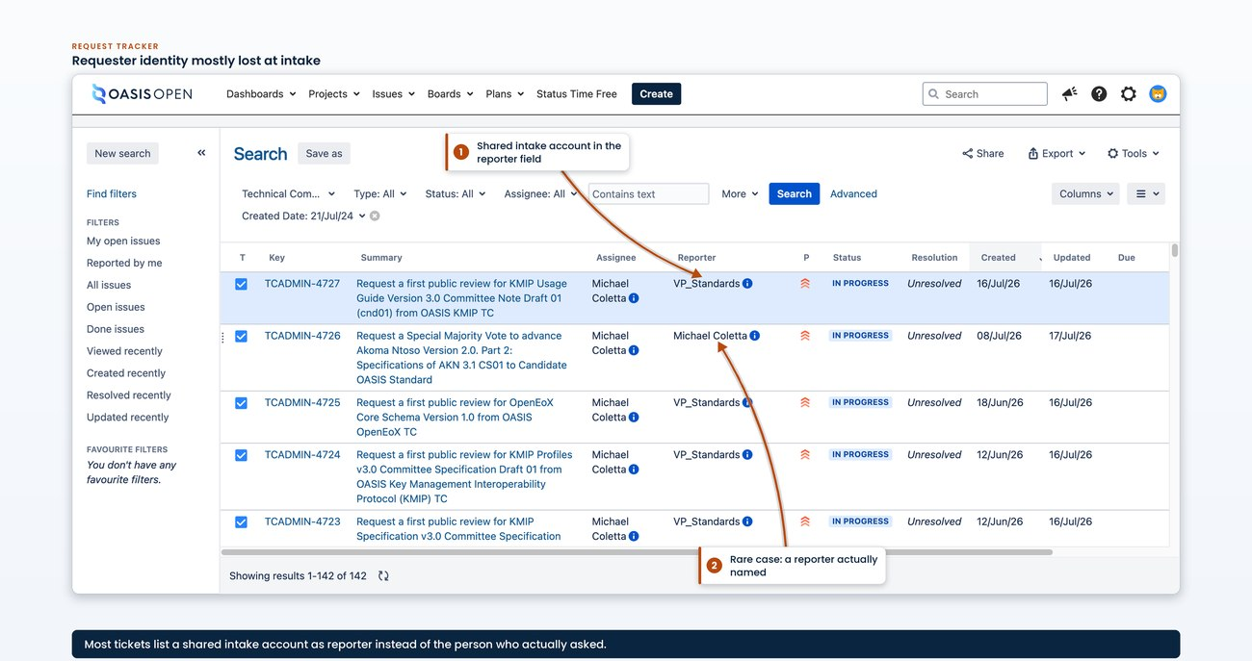
the reporter breakdown over the same window, showing the shared intake account, the tickets with no reporter, and the handful of tickets carrying a named one

9.3 The committee record on the member platform
The records above are the operation's. The committees keep their own, and for many of them the member platform holds it. Measured in July 2026, the platform's 46 TC workspaces hold 16,440 documents all time; the recent filings counted below are a subset of that total, not additions on top of it. For the committees whose record of record for minutes is the workspace, the minutes are filed to the workspace, approved by motion, and cited from it.
Formal motions in approved minutes cite platform document identifiers and ballot URLs as the evidence of what was decided, so those links carry the committees' governance record the way a ticket carries the operation's. A change that breaks a workspace document link or a ballot URL breaks the evidence chain inside minutes a committee has already approved. Any replacement or restructuring of the platform therefore has to keep those links resolving, by survival or by redirect, and any staff work that moves or deletes a workspace document should treat an inbound citation from minutes as a reason not to.
753  documents filed between March 2024 and July 2026, within the all-time total | 377  of those are meeting minutes | 17  committees whose record of record for minutes is the workspace | 83  ballots run on the platform in the same window
- Owner: each TC owns its record; the TC Administrator protects the links the record depends on
- System: the member platform, the Documents and Ballots areas of each TC workspace
- Permission: read access to each TC workspace's Documents and Ballots areas
- Record: the filed minutes and the platform documents and ballots they cite

10. Roles and ownership

10.1 The role map today
The operation depends on four roles:
- Technical Advisor, engaged externally. Performs TC Administration.
- Director of IT. Holds the platforms and the accounts they run on.
- Chief Operating Officer. Holds organizational oversight.
- A standards role that would own policy. Not filled.
4  roles the operation depends on | 3  filled as of 22 July 2026 | 1  standards role not filled | 2  roles held by the one external advisor | 1  publish-and-review handoff that no longer exists
The staff member who ran publication and public-review administration left OASIS in June 2026. Since then one person holds the TC Administrator and staff contact role for these TCs and handles both the publication and the opening and running of the public review. The handoff in which one person published the files and another opened the review no longer exists. This handbook records that as a role fact.
TC Administration is an OASIS staff authority. Staff authorize and determine. No OASIS document should describe TC Administration as an outside party whose consent must be obtained; TC Administration usually writes the document itself.
TC Administration is a staff authority
Staff authorize and determine. No OASIS document should describe TC Administration as an outside party whose consent must be obtained; the document is usually written by TC Administration itself.
Function | Owner as of 22 July 2026
Standards policy and TC Process interpretation | Not filled
Publication, public review and ballot operations | Technical Advisor, acting as TC Administrator
Platforms and the accounts they run on | Director of IT
Organizational oversight | Chief Operating Officer
- Owner: as in the table; the operational rows are held by one person
- Record: this handbook, and the tracker rows and tickets each piece of work leaves behind
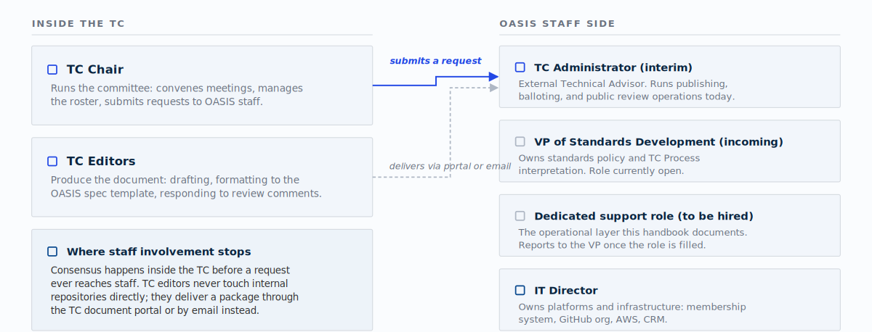
the four functions against their owners as of 22 July 2026, with the unfilled standards role and the three operational functions held by one person, shown distinctly

10.2 What the incoming standards hire inherits
This section tells a person taking the standards role what is actually in their hands on day one. It is an inventory.
They inherit the operation this handbook describes:
- Publication to the docs site end to end, from intake through the acceptance criteria, the repository chain, the manual four-layer deploy and the review that confirms the live site (chapter 4).
- Balloting, including the roster arithmetic, the Special Majority Vote and the route from Committee Specification through Candidate OASIS Standard to OASIS Standard (chapter 5).
- Opening, running and closing public reviews, where the announcement is itself the act that starts the clock (chapter 6).
- The announcements and TC-facing correspondence attached to all of it (chapter 7).
- The access grants on every system involved, which are granted separately rather than bundled behind one login (chapter 8).
- The records in chapter 9, which are what makes any of the rest auditable afterwards.
They also inherit the current working conditions of the operation without exception:
- The deploy is manual and runs from a staff workstation.
- Two of the automated deploy steps stopped working after an infrastructure migration, and nobody has replaced them.
- Two of the systems the operation used to rely on no longer work; staff work around them rather than fix them.
- The request tracker cannot report on its own contents by request type or by requester.
Whoever takes the role next starts with the operation in this state.
What they do not inherit is a written policy mandate for the mechanics. The intent described to date is that the standards role owns policy, meaning how OASIS interprets and applies the TC Process, and that the day-to-day publication and balloting mechanics move to a dedicated support position reporting into it once that position exists [VERIFY].
The transfer mechanism
Until such a position exists, the mechanics stay where they are. This handbook is the transfer mechanism: it hands the role over as a documented operation rather than as a gap.
- Owner: the organizational design decision sits with the Chief Operating Officer and the Director of IT; interim execution sits with the Technical Advisor
- Record: this handbook, kept current as the standards role and any support role are defined and filled

10.3 TC-side roles and where staff involvement stops
The TC owns four kinds of decision:
- what the specification says
- the companion artifacts that travel with it
- the per-specification publication preferences
- the TC-wide publication defaults
The committee reaches consensus on all four before any request comes to staff. The TC does not have to maintain:
- the rendering toolchain
- the render filters
- the PDF configuration
- the deployment pipeline
OASIS operates and refines those under the stated contract.
Staff involvement stops at the content.
What OASIS does not promise | What happens instead
Editorial review of specification content | That is the TC's responsibility
Visual perfection of every edge case in author-supplied Markdown | The TC editor and OASIS publication staff do the quality pass together before a final stage is published
Forward compatibility of the source with future renderer changes | OASIS publication staff manage a major renderer change with deliberate migration
Each of these is a stated limit in the contract OASIS gives its TCs, which makes it as binding as the promises beside it.
The same posture governs the ballot. Staff take Statements of Use and their links at face value. They do not:
- audit conformance
- chase Primary Representative endorsements
- police the comment facility as a prerequisite
Those are real policy, handled only if someone objects. The role is to run the mechanics cleanly, not to gatekeep the committee.
Run the mechanics
The role is to run the mechanics cleanly. Statements of Use and their links are taken at face value, and those are real policy, handled only if someone objects.
At delivery the boundary is a handover. TC editors deliver the final package through the TC document portal or by email, and staff move it into the internal publishing repositories. Staff never ask a TC to upload to those repositories: the repositories are OASIS's internal publication bookkeeping. A TC may keep whatever it wants in its own space, and a package may arrive fully rendered or as source for staff to render. The requirement that does not change is that the final published form conforms to the naming directives, the template and the acceptance criteria, whatever form it arrived in.
- Owner: the TC chair submits the request, the TC editor produces the document, and the TC Administrator moves the package and executes
- System: the TC document portal or email at intake; the internal publishing repositories for execution
- Permission: the requester needs no repository access; only staff hold write access to the internal repositories
- Record: the delivered package, and the ticket staff open on receipt (9.1)

Appendix A. Open verification items
Every claim in this handbook has a source behind it, or it carries a [VERIFY] marker and
appears in this list. The appendix is the complete list. Nothing here is known to be wrong.
Each entry is a claim that is not yet proven, kept in view so nobody mistakes an assumption
for a record.
19  actionable markers | 10  questions they reduce to | 3  policy conflicts | 10  markers in Chapter 8 alone | 4  in Chapter 5
Nineteen [VERIFY] markers in this draft need action, and they reduce to ten
questions. They sit in these chapters:
Chapter | Markers | Detail
Chapter 8 | 10 | most are cells in the access table
Chapter 5 | 4
Chapter 3 | 2
Chapter 7 | 2
Chapter 10 | 1
Chapter 1 and this appendix mention the marker to explain it; those mentions are not items.
Three of the ten are policy conflicts rather than gaps: A.2, A.3 and A.4 each record a
place where current practice and a Required rule disagree.
Policy wins
The contract's rule is that policy wins and the disagreement is a defect to file, so those three are not waiting on a decision about what OASIS should do. They are waiting on a reading of what policy already says.

A.1 Who grants access to each system
Where: 8.2, seven cells in the inheritance table. 8.3 restates it as the section's own
open question.
Every system in the operation is known, and so is the access each one needs. Who grants
that access is recorded for exactly one of them: the request tracker, where the TC
Administrator also holds tracker administration. For these systems the granting authority is
not written down anywhere:
- the member platform;
- the internal publishing repositories;
- the four publication layers;
- the public website;
- the work tracker;
- mail.
Needed: for each system, the role that grants access and the role that owns the account.
Why it matters: this is the single largest gap in the handbook.
The largest gap
An incoming staff member cannot be onboarded from a document that lists what they need but not who to ask. One person currently holds that information, and it is not written down.

A.2 Whether a Special Majority Vote must offer an abstain option
Where: 5.3.
The operating procedure sets the ballot options to Yes and No with no Abstain, following
current practice and the immediately prior ballot on the same TC. TC Process section 1.11
requires that any Work Product Ballot conducted as an electronic ballot must permit each
voter to choose yes, no, or abstain. Committee Specification Draft ballots from 2018 did
offer abstain. [VERIFY]
Needed: a policy reading of whether a ballot submitting a Committee Specification as a
Candidate OASIS Standard is a Work Product Ballot within the meaning of section 1.11.
Why it matters: the threshold arithmetic is unaffected either way, because Yes and No
are each counted against the eligible-voter total and an abstention changes no outcome. The
option to abstain matters in its own right, and if section 1.11 applies then current
practice does not conform and the defect was inherited from a predecessor.
Treat it as a defect to file rather than a practice to write down. Resolve it before the next
Special Majority Vote opens. Until then, record which options each ballot used.

A.3 Whether the ballot form's single-vote setting removes the right to change a vote
Where: 5.3.
The setting used to date on the Add Ballot form is that voters may vote once. TC Process section 1.11 states, as a Required rule, that eligible voters may change their vote up until
the end of the voting period. A single-vote setting removes exactly that right. This is the
second section 1.11 conflict in the same field map, alongside A.2, and it has been in place longer.
Needed: an inspection of the live Add Ballot form to establish what the vote-once setting
actually does. If it still lets a voter re-open the ballot and change a cast vote before
close, there is no conflict and this item is closed here. If it does not, revoting is set to
allow changes until close.
Why it matters: unlike A.2, this one may not be a real breach at all, which is why it
needs an inspection rather than a policy reading. It cannot be settled by precedent: every prior ballot
used the same setting, so precedent proves only that the question was never asked. Until it
is answered, record which revoting setting each ballot used.

A.4 Whether a wrong Committee Specification number invalidates a Statement of Use
Where: 5.4.
Current practice records a wrong Committee Specification number in the prose of a Statement
of Use as a defect and proceeds, on the ground that the prose still identifies the
specification. The Defined Terms rule that a Statement of Use must be made to a specific
version of the Specification, and must include that Specification's approval date, is
Required. Recording the defect and proceeding waives it.
Needed: a reading of what a wrong version number in the prose does to the statement when
the hyperlinks and the surrounding text otherwise identify the specification.
Why it matters: the operating approach itself is sound. Statements of Use are
taken at face value and are not audited, and that approach is deliberate and correct. The
problem is that one specific waiver contradicts a Required rule and has not been visible
anywhere in the record. Three Statements of Use are what a Special Majority Vote to submit a
Candidate OASIS Standard rests on, so a defect in what counts as one is a defect in the
ballot. Resolve it before the next Special Majority Vote opens.

A.5 What the recorded 12 to 15 day Call for Consent range measures
Where: 5.6 and 7.3.
The operating procedure records that the Call for Consent itself ran 12 to 15 days across
the four specifications measured from review close to OASIS Standard. Two of the four can
be reconstructed from the record, and both conform:
- PKCS#11 v3.2 opened 19 May 2026 and closed 3 June 2026, 15 days;
- OpenDocument v1.4 was announced to the membership on 22 September 2025 and was an OASIS Standard on 6 October 2025, 14 days.
The 12 at the bottom of the range matches no open-and-close pair in the record.
Needed: the ballot opening and closing timestamps for all four Calls for Consent, and
the method behind the recorded figure. Either it measures something other than the open
window, such as the interval from the announcement post to the close, or a Call for Consent
was run for less than the minimum.
Why it matters: section 2.8.3 requires the consent period to be open for at least 14
days. A 12-day open window is a breach. It currently appears in the record as a routine statistic in a forecasting note, with no defect flag. The figure is quoted to marketing when
a standard's date is forecast, so it is in circulation. It remains in the handbook while it is
unresolved, still marked, because if OASIS ran a short Call for Consent, that
matters more than the forecast the figure was collected for.

A.6 The written mandate for the standards role
Where: 10.2.
Draft 0.1 asserted, without a citation, that the standards role owns policy while the
publication and balloting mechanics move to a dedicated support position reporting into it.
Nothing in the handbook's sources states this.
Needed: a written source for the role definition and the reporting line.
Why it matters: 10.2 exists to tell an incoming hire what they are taking on. An
uncited organisational intent is the wrong thing to tell them.

A.7 How a news story reaches the website
Where: 8.2.
A page is edited by opening it in the content management system's editor, changing the
content in place and republishing. How a news story gets from a draft to published is less
clear when the author and the publisher are different people.
Needed:
- whether news stories arrive through a submission form;
- who moves a draft to published when the author and the publisher differ;
- and whether the author role publishes directly or only submits for review.

A.8 Whether a press process exists
Where: 7.3.
The rule about who is copied on a website news post is recorded, and the drafting practice
for news posts is recorded. Nothing records a press process as such.
Needed: whether a recorded press process exists at all, and if so:
- its lead time;
- its sign-off task;
- and whether press distribution is a channel distinct from ordinary member announcements.

A.9 The document that states the five publication guarantees
Where: 3.3.
Section 3.3 states the five things the publishing pipeline does not promise, as the limits
that sit beside the publication guarantees a TC may rely on. The specific TC-facing document
and its URL that state those guarantees and their matching limits are not yet identified.
Needed: the document and its URL.
Why it matters: the limits bind what a TC may expect as firmly as the guarantees do, so
a TC-facing statement of them should be citable rather than described.

A.10 The Board and Board Process Committee template-approval record
Where: 3.4.
Section 3.4 records that the Board approved a master template for the OASIS Standard,
Committee Specification and Committee Specification Draft stages on 24 April 2025 and
delegated derivative templates to the Board Process Committee, which released the Committee
Note template on 3 June 2025, and that the Technical Report template does not appear in the
record. The Approvals-record URL and its two dated entries are not yet cited.
Needed:
- the Board and Board Process Committee Approvals-record URL;
- its 24 April 2025 master-template entry;
- and its 3 June 2025 Committee Note entry.
Why it matters: the two dates and the negative claim about the Technical Report template
rest on a record that is not yet linked.
---
How to close an item.
1. Confirm the answer against a real source.
2. Add it to _build/ops-facts.json with the source and the section.
3. Remove the [VERIFY] marker from the chapter.
4. Delete the entry here.
When an item is closed
An item is closed only when the fact registry can prove it.

